

WAIROA HOSPITAL

EMERGENCY CONTROL PLAN

INDEX

Emergency Control Plan | 1
Communication | 2
Multiple Casualties | 3
Telephonists | 5
Category Red | 7
Telephone List of Essential Numbers | 12
Site Maps | 13
Appendix 1 – Distribution List | 15
Appendix 2 – Call-back Checklist | 16
Appendix 3 – Equipment | 17
Appendix 4 – Documentation | 20
Appendix 5 – Action Cards | 26

Hawke’s Bay District Health Board
Emergency Control Plan

The primary function of this plan is to outline the actions required of personnel employed within the hospital in the event of a mass casualty event. This plan is also designed to work within the framework of the Major Incident Plan in the event of a declaration of a Civil Defence or Public Health Emergency.

It is the responsibility of Heads of Departments to ensure that all staff are familiar with the content of this plan and are competent to carry out the duties outlined.

The contents of this plan are to be followed as closely as possible but appropriate discretion must also be employed where no specific direction is laid down.
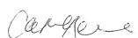

Signed:
Executive Director Provider Services Hawke’s Bay District Health Board

Dated this 30th day of November 2019

EMERGENCY CONTROL PLAN
WAIROA HOSPITAL

Multiple Casualties arising from localised incident

Category Red arising from civil defence emergency

Patient Classification -

Status 1 = critical injuries (unstable/receiving CPR)

Status 2 = serious injuries (unstable)

Status 3 = moderate injuries (stable)

Status 4 = minor injuries (no concern/stable)

Status 0 = fatal / NFR

COMMUNICATION
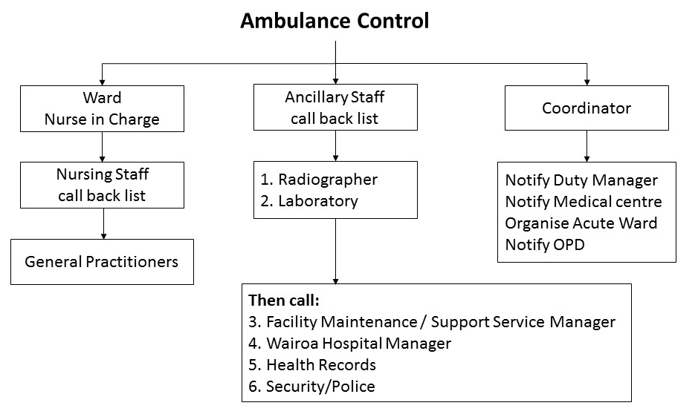

MULTIPLE CASUALTIES

Communication

Ward
Nurse in Charge to → activate Nursing Staff Call Back List

→ delegate Co-ordinator

→ activate Ancillary Staff Call Back List

→ delegate communication between switchboard, ambulance R/T and triage area to a suitable staff member, situated in Ward Office, use Communication Record and Ambulance Communication Forms

→ delegate triage nurse, assistant to set up Triage Area and one nurse to check the treatment areas using provided checklist

→ allocate identification shirts to Triage Nurse, Communications Nurse, Co-ordinator

→ allocate staff to roles using Staff Placement Form (see Appendix 4)

Triage Area – Main reception/foyer

- Delegated triage nurse prepare foyer with help of assistant and transport nurses via Co-ordinator

- Equipment to be sent to area:
- Triage/emergency trolley and first response pack (behind main reception)

- Dedicated person will deliver other equipment necessary

- Triage Nurse responsible for triage of patients, Red Bracelet application and documentation

- Hand set radios to be used for communication with other areas

Staff- Triage Nurse > from Ward: responsible for triage of patients,
red bracelet system and documentation

Nursing Staff x 2 > to transport patients status 1, 2 and 3

Assistant to Triage > to assist in preparation of area and where
necessary

Support Associate > to transport patients and relay messages to
and Volunteers and from ward as required
to secure helicopter pad and assist with
transportation from pad as necessary

Clerk x 1 > Reception area, to document where patients are transported to

Equipment

> extra linen (in Linen Room)
> whiteboard
> rubbish bags with liners
> linen bags
> triage / emergency trolley (in Emergency Room)
> portable suction units
> portable oxygen cylinders

Acute Ward

Staff > Available Ward nurses
> Two medical officers
> One Clerk to collect patient details when available.

Equipment > Contact laboratory for extra supplies as required – dedicated person to collect.

> Extra portable suction unit and oxygen regulators to be collected by Support Associate from Ward and PRIME bags from Health Centre

Treatment Areas
Emergency Treatment to be carried out in Ward. Nurse in Charge of Ward to allocate patients to rooms on arrival.

Stand down of staff to be advised by Co-ordinator or
Senior Medical Officer on duty.

Casualty Flow

Status 1 > from triage direct to Emergency Room, Rooms 1 and 2 in ward

Status 2 > from triage direct to Emergency Room, Rooms 1 and 2 in Ward

Status 3 > from triage direct to Room 9 in Ward

Status 4 > from triage direct to Health Centre waiting room with Care Associate

Status 0 > direct to Mental Health Service rooms

TELEPHONISTS

On advice of an emergency from Ward Nurse in Charge, complete call out of Medical and ancillary staff :

1. General Practitioners

2. Radiographer

3. Laboratory

Then Call:

4. Facilities, Maintenance & Support Staff Manager

5. Hospital and Health Centre Manager

6. Practice Managers

7. Health Records

10. Mental Health Co-ordinator or D.A.O.

Nurses Call Back List
Kept on Acute ward and in each folder. Must be regularly updated by CNM.
Ancillary Call Back list
Must be regularly updated and in each folder. Updated by Facilities, Maintenance and Support Staff Manager.

Telephonist’s message

This is Wairoa Hospital

We have a Multiple Casualty Response in progress

THIS IS NOT A PRACTICE

Brief description of event as written on checklist

Record all communication following call-back of staff on Telephonist Emergency Log.

PROCEDURES AND GENERAL INFORMATION

A. Second Telephonist to assist with staff call backs and to carry out clerical duties as required.

B. All media calls to be referred to the Communications Manager.

C. Maintain updated call back lists; CNM maintains the Nursing call back list and Facilities, Maintenance and Support staff Manager maintains the Ancillary call back list. List to be checked Ist July and Ist February - with Head of Department.

D. Maintain essential phone numbers list.

CATEGORY RED

(30 plus casualties from civil disaster)

It is not possible to detail contingency plans for such an event because:

- the hospital may not be habitable
- access to the health centre may be blocked
- many staff may be unable to get away from personal responsibilities

NEVERTHELESS, initial responses should be:

A) Listen to local radio for special instructions

B Automatic reporting to hospital of all staff as able

C) If hospital still habitable:

- staff with multiple casualty duties set up for response
- all other staff report at the Hospital Control Centre situated in the Main Reception of the Wairoa hospital

D) If hospital evacuated or uninhabitable, report to front car park.

The senior person per area will be expected to take charge of the area and staff.

E) Alternatively, a temporary hospital may need to be established. If such is announced on the radio (or by other official channel) then proceed to this place as soon as possible.

Hawkes Bay District Health Board is the prime facilitator for all health responses and resources within the Hawkes Bay region during a state of Civil Defence or Public Health Emergency.

The Co-ordination of a Civil Defence or Public Health Emergency Declaration, regionally, will be carried out through the Health Incident Controller situated in the Emergency Operations Centre in the Clinical Skills Laboratory at Hawkes Bay Hospital.

Liaison Officers may be sited at local Civil Defence Centres with overall liaison with Civil Defence being maintained at the Group Emergency Operations Centre. Civil Defence is responsible for logistic support of health services during a declared emergency.

In the event of the Civil Defence Emergency Management Operations Centre (EOC) becoming non functional, the EOC will be relocated to the Basement Room (purple room) at Wairoa Hospital.

RESPONSE

All off duty staff will ensure the safety of their families and properties and then report to their place of work. Those staff involved in a multiple casualty response will carry out their duties under the current health centre plan. Personnel not involved directly in the plan should report to the Hospital Coordinator and will be deployed appropriately.

CONTROL

Control of the event will be managed by the Emergency Operations Centre at Hawkes Bay Hospital using a coordinated incident management structure. The Hospital Coordinator will be responsible for managing the facility and reporting to the In-patient Unit of the Operations Section.

CIVIL DEFENCE LIAISON OFFICERS

Civil Defence liaison will be undertaken by a member of the Incident Management Team sited at the Group Emergency Operations Centre.

If required a staff member may be transported to the local Civil Defence Emergency Management EOC to act in the role of liaison between the hospital/health centre and Civil Defence Emergency Management. Essentially this role is one of information carrier between the hospital/health centre and Civil Defence Emergency Management. Responsible for supplying information to the hospital/health centre on at least a two hourly basis.

SERVICES

All services are expected to continue to operate within their particular area of expertise, co-ordinating all efforts with their Control Centre. A Damage Assessment Form should be completed for each area and returned to the Hospital Control Centre as soon as possible after the event.

UNOCCUPIED AREAS

Any unoccupied areas in each hospital/health centre will be utilized by the Control Centre as necessary.

BED CENSUS

Each area is responsible for providing the Control Centre with an updated bed census every four hours for the first 24 hours and eight hourly thereafter.

Casualties are to be reviewed every eight hours with ward placement and/or readiness for discharge being assessed.

MORTUARY FACILITIES

Temporary mortuary facilities may be provided in the form of cool storage containers. This will be actioned by the Emergency Operations Centre if required.

BACK-UP FACILITIES

In the event of the hospital/health centre facilities becoming overloaded back-up facilities for casualty overflow have been earmarked.

Napier - Eastern Institute of Technology (EIT)
Hastings - Royston Hospital
Wairoa - Wairoa College
Waipukurau - Central Hawkes Bay College

PUBLIC RESPONSE

All existing outside direct lines to be manned by Administration personnel. Telephone numbers to be broadcast via radio stations in liaison with the Emergency Operations Centre.

SECURITY

Existing security arrangements in the hospital plan to continue to operate.

ALTERNATIVE ACCOMMODATION

If hospitals and other buildings become untenable as the result of a major disaster such as an earthquake, it is most likely that the majority of buildings in the disaster area will also be in a similar condition. The extent of planning for alternative hospital accommodation must be made with this premise in mind. The eventual locations for temporary hospitals can only be determined after the disaster has occurred, although possible suitable locations are as follows:
Napier - EIT, McLean Park
Hastings - Royston Hospital, HB Racecourse, Nelson Park
Wairoa - Wairoa College
Waipukurau - Central Hawkes Bay College

It will be the task of HBDHB, in consultation with Civil Defence Emergency Management to decide upon the most suitable premises for the temporary hospitals, dependent upon the condition of existing hospitals in the first instance and alternative accommodation in the second instance.

Evacuation procedures to be followed as for fire; relocation of patients to be carried out using HBDHB vehicles with additional resources being requested from Civil Defence Emergency Management as necessary.

DECONTAMINATION

Decontamination of casualties, when necessary, is to be carried out in the car park area alongside the entrance to the Triage Area of each hospital/health centre. Casualties are to be washed down (portable showers may be obtained from the Fire Service) and contaminated clothing removed, placed in plastic bags and tagged. Until decontamination procedures have been completed contaminated casualties should be separated from non contaminated casualties.

CONSERVATION OF ESSENTIAL RESOURCES

Careful utilisation of existing supplies/resources is essential.

The conservation of water is particularly important. The following general rules should be followed:

- Do not use sinks, showers/bath tubs, ice machines
- Do not flush toilets after each use
- Use paper products where possible for the serving of food/drink
- Use alcohol based solutions for washing hands

SUPPORT SERVICES

Building and Engineering Service

This service will provide a complete and Organisation wide assessment and control facility along with recovery and restoration procedures which will help ensure continuity of services for essential areas.

The Facilities Manager will appoint an individual to assume the responsibilities of the Damage Assessment Co-ordinator in co-ordinating damage assessment and recovery procedures, reporting directly to the Facilities Unit in the Logistics Section at the Emergency Operations Centre. Staff will assess damage using provided checklists. Priority would be given to the restoration of the following:

Electricity supply via emergency generators (self contained units diesel powered with 5 days running time) - power supply to critical areas only.

Water Supply D Block

Sewage Patient Areas

Medical Gases Emergency Room, Acute Ward
(additional supplies to be obtained from BOC Gases (NZ) Ltd)

Refrigeration Kitchen, Mortuary

The buildings will be checked and/or repaired to ensure safety with top priority being given to the clearance of entrances and exits and the prevention of fire and hazardous materials risks.

Building maintenance supplies/resources are housed in the services workshops in each hospital/health centre.

To ensure restoration of essential services existing personnel will be utilized where available with assistance being sought through usual channels, if necessary. The Civil Defence Emergency Management Group Controller will be informed by the Health Incident Controller should additional assistance be required.

Transport Services

All transport resources available shall only be used for emergency purposes and will be under the control of the Health Incident Controller. Any request for additional transport will be made via the Emergency Operations Centre to Civil Defence Emergency Management.

Resources will be utilized to:

(a) Evacuate patients and staff from an affected area.

(b) Deliver essential resources into an area.

(c) Move personnel and supplies through or around a disaster area.

(d) Move patients from EMU's to other facilities as necessary.

Linen Services

Linen is to be regarded as an essential commodity. After in-house stocks have been depleted additional resources will be obtained from local suppliers using normal purchasing systems. Requests for supplies which cannot be obtained locally will be made through the Supply Unit in the Logistics Section at the Emergency Operations Centre.

Domestic Services

Cleaning and associated services are to be regarded as an essential activity and there will be a substantial increase in the workload during an emergency. Private contractors may, should the situation demand, be co-opted to assist.

Nutrition and Food Services

Food and its preparation are to be regarded as an essential commodity. The first priority therefore is to provide continuity of service of its preparation and delivery. Resources should be obtained from local suppliers using normal purchasing systems.

Public Health, Community Health and Mental Health Services continue to operate following individual service plans.

An Emergency Medical Unit may be set up at Glengarry Rest Home and Hospital if the situation demands. This unit will attend to all presenting casualties and refer those requiring secondary care to Wairoa Hospital in the first instance. The site will be broadcast on local radio stations.

TELEPHONE LIST OF ESSENTIAL NUMBERS

TITLE & NAME | HOSPITAL EXTENSION | ALTERNATIVE  NUMBER
Hospital Manager Sonya Smith | 4849 | Cell 027 742 8498 | 06 281 5014
Facility Maintenance & Support Staff Manager Robin McOnie | 4804 | Cell 027 232 1978
CNM | 4843 | Cell 027 216 2204
ACNM | 4866 | Cell 027 647 6671
Practice Manager | 4930 | 06 838 8333
Acute Ward | 4820 / 4821 | 06 838 3714
Ambulance Station | 4847 | 06 838 3711
Wairoa St Johns Manager Raewyn Gordon |  | 06 838 6662
Radiology | 4831 | 06 838 9707  06 838 3998 | 027 226 0108
Radiology Reception | 4842 | 06 838 7099
Laboratory | 4859
- J Forrest | 4859 | 06 838 6929
- S Hagen | 4859 | 06 838 3160
Triage Area / Radiology Office | 4809 | 06 838 7451
Kitchen | 4846
Maternity Office | 4841 | 06 838 3174
Medical Records - J Dawson | 4844 | 06 838 7118
OPD Nurse - V Manson | 4819 | 06 838 6614
Undertaker - M Pickering |  | 06 838 7606 work  06 838 8560 home
Police |  | 06 838 8345
Hawkes Bay Hospital | *7318 | 06 878 8109
Civil Defence Emergency Management |  | 06 838 7309
Mental Health Team | 4875 | 027 457 6618

SITE MAP

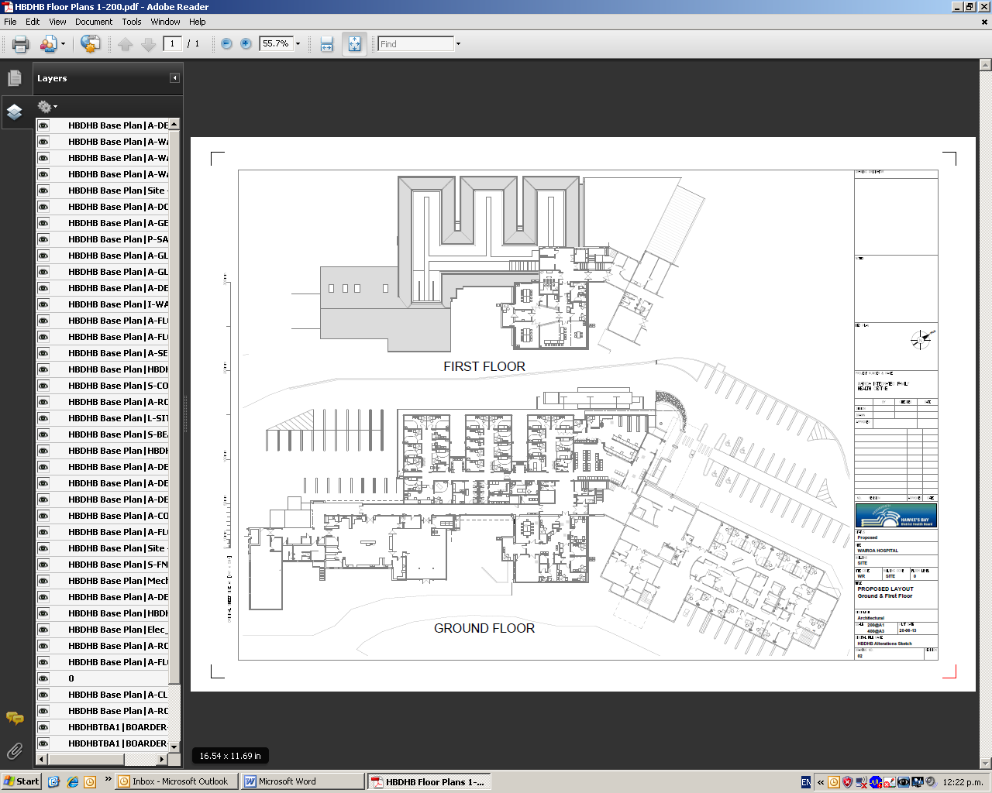

SITE PHOTO

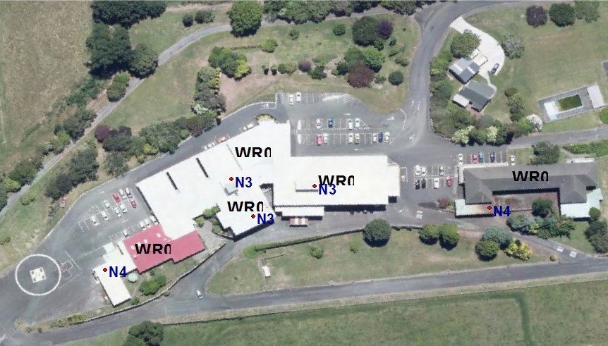

DISTRIBUTION LIST

Emergency Department – Hawke’s Bay Hospital
Civil Defence Emergency Management – Wairoa
Duty Manager Hawke’s Bay Hospital
Emergency Management Advisor – Sandra Bee
Police
Territory Manager – St John's Ambulance (2 copies,1 for local station,1 for territory base)

Acute Ward
Acute Ward Clinical Nurse Manager
Front Desk Reception
General Practitioners Clinical Lead x1
Health Care Centre
Queen Street Practice
Kitchen
Laboratory Department – Wairoa and Hastings
Wairoa Hospital Centre Manager
Facility Maintenance & Support Staff Manager
Maternity Ward
Outpatients Department
Radiology Department
Community Mental Health

Distribution:

- All other copies responsibility of Emergency Management Advisor
- Copies for Wairoa responsibility of Team Secretary, Wairoa Hospital

CALL BACK CHECKLIST

Description of Event _________________________________________________

___(for use by Ward Nurse in Charge)
⏐
✵
 | Who | How | Call Out | Response
 | Contacted |  | Time | Time
General Practitioners
Radiographer
Laboratory
Facility Manager
Hospital Manager
CNM - Acute
Practice Manager HCC
Practice Manager QSP
Health Records
Security (Police)
Food Supervisor
Mental Health Co-ordinator

Equipment

Triage / Emergency Trolley & first response pack

Trolley list
Sharps Box
Stethescopes x 2
Clothing Scissors x 1
Vomit Bowls
Penlight x 1
Yankeur Suction Handles x 2
Suction Catheters x 2
Gamgee x 10
Crepe Bandages x 5
Gloves - 1 box
Adult 0xygen Masks x 2
Child 0xygen Masks x 2
0xygen Tubing x 4
Ambu Bags single use x 6
Airways x 2 each size 1, 2, 3, 4; 2 x O; 1 x 00; 1 x 000
Thermoblankets x 2
Normal Saline x 2
Box of Red Bracelet Packs
Clipboard
Message Pad
Plastic Aprons

Res-q-vac x 2
Tissues x 1 box
Whiteboard pen

First Response Pack
Date Checked: |  |  | Staff Sign:
No. | Outside Front Pocket Upper |  | No. | Inside Lid Top Pocket
1 | Thermometer |  | 6 | Incontinence sheets
1 | Scissors |  | 1 | Yellow biohazard bag
1 | Pupil torch
1 | Stethoscope |  | No. | Inside Lid Middle Pocket
1 | Adult BP cuff |  | 1 | Laryngoscope
 |  |  | 1 | Blades size 2 and 4
No. | Outside Front Pocket Lower |  | 1 | Nasopharyngeal Tube 7mm
1 | CAT tourniquet |  | 1 | Nasopharyngeal Tube 8mm
1 | Thermal blanket
2 | Micropore tape |  | No. | Inside Lid Lower Right Pocket
4 | Primapore large and small |  | 5 | Adrenaline 1:1000
2 | Triangular slings |  | 3 | Adrenaline 1:10000
6 | Saline/Chlorhex irrigation |  | 4 | Salbutamol
4 | Large bandages |  | 4 | Atrovent
4 | Small bandages |  | 2 | Aspirin
4 | Large combines |  | 1 | GTN Spray
4 | Small combines
 |  |  | No. | Inside Lid Lower Left Pocket
No. | Outside side Pocket (Upper) |  | 1 | Adult neb and mask
1 | Marker Pen |  | 1 | Paed neb and mask
1 | Pad
1 | Pen |  | No. | Adult BVM Kit
 |  |  | 1 | BVM mask
No. | Outside side Pocket (Lower) |  | 1 | 02 tubing
1 | 50mL syringe |  | 1 | High concentration 02 mask
1 | 500mL Glucose 10%
2 | Hypofit gel |  | No. | Child BVM Kit
1 | Giving set |  | 1 | BVM Mask child/infant
1 | Drawing up needle |  | 1 | 02 Tubing
 |  |  | 4 | Ventilation masks selection
No. | Large Outside Pocket
6 | Masks |  | No. | IV Roll
2 | Protective Glasses |  | 2 | IV cannulas size 14-24
6 | Aprons |  | 6 | 5mL prefilled saline syringes
1 | Hand gel |  | 4 | Normal Saline 10mL amps
 |  |  | 6 | Drawing up needles
No. | Main inside cell |  | 4 | 22g IM needles
1 | Sharps Container |  | 4 | 25g needles
1 | Towel |  | 3 | Syringes 1mL,3mL,5mL,10mL
2 | Vomit bowls |  | 6 | Luer plugs
1 | Portable suction |  | 6 | Alcohol wipes
No. | Laryngeal Mask Kit |  | 1 | Tourniquet
1 | LMAs size 2, 2.5 and 4 |  | 6 | Medicaton addition stickers
1 | 30 ml syringe |  | 6 | Tegaderms
1 | Cob connector |  | 6 | IV pressure pads

Preparation of Work Areas

Ward – (equipment that may be needed and is located on Acute Ward)

→ gloves
→ 6x normal saline
→ 6 x gelofusine
→ 12 x blood sets
→ IV cannula 6 x each size
→ red top blood tubes x 20
→ purple top blood tubes x 15
→ airways x 2 each size
→ suture packs x 2
→ property bags
- tetanus toxoid - from medication fridge
→ burns sheets x 2
→ arm splints
→ blankets
→ plastic bags
→ gamgee and crepe bandages
→ vomit bowls

Restock linen
Resuscitation trolley
Collect other equipment as required

TRIAGE RECONCILIATION FORM

Time of Arrival | Mode of Arrival | Status Code | Age/Sex of Patient | Injuries of Patient | Dest. Of Patient | Triaged By | Red Bracelet No.

Form Number of Date Sign

EMERGENCY COMMUNICATION LOG
Date
No. | Time | Caller | Request | Destination | Action

AMBULANCE COMMUNICATION

Time of Call

ETA

Number and Status of Casualties:

Status 1 |  | Status 2 |  | Status 3 |  | Status 4 |  | Status 0
Message to Triage Area |  |  |  |  | Time

Comments:

Time of Call

ETA

Number and Status of Casualties:

Status 1 |  | Status 2 |  | Status 3 |  | Status 4 |  | Status 0
Message to Triage Area |  |  |  |  | Time

Comments:

Time of Call

ETA

Number and Status of Casualties:

Status 1 |  | Status 2 |  | Status 3 |  | Status 4 |  | Status 0
Message to Triage Area |  |  |  |  | Time

Comments:

MEDICAL/NURSING STAFF PLACEMENT FORM
WAIROA

Medical Officers:
Ward (2)
Nursing Staff:
Communications
Triage Nurse
Assistant Nurse
Transport Nurses (2)
Co-ordinator
Palliative Care Nurse
Receptionist

Date: Location:

PATIENT INFORMATION FORM

ID No. | NAME | DOB | ADDRESS | TELEPHONE | N.O.K

TELEPHONIST RECORD OF EVENTS

Date

Time of advice from ward

Category

No. of casualties Status

Time of activating emergency paging group call

WARD NURSE IN CHARGE

Activate communication tree after hours
Activate Nursing Staff Call Back List
Delegate Co-ordinator
Activate Ancillary Staff Call Back List
Delegate Triage Nurse and Communications Officer and explain roles
Hand out action cards
ID shirts - Triage Nurse, Communications Nurse, Co-ordinator, Nurse in Charge
Allocate areas of responsibility to incoming staff
Initiate inpatient transfers to Maternity Unit if necessary
Delegate staff to prepare Ward to accept casualties
Delegate Nurses x 2 to Emergency Room
Delegate Care Associates to assist in status 4 area or ward as necessary

TELEPHONIST

Notification by Ward Nurse in Charge.

Complete Ancillary Staff Call Back List
Refer media calls to DHB Communications Manager
Refer patient enquiries to Community Health

CO-ORDINATOR

Collect identification shirt from Ward
Notify on-call Intensivist and request medical team
Notify OPD and Health Centre during working hours
Utilize community volunteers where required
Update Hospital Manager or Corporate on-call Manager every 30 minutes
Arrange for extra linen supplies as necessary
Assess need for domestic services once treatment areas are cleared

WARD STAFF

Report to Nurse in Charge for briefing
Prepare ward to receive casualties
IV/blood trolley fully stocked
Adequate analgesia
Adequate linen
Beds prepared to receive casualties
Adequate paperwork (labels, stationery, folders)
Prepare inpatients for transfer if necessary
Prepare Health Centre to receive minor injuries

DEDICATED PERSON

Clear Ward if necessary
Collect wheelchairs and deliver to Triage Area
Place 4 beds along corridor from Radiology
Collect Triage Trolley from Acute Ward
Clear car park if necessary
Collect portable oxygen cylinders and suctions from Ward, deliver to Triage Area
Secure helicopter pad

