

Pandemic Plan
Template for
Schools

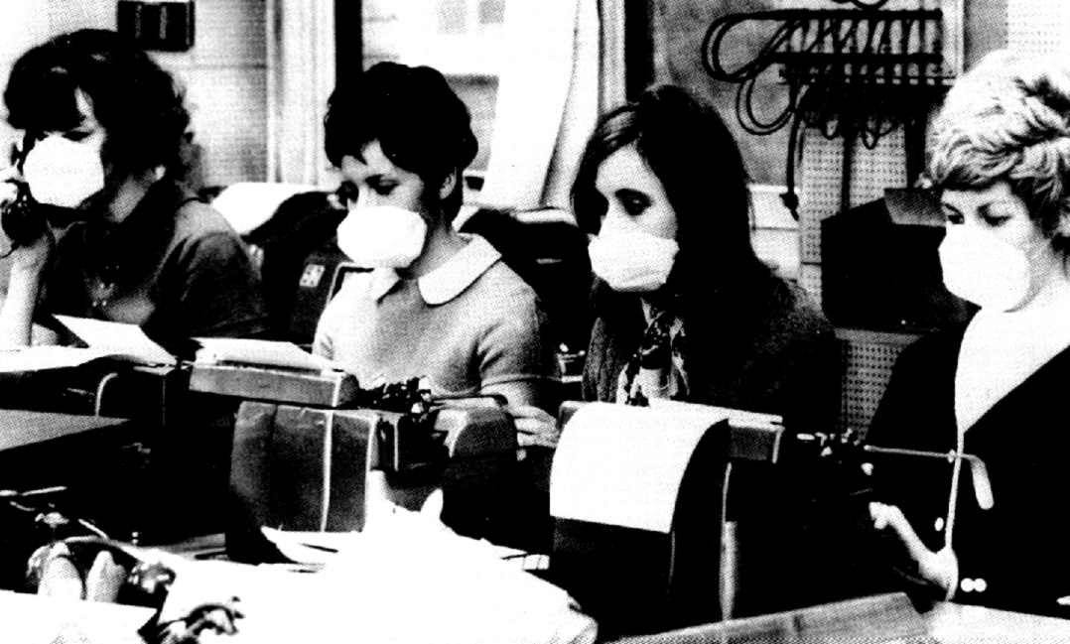

May 2009

CONTENTS

Introduction | 2
Pandemic Phases | 3
Case Definition | 5
Response within the School | 6
Options for Service Delivery | 6
Response to the Student with Suspected Influenza | 6
Communication Plan | 8
Infection Control Precautions | 8
Environmental Cleaning | 9
Information | 9
Training | 9
Workforce Management | 9
INTRODUCTION

Influenza pandemics are typically characterised by the rapid spread of a novel type of influenza virus to all areas of the world, resulting in unusually high morbidity and deaths for approximately two to three years. Factors that need to be present for a pandemic to occur include: the emergence of a new viral subtype; the capacity for the virus to spread efficiently from person to person; and being virulent enough to cause disease.

The primary purpose of this plan is to provide the framework and methodology to efficiently respond to an influenza pandemic in schools.

Assumptions

- An influenza pandemic is inevitable.

- There will be very little warning. Most experts believe that we will have between one and six months between the time that a novel influenza strain is identified and the time that outbreaks begin to occur in New Zealand.

- Outbreaks are expected to occur simultaneously throughout much of New Zealand, preventing shifts in human and material resources that normally occur with other natural disasters.

- The effect of influenza on individual communities will be relatively prolonged -- weeks to months -- when compared to minutes-to-hours observed in most other natural disasters.

- The impact of the next pandemic could have a devastating effect on the health and well being of the New Zealand public. Based on CDC projections it is estimated that in Hawke’s Bay alone, over a course of 2 to 3 months:
  - Up to 53 thousand people will become clinically ill
  - Up to 25 thousand people will require primary health care
  - Up to 600 people will be hospitalized
  - Up to 1385 people will die (this is a conservative estimate of the impact)

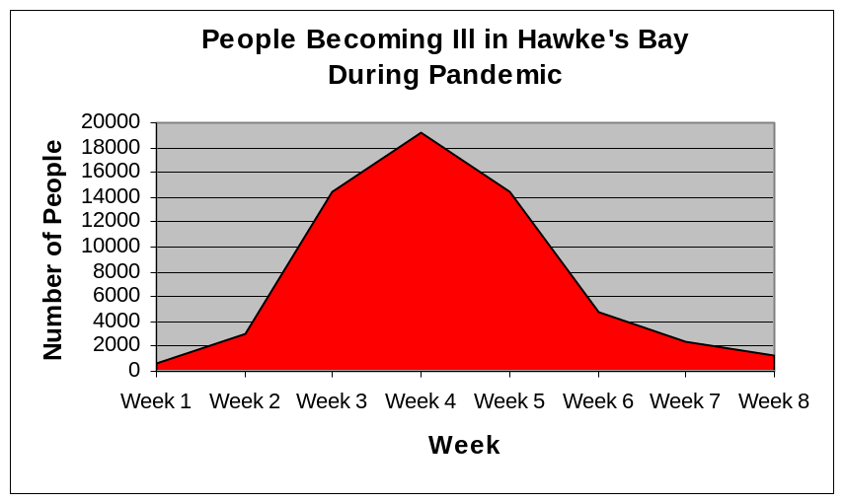
Note: This is one scenario for a pandemic wave based on a Ministry of Health modelling tool which draws on data from the 1918 pandemic. The New Zealand Influenza Action Plan (version 15) uses a “standard planning model” of 40% attack rate and 2% case fatality rate. This would result in 59,702 cases and 1385 deaths in Hawke’s Bay.

    - Effective preventive and therapeutic measures -- including vaccines and antiviral agents -- will likely be in short supply, as well as antibiotics to treat secondary infections.

    - Health-care workers and other first responders will likely be at even higher risk of exposure and illness than the general population, further impeding the care of victims.

    - Widespread illness in the community will also increase the likelihood of sudden and potentially significant shortages of personnel in other sectors who provide critical community services: police, firemen, utility workers, and transportation workers, just to name a few.

PANDEMIC PHASES – DEFINITIONS

For purposes of consistency, comparability and co-ordination of the national, regional and local response, identification and declaration of the following phases will be done at the national level.

WHO Pandemic Phase | Definition
Inter-Pandemic Period  (WHO Phase 1) | No new influenza virus subtypes have been detected in humans. An influenza virus subtype that has caused human infection may be present in animals. If present in animals, the risk of human infection or disease is considered to be low.
Novel Virus Alert  (WHO Phase 2) | No new influenza virus subtypes have been detected in humans. However, a circulating animal influenza virus subtype poses a substantial risk of human disease.
Pandemic Alert  (WHO Phase 3) | Human infection(s) with a new virus sub-type, but no human-to-human spread, or at most rare instances of spread to a close contact.
(WHO Phase 4) | Small cluster(s) with limited human-to-human transmission but spread is highly localised, suggesting that the virus is not well adapted to humans.
(WHO Phase 5) | Larger cluster(s) but human-to-human spread still localised, suggesting that the virus is becoming increasingly better adapted to humans, but may not yet be fully transmissible (substantial pandemic risk).
Pandemic Period  (WHO Phase 6) | Pandemic: increased and sustained transmission in general population.

WHO PERIOD* | WHO PHASE* | NZ STRATEGY | MoH/DHB ALERT CODE
Interpandemic Period | Phase 1 | Planning | N/A
Interpandemic Period | Phase 2 | Planning | N/A
Interpandemic Period | Phase 2 | Planning | WHITE (Information / Advisory)
Pandemic Alert Period | Phase 3 | Planning | WHITE (Information / Advisory)
Pandemic Alert Period | Phase 3 | Planning | YELLOW (Standby)
Pandemic Alert Period | Phase 4 | Border Management | RED (Activation)
Pandemic Alert Period | Phase 5 | Border Management | RED (Activation)
Pandemic Alert Period | Phase 5 | Cluster Control | RED (Activation)
Pandemic Period | Phase 6 | Pandemic Management | RED (Activation)
Post Pandemic Period | Post Pandemic Period | Recovery | GREEN (Stand Down)

MINISTRY OF HEALTH CASE DEFINITION

This is the case definition for H1N1 influenza. If there is an influenza pandemic, the case definition will be similar to this.

Possible case of Influenza A (H1N1)
Person with acute lower respiratory tract illness of abrupt onset, characterised by:
  - fever (temperature >37.8 C) or sore throat
And/or recent onset of at least 2 of the following
  - cough or dyspnoea (difficult or laboured breathing)
  - runny nose or nasal congestion
  - sore throat
  - fever or feverishness
AND one or more of the following:
- recent history of travel within 7 days prior to the onset of symptoms in an area where there are confirmed cases of pandemic influenza
- recent contact within 7 days prior to the onset of symptoms with a probable or confirmed case of H1N1
Probable case of Influenza A (H1N1)
- possible case; and
- limited laboratory evidence for Influenza A.
Confirmed H1N1 case:
An individual for whom laboratory testing demonstrates one or more of the following:
      - positive viral culture for Influenza A (H1N1); or
      - positive PCR for Influenza A (H1N1); or

RESPONSE WITHIN THE SCHOOL

During inter-pandemic period:
- Encourage annual influenza immunisation.

During pandemic alert:
- Determine daily activities that can be deferred during the pandemic event.
- Ensure access to updated information.
- Promote the public education strategy led by the HBDHB.
- Initiate staff training plan.

During pandemic imminent stage:
- Fully activate the response plan.
- Increase cleaning services in all areas.
- Educate all parents who think their child may have influenza to keep their child at home.
- Identify an area within the school that could be used to isolate a student who develops symptoms of influenza while at school.

During the pandemic:
- It is possible that schools will be closed by the Medical Officer of Health in the early stages of a pandemic in an effort to prevent the spread of the disease. Once a pandemic is established closure may be lifted but many schools will either be unable to support service delivery due to a lack of available teachers or find reopening is not viable due to the absence of large numbers of students who are ill.

Responsibilities

Every school must identify a liaison person whose role will be to:
- Take lead responsibility for all infection control issues affecting the school.
- Ensure that all staff are kept up to date with current information from the DHB and the Ministry of Health.
- Ensure that all staff are adequately trained in infection control practice.

OPTIONS FOR SERVICE DELIVERY

Options to consider:
- Schools with a limited number of staff may elect to take a collaborative approach with another school.
- Schools may elect to provide home-based education for students.

RESPONSE TO THE STUDENT WITH SUSPECTED INFLUENZA

- Place a surgical mask on the student who is unwell and place them in a room with windows that can be opened and contact their caregiver requesting the child be collected from the school as soon as possible.
- Notify the parents or school doctor if any student is suspected to have synmptoms of influenza as soon as possible.
- Students should be asked to cough/sneeze into a tissue and to dispose of the tissue afterwards, then wash hands in warm water with soap or use an antiseptic hand gel. Dry hands thoroughly afterwards.
- Once the student has been collected the room must be cleaned thoroughly (see below Environmental Cleaning).

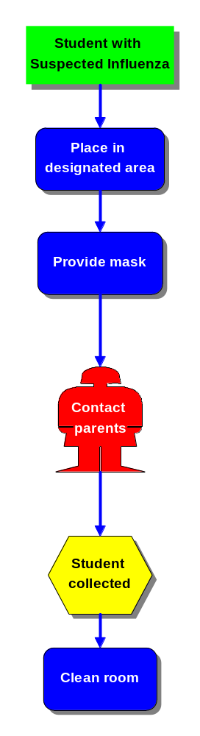
COMMUNICATION PLAN

Name | Title | Contact
Sandra Bee | Emergency Response Advisor | 0272-453692
Barbara McPherson | Infection Control Advisor | 878-8109
Public Health Unit | Seek advice from your school Public Health Nurse | 834-1815

Useful Websites:
Ministry of Health http://www.moh.govt.nz/pandemicinfluenza
WHO http://www.who.int/en/
CDC http://www.cdc.gov/h1n1flu/
Hawke’s Bay DHB http://www.hawkesbaydhb.govt.nz

INFECTION CONTROL PRECAUTIONS
Initial precautions
Such a major health event can only be handled by the whole team and we suggest you involve your team in any planning and preparation. Do not forget the cleaner. Your first suspicion of influenza in your community may come through a phone call. Consider how you will deal with this.
We recommend that all staff be vaccinated each year against seasonal influenza. While this may not protect against pandemic influenza, it will maintain the general wellness of your team. Create an expectation that sick staff should stay at home.
Initial precautions for people dealing with someone suspected of having pandemic influenza include:
  - Keep your distance
One metre is accepted as safe and significantly reduces your exposure.
  - Wear a surgical mask and gloves
Also offer a mask to any student suspected of having influenza.
  - Rigorous, frequent hand washing
Wash in warm water with soap, or use an antiseptic hand gel. Dry hands with paper towels
  - Where possible try to separate students with respiratory symptoms from other students
  - Ventilation
Keep windows open if possible, if air conditioning is used, ensure that designated areas can be isolated from the rest of the facility.
Each school should promote hand washing, the use of tissues when coughing or sneezing, or sneezing/coughing into the elbow.

Include in your plan:
- Environmental cleaning
    - Appropriate waste disposal processes
    - Support for staff to regularly monitor their own health
    - Identify individuals responsible for monitoring staff infection control practice
Essential supplies
  - Surgical masks
  - Tissues
  - Waste disposal bins – with foot-operated lids for infection control
  - Soap or antiseptic hand gel and paper towels for drying.

ENVIRONMENTAL CLEANING

Protective clothing (mask, gown and gloves) must be worn. Use detergent and water followed by sodium hypochlorite 3-5% 1:100 solution 1 part household bleach to 10 parts water (10mL/1L water). Clean all horizontal surfaces and all surfaces that are touched by students and staff. Floors are to wet mopped with clean water and detergent with the mop rinsed thoroughly on completion and inverted to dry. Cleaning cloths should be disposed of in a biohazard bag.

A linen skip and a biohazard bag must be kept in the designated area. Minimal linen should be used and changed after each use taking care not to shake it. All waste must go into a rubbish bag. Linen and waste must be emptied daily or when containers two thirds full.

INFORMATION

Messages to the public will be distributed centrally by HBDHB following Ministry of Health advice. This will assist in managing expectations. HBDHB will also provide public information on local arrangements.

Information pamphlets are available on the MOH website. (www.moh.govt.nz/pandemic). Regular bulletins will be coordinated through the DHB. A hotline number is available through the DHB for updated information on 0800 777790.

TRAINING

A training plan has been prepared by HBDHB to ensure consistent messages for all staff.

WORKFORCE MANAGEMENT

Workforce management requires provision of cover for sickness and absenteeism and attention to staff welfare. Volunteers and ex staff may be utilised.

Discussion with staff in the planning phase is essential to determine who will be most likely to be available, and skills that might be adapted to provide cover.

In the event of schools amalgamating to provide cover, advice should be given to parents using a standardised approach.

