May 2023


Pandemic Plan

Annexes Part 1

Contents

Antiviral and PPE Distribution Plan

CDEM Group Sub-Plan Pandemic Hazard Plan 2

Community Assessment Centre Plan

Communication Plan

Deceased Persons Procedures

Human Resources Frequently Asked Questions

Interagency Plan for Management of First Cases

Maori Pandemic Plan Template

Antiviral and PPE Distribution

DISTRIBUTION OF ANTIVIRAL DRUGS
Plan for pandemic

Preface:

Abbreviations and definitions
CAC | Community Assessment Centre
HB | Hawke’s Bay
MoH | Ministry of Health
MOH | Medical Officer of Health
NZIPAP | New Zealand Influenza Pandemic Action Plan
PHS | Public Health Service

Introduction:

This plan is developed as part of a number of work streams to enhance Hawke’s Bay pandemic preparedness.

Antiviral drugs, for example, Oseltamivir (Tamiflu™), can shorten the course of infection if given early in the disease, and can provide short-term protection. The Ministry of Health has secured a Tamiflu™ reserve, sufficient to treat 21% of the New Zealand population.

Te Whatu Ora Hawke’s Bay holds 440 courses for immediate use for cases and/or contacts.

Scope

This plan includes antiviral medication that Te Whatu Ora Hawke’s Bay holds in stock and the national reserve.

It does not include antiviral medication purchased by individuals privately.

This plan does not cover:
- dosage, side effects, efficacy, drug interactions or other pharmacological aspects of antiviral treatment
- patient information on antivirals

These are to be found in the Pandemic Plan for Community Assessment Centres.

Definitions

Antiviral – an oral medication used to treat or prevent a viral infection.

Related legislation
Medicines (Standing Order) Regulations 2002

Aims and general purpose
To develop a plan for access, storage, transport, prescribing, and monitoring of stocks of antiviral medication.

Assumptions
The MoH will be responsible for a national distribution strategy.
Antiviral distribution will comply with the national priority groups and indications for use.
The MOH is responsible for Hawke’s Bay distribution.
The small reserve held locally (440 courses) will be used on first cases and contacts (including health-care workers).
Further supplies will be available from the national reserve held by the MoH.
During the “Control-It” phase, pandemic reserve antiviral medication will be available only from hospitals, CACs, PHS or home-visiting Community Outreach Services. It will not be available from all GPs or from community pharmacies. The reasons for this are:
- the logistics of stock supply, monitoring and control in all GP settings are too difficult
- for infection prevention and control reasons patients or their relatives visiting community pharmacies are discouraged
- providing medication at the point of consultation is efficient and easier for patients

There will be home-visiting Community Outreach Services to provide medication to cases who are unable to attend CACs but who are ineligible or too numerous to be admitted to hospital.
Patients requiring antivirals will sometimes require other medications such as antibiotics and antipyretics and these should be made available to patients with the antivirals. Pharmac is planning to build up national antibiotic stock of: amoxycillin clavulanate, doxycycline, flucloxacillin, cephazolin and cotrimoxazole. Currently plans for stockpiling antipyretics are unclear.
The MoH will require timely reports from Te Whatu Ora Hawke’s Bay on CAC location, date, assessor, NHI, demographics, priority group, medication provided, purpose of mediation (prophylaxis or treatment). They are likely to want this for antivirals and antibiotics.
The MoH will want Te Whatu Ora Hawke’s Bay to ensure compliance with legislation governing prescribing.
Some Māori will wish to use their marae as places to take their sick. They will expect treatment services to be there and to be able to leave or remain with their sick according to their preference. Not all Māori will take this course – some will stay away from the marae for fear of infection. This will increase transmission as well people mix with infectious people.

Conditions under which the plan comes into force
- When any individual in Hawke’s Bay meets the “probable case” criteria.
- When the MOH approves Hawke’s Bay distribution of antivirals for a pandemic.

Operational Structure

Relationships with other levels of government

The Ministry of Health will provide/direct:
- Indications for use
- Controls over distribution
- Prioritisation criteria
- Information pamphlets

Communication Plan/Issues:

Types of messages, how they will be distributed

Information | Audience | Method
Who is eligible | Everyone  Media | In NZ Pandemic Action Plan.  - Hawke’s Bay 0800 number  - Te Whatu Ora Hawke’s Bay website  - Media
How to obtain | Everyone  Media | - Hawke’s Bay 0800 number  - Te Whatu Ora Hawke’s Bay website  - Media
Appropriate use | Everyone  Media | - Hawke’s Bay 0800 number  - Te Whatu Ora Hawke’s Bay website  - Media
How to prescribe and obtain supply | Prescribers and nurses under standing orders | - Information bulletins  - Training plan
Consumer medicine information (e.g. pregnancy, drug interactions, precautions, side effects) in English | Recipients of medication | Ministry of Health  - Tamiflu Consumer Medicine Information from Roche  - Te Whatu Ora Hawke’s Bay Public Health Unit Non-seasonal Influenza Policy
Consumer medicine information in other languages | Recipients of medication | Ministry of Health

Preparedness:

Relationships required

Hospital clinicians
Primary Health Organisation
General Practitioners/Practice Nurses
Māori and Pacific Island providers
Pharmacists
All other primary care providers
Midwives
Advocacy NGOs
General public

Risk assessment
 | Risk | Mitigation
1 | The Te Whatu Ora Hawke’s Bay supply is exhausted prior to the release of the national reserve. | Purchase larger supply
2 | Wastage of courses because people do not take as directed, or courses prescribed for non-cases (and their contacts) are discontinued. | Reclaim courses from PCR negative cases and their contacts  Possibility of 48 hour supply until virus confirmed
3 | The supply may be prone to theft. | Security plan
4 | The security of professionals holding supplies may be threatened. | Security plan
5 | Health care professionals may be unaware of the process for distribution of antivirals laid out in this plan. | Training plan  Communication plan
6 | Community pharmacists have indicated that they are unable to supply pharmacists to assist with point-of-consultation drug counselling and supply at CACs. | Workforce and training plans will need to identify and train personnel to carry out this function

Operational Procedures:

Roles, relationships and tasks
The MOH will approve the distribution of antivirals and request the release of the national reserve.

The Hospital Pharmacy will:
- store antivirals
- pre-label the antivirals so that a doctor or nurse can issue courses by writing the name and required dose on the label
- arrange transport to the provider who will supply the medication to the patient
- monitor stock issued

In the “stamp-it-out” phase antivirals will be distributed only from the hospital pharmacy and PHS. In the “manage-it” phase antivirals will be distributed from the hospital pharmacy, CACs and by home-visiting Community Outreach Services.

Antivirals will be prescribed by doctors or supplied by nurses operating under standing order (see Standing Order for Administration of Antiviral Medication HBDHB/IVTG/047).

Antivirals will be given to the patient by:
- hospital staff (for in-patients)
- by GPs or PHS staff or CAC staff or home-visiting Community Outreach Services (for out-patients)

Overview of supply of antivirals
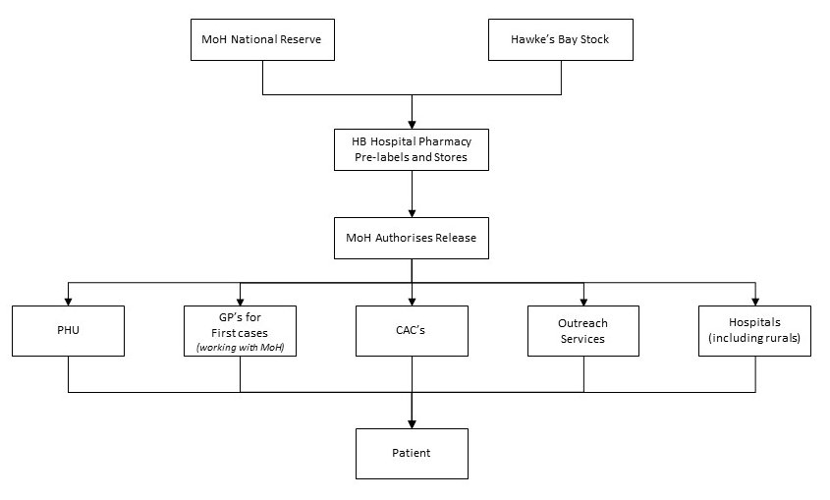

Action required at different alert phases

Alert Phase | Action
Stamp-it-out | - the treatment of early cases  - post-exposure prophylaxis of contacts  - possibly pre-exposure prophylaxis of groups at high risk (e.g. contact tracers or people having contact with quarantined people)
Manage-it | - the treatment of cases

Process

“Stamp it out” phase

Access
The MOH will control access but will work with the Incident Controller for the health response under a CIMS structure.

The medication will be used for:
- the treatment of early cases
- post-exposure prophylaxis of contacts
- possibly pre-exposure prophylaxis of health-care workers

Storage
The medication will be stored at the HB Hospital Pharmacy and the PHS.

Prescription
When a doctor suspects a probable pandemic case, he/she will notify the MOH.
The MOH will contact the on-call pharmacist (available 24/7 through the hospital call centre) indicating that the antiviral pandemic plan is being activated.
The prescriber (or nurse operating under standing orders) will:
- record the information in Appendix 1 Prescription information needed.
- provide advice and instruction on the use of the medication (see Appendices 2 and 3).

The Hospital Pharmacist will issue the prescribed medication and/or supply medication for supply under the standing order.
PHU staff will provide the medication to cases or contacts under standing orders. They will use documentation in the Non-seasonal Influenza Policy.

Transport
The MOH will work with the hospital pharmacy to get the medication to the patient, on a case-by-case basis, depending on the patient’s location and circumstances. Where possible, transport will be coordinated with the delivery of PPE by Purchasing and Logistics. If necessary a taxi, courier or personal delivery may be used.
Designated driver to collect from HBH Pharmacy
HBH
Pharmacy
Liaise with EOC to nominate a designated driver to deliver PPE to the distribution points
Call the Fleet Department on extension 2716 to arrange collection of the vehicle
If a Procurement delivery is not pending within the required timeframe
Pharmacy to organise a courier / taxi / personal delivery
Purchasing and Logistics have arranged / booked with Fleet a vehicle for their sole use during a pandemic

Monitoring
The MoH may stipulate minimum monitoring requirements.
The HB Hospital Pharmacy will maintain records of inventory and stock issued.

“Manage it” phase

Access
The MOH will be responsible for application to the MoH for release of the national supply to the HB Hospital Pharmacy.
In this phase the medication will be used only for treatment of cases.

Storage
The supplies will be stored in:
- The hospital pharmacy
- Hospital wards
- Health centres at Wairoa and Central Hawke’s Bay
- The CACs
- Bases for home-visiting Community Outreach Services

Prescription
Within the hospital and CACs, doctors will prescribe the medication.
PHS and home-visiting Community Outreach Services staff will provide the medication under standing orders.
The prescriber (or nurse operating under standing orders) will:
- record the information in the patient’s health record refer Appendix 1 Prescription information needed
- provide advice and instruction on the use of the medication (see Public Health Unit Non-seasonal Influenza Policy).

Transport
The Hawke’s Bay Hospital Pharmacy will deliver stocks to the PHS, CACs, hospital wards and home-visiting Community Outreach Services. Medication will be given directly to patients by staff of these services.

Monitoring
The MoH may stipulate minimum monitoring requirements.
The HB Hospital Pharmacy will maintain records of inventory and stock issued.

Workforce issues
A workforce home-visiting Community Outreach Services needs to be identified and trained.

Reporting
The MoH will identify reporting requirements.

The MoH, MOH and Te Whatu Ora Hawke’s Bay is likely to want timely reports from the hospital pharmacy on the amount of stock held and providers to whom it is distributed (e.g. PHS, CAC, home-visiting Community Outreach Services, hospital).

Locations, equipment, operation, staffing
The need for home-visiting Community Outreach Services has been identified in the CAC Plan.

Appendix 1. Prescription information needed

Date of prescription/supply

Drug
- name and strength
- formulation
- dose
- directions
- quantity

Patient
- Name
- Address
- Date of birth if under 13 years

Doctor (or nurse operating under standing order)
- Name
- MCNZ number / NCNZ number
- Signature
- Address

Appendix 2. Patient information on Tamiflu

INFORMATION ON TAMIFLU

How effective is the anti-viral medicine Tamiflu against influenza?
Tamiflu is one of two medicines that are effective against the strains of Influenza A and B.
The WHO have advised all health authorities to stockpile anti-viral medicines to prepare for a pandemic. New Zealand has followed that advice.
Will Tamiflu cure people sick with the pandemic influenza virus?
We don't know for sure.
When people have seasonal influenza, Tamiflu reduces symptoms and may shorten the duration of illness by a day and a half.
If otherwise healthy people who are ill with influenza take it, they are less likely to develop complications of influenza. Those complications are usually treated with antibiotics.
Does Tamiflu prevent people from getting influenza?
Yes it does, but it is not the best means of preventing influenza. Vaccination is the best protection against influenza, which is why people are encouraged to immunise against seasonal influenza every year. Tamiflu will help until a pandemic vaccine arrives.
For more information on Tamiflu, including how it works against influenza, see the datasheet, http://www.medsafe.govt.nz/profs/datasheet/t/Tamiflucapsusp.pdf.

How does Tamiflu work?
It is a medicine that only works against influenza viruses A and B.
It does not work against other viruses or bacteria that can cause illness similar to influenza or that can cause respiratory infection. If taken within 48 hours of becoming ill it stops the virus from bursting out of infected cells, infecting new cells and possibly other people.
Will masks help protect me and my family from the influenza virus?
A surgical mask, if put on someone who is sick, will help reduce the spread of infection, because it will reduce the amount of virus spread by coughs and sneezes.
People who are not sick and who are very close to the person who is coughing and sneezing - closer than 1 metre - may get some protection by covering their own nose and mouth with a mask. Again, this is because the mask will catch some of the virus in the cough and sneeze droplets.

The following people should not take Tamiflu
- People with past hypersensitivity to oseltamivir phosphate or any component of the product.
- Not to be used as treatment children under 1 year of age.
- Not to be given to pregnant women.
- Not to be used as prophylaxis in children under 13 years of age.
- Dose adjustment required for people undergoing haemodialysis or with end stage renal disease, or who are fructose-intolerant (see protocol and consult with Medical Officer of Health).
- Animal studies do not suggest harmful effects to the fetus or breast-fed babies but there are no human data. Tamiflu should therefore be used only if the potential benefit justifies the potential risk.

What about interactions between Tamiflu and other drugs I am taking?
There are no significant interactions known.

Side effects
Most people taking Tamiflu experience no side effects. A small proportion will experience one or more of the following:

Common | Less commonly
Nausea 4-10%  Vomiting 2-15%  Headache  Diarrhoea  Abdominal pain 2-5%  Dyspepsia  Conjunctivitis | Eczema  Rash  Convulsions  Arrhythmias  Altered consciousness  (usually in children or adolescents)

Appendix 3. Consumer medicine information sheet on Tamiflu

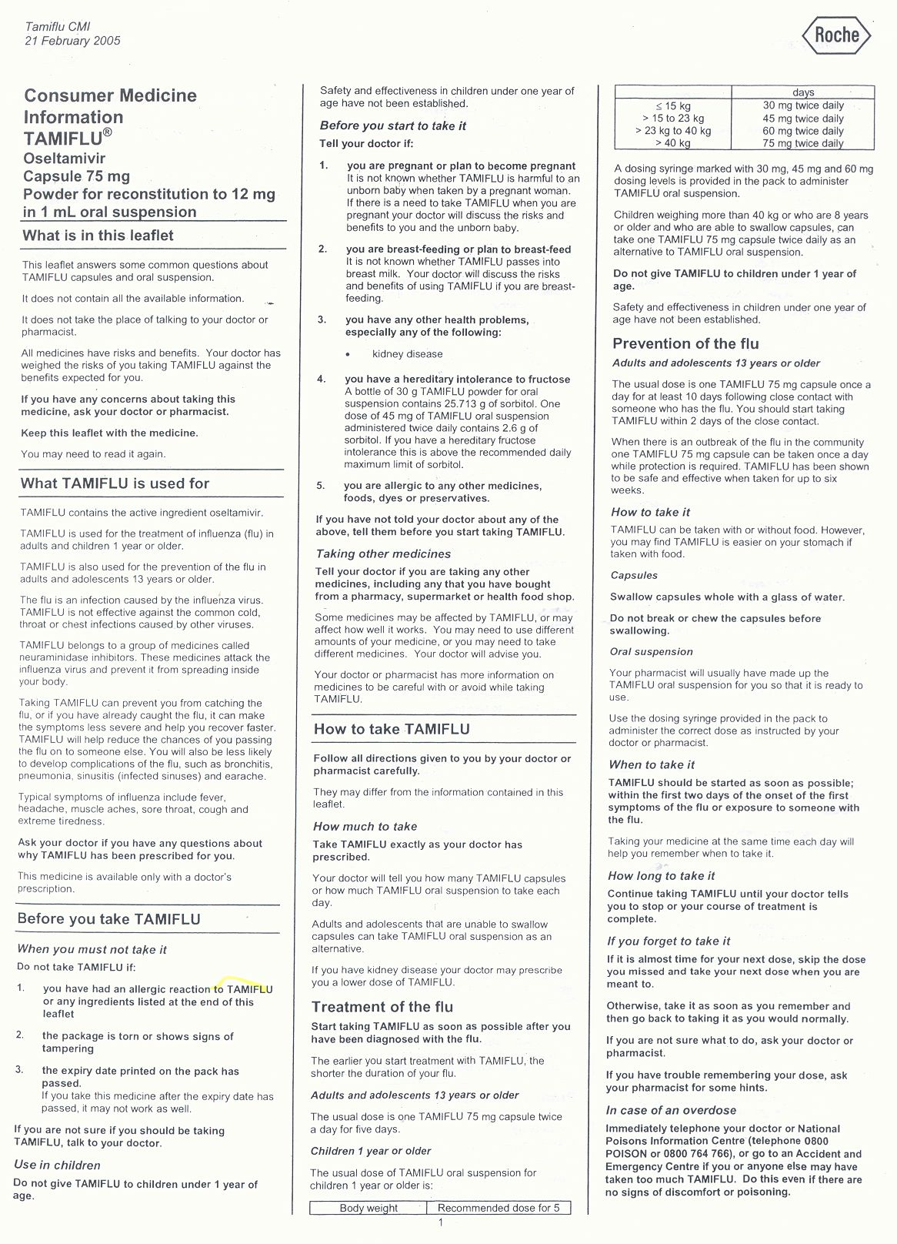
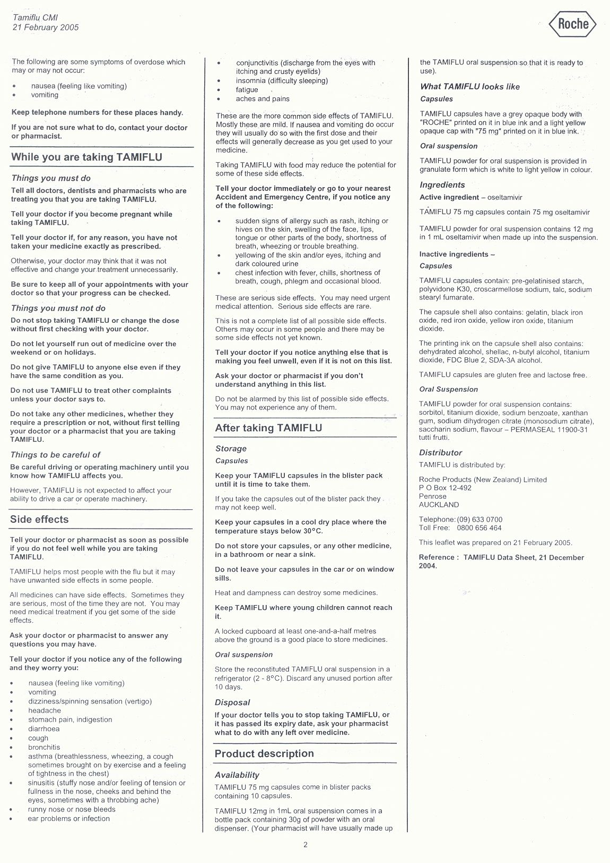

Appendix 4. Standing order for administration of Tamiflu
See Standing Order: Antiviral Medication in Pandemic IVTG/047.

Abbreviations

od once daily
bid twice daily
HPO health protection officer
MOH medical officer of health
PHA public health agents (see below for explanation of this term)
PHN public health nurse
PH Public Health

Reasons for the Standing Order

- To facilitate the administration of antiviral medication for treatment and prophylaxis of pandemic influenza.

- To ensure that information given to cases and contacts is consistent and complete.

Persons permitted to supply and administer antiviral medicines

This standing order applies to public health agents (PHA) who will be authorised by the MOH under this standing order during an influenza pandemic. A PHA will be a person with the necessary skills in community health or health protection work to enable them to carry out the provision of medicine and information described in this standing order. PHAs will be PHNs, HPOs and such other persons as the MOH deems appropriate during a pandemic.

It authorises PHAs to supply and administer antiviral medication for treatment and prophylaxis in accordance with this standing order.

SCOPE

This standing order defines the standard of practice which Medical Officers of Health, as the issuers, consider acceptable. It defines the boundaries within which PHAs must practise. The PHA is responsible for practising within these boundaries.

- The PHA must have been assessed by the Medical Officer of Health (or by PH staff authorised by the MOH) as competent to carry out this standing order.

- The PHA may operate under this standing order only when deemed to be on duty working within the Te Whatu Ora Hawke’s Bay Public Health team.

- This standing order is to be used in conjunction with a PH operational policy (“the policy”) which will vary depending on the nature of the epidemic influenza virus.

- The PHA is accountable for clear documentation and for application of this standing order.

- This standing order must be dated, signed and reviewed at least annually by the issuers.

- If a PHA acts entirely within this standing order, then any consequence of the action of the PHA is the responsibility of Te Whatu Ora Hawke’s Bay.

- This standing order applies until it is replaced in writing by a new standing order covering the same subject matter.

Persons to whom medication may be supplied or administered for treatment or prophylaxis purposes

Cases or contacts of pandemic influenza as defined by the MOH from time to time for influenza epidemics.

Pre-exposure prophylaxis for health-care workers as authorised by the MOH.

Medicines that may be supplied or administered

Oseltamivir (Tamiflu®)

Source: Medicine Data Sheet on Medsafe website. http://www.medsafe.govt.nz/profs/Datasheet/t/Tamiflucapsusp.pdf

- 75mg capsule
- Powder for oral suspension 6mg/mL

Pharmaceutical
Active ingredient: oseltamivir phosphate
Hard capsule 75mg and powder for oral suspension
Do not store capsules or powder above 25 ⁰C
After reconstitution, store the suspension below 25⁰C. Discard any unused portion 10 days after reconstitution.

Indications
- Treatment of influenza in adults and children ≥ 1 year of age
- Prophylaxis of influenza in adults and children ≥ 1 years of age

Contraindications
- Hypersensitivity to oseltamivir phosphate or any component of the product.
- Not to be used as treatment of children under 1 year of age.
- Not to be used as prophylaxis in children under 1 year of age.
- Tamiflu should only be used during pregnancy if the potential benefit justifies the potential risk to the foetus.
- Lactation. Human and animal data suggest that oseltamivir is secreted in milk in low concentrations. Tamiflu should be used if the potential benefit for the lactating mother justifies the potential risk for the nursing infant.

Precautions
- Dose adjustment required for people undergoing haemodialysis or with end stage renal disease, or who are fructose-intolerant (consult with Medical Officer of Health who will consult the datasheet and discuss with a physician).
- No dose adjustment is required for patients with hepatic dysfunction in the treatment or prophylaxis of influenza.
- Patients, especially children and adolescents, should be closely monitored for signs of abnormal behaviour. Convulsion and delirium like neuropsychiatric events have been reported during Tamiflu administration in patients with influenza, predominantly in children and adolescents.

Interactions
No significant interactions known. Can be given with paracetamol.

Efficacy – treatment
Reduces duration of symptoms by 32 hours in adults and 36 hours in children
Reduces severity of symptoms in 38% of patients
Reduces complications (leading to antibiotic treatment) by 50%
Reduces duration of virus shedding

Efficacy - prophylaxis
Reduces disease rate among household contacts from 12% to 1%

Making up the suspension
Add 55mL (1 cup, supplied) to the bottle of Tamiflu powder, then shake until dissolved.

Tamiflu

If bottles of Tamiflu powder for oral suspension are not available, mix the contents of a capsule with palatable food as described below:
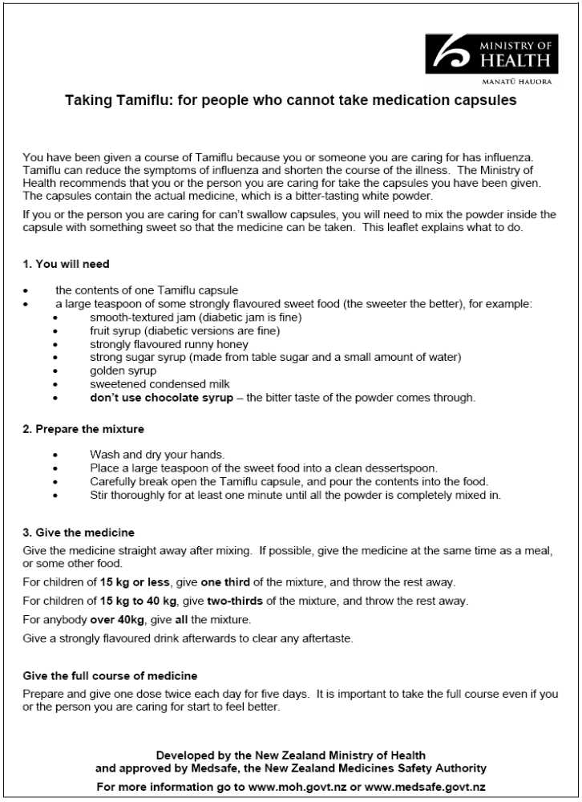

Dosage and method of administration

Tamiflu may be taken with or without food. However, Tamiflu taken with food may enhance tolerability in some patients.

Children should be weighed using scales.

A dosing syringe is provided with the powder for oral suspension.

Age group | Dose |  | Total amount needed | TREATMENT | PROPHYLAXIS
Adults | 1 x 75mg capsule |  | 10 capsules
Adolescents >13 years | 1 x 75mg capsule |  | 10 capsules
Children > 40kg who can swallow capsules | 1 x 75mg capsule |  | 10 capsules | Twice daily for five days | Once daily for ten days
Children by suspension | Dose | Volume
<15kg | 30mg | 5mL | 1 bottle
>15 – 23 kg | 45mg | 7.5mL | 2 bottles
>23 – 40kg | 60mg | 10mL | 2 bottles
>40kg | 75mg | 12.5mL | 2 bottles

Treatment with oseltamivir should ideally begin within two days of onset of symptoms of influenza.

Prophylaxis should ideally begin within two days of exposure. The duration of protection lasts for as long as dosing is continued.

A contact who becomes a case should begin a new five-day treatment course.

Information for Client

Supply information on antiviral medication as outlined in the PH operational policy relevant to the epidemic influenza virus being managed. Patients wishing more detailed information should be referred to the Medicine Data Sheet on

http://www.medsafe.govt.nz/profs/Datasheet/t/Tamiflucapsusp.pdf

Documentation

Record details of medication supplied as required in the policy.

This enables the PHA to record:

- Name and details of client
- Name of medication
- Formulation, dosage, frequency and amount supplied
- Name and signature of person supplying the medicine

The medication record in the policy must be completed and forwarded by the PHA within 72 hours to the issuing Medical Officer of Health for signing.

COMPETENCY

Level of competency required by a PHA

In order to supply and administer oseltamivir under this standing order, each PHA is required to attain the competencies set out below and be conversant with and adhere to the policy.

Each PHA must be assessed as competent, by the MOH (or by PH staff authorised by the MOH), to carry out this standing order.

Attaining Competency

Full attendance at MOH-approved training of persons for supply and administration of oseltamivir.

Maintaining Competency

PHAs must attend any additional education sessions concerning the supply and administration of antiviral medication as required by the Medical Officer of Health.

PHAs must be aware that guidelines on the use of antiviral medication are likely to change during the course of an influenza outbreak. If guidelines change then PHAs must attend extra training.

Declaration

I, the undersigned Medical Officer of Health of the Public Health Service, Te Whatu Ora Hawke’s Bay:

- Am satisfied that this standing order provides adequate guidelines for a PHA providing oseltamivir for the treatment or prophylaxis of influenza.

- Understand that the PHA will practise according to the relevant PH policy.

- Understand that the PHA accepts full accountability to practise within the standing order and is answerable if acting beyond the scope of this order.

- Understand that I am responsible for providing advice and support to the PHA; and

- Hereby issue this standing order.

DISTRIBUTION OF NATIONAL RESERVE EQUIPMENT
Plan for pandemic

Preface:

Abbreviations and definitions
PPE | Personal Protective Equipment
HECC | Health Emergency Coordinating Committee
CIMS | Coordinated Incident Management System
MoH | Ministry of Health

Introduction:
This plan is developed as part of a number of work streams to enhance Hawke’s Bay pandemic preparedness.

Scope

This plan includes PPE that Te Whatu Ora Hawk’es Bay holds in stock and the national reserve along with additional clinical supplies required.
It does not include PPE purchased by agencies privately.

Definitions

Personal protective equipment includes masks, gowns, gloves and face shields.

Aims and general purpose
To develop a plan for access, storage, transport and monitoring of stocks of personal protective equipment and critical clinical supplies.

Assumptions
The MoH will be responsible for activation of the national reserve.
Te Whatu Ora Hawke’s Bay is responsible for Hawke’s Bay distribution.

Conditions under which the plan comes into force
- When the MoH approves Hawke’s Bay distribution of the national reserve for a pandemic.

Communication Plan/Issues:

Types of messages, how they will be distributed

Information | Audience | Method
Appropriate use | Healthcare personnel  Emergency services personnel  Front line services | - Training plan
How to obtain supply | Managers of service units | - Communication plan

Preparedness:

Relationships required

Te Whatu Ora Hawkes Bay hospital clinicians
Primary Health Organisations
General Practitioners/Practice Nurses
Māori and Pacific Island providers
All other primary care providers
Emergency services personnel

Risk assessment
 | Risk | Mitigation
1 | Te Whatu Ora Hawke’s Bay supply is exhausted prior to the release of the national reserve. The supply may be used up on non-cases (early in a pandemic). | Purchase larger supply
2 | The supply may be prone to theft. | Security plan
3 | The security of professionals holding supplies may be threatened. | Security plan

Operational Procedures:

Roles, relationships and tasks
Te Whatu Ora Hawke’s Bay will approve the distribution of the national reserve following notification from the MoH.

Process

Access
The Te Whatu Ora Hawke’s Bay Procurement Department will control access but will work with the Incident Controller for the health response under a CIMS structure.

The PPE will be supplied to:
- Hospitals and health centres
- Public Health Unit
- General practices
- Residential homes
- Ambulance Service
- Police
- Fire Service

An initial supply will be designated with some supply held in reserve to ensure availability to areas of greatest need.

Storage
The equipment is stored at the Te Whatu Ora Hawke’s Bay Warehouse at 700 Omahu Road, Hastings.

Transport
The Procurement Department will work with the hospital pharmacy to get PPE, medication and equipment to the areas requiring it. A vehicle has been allocated from the DHB fleet to enable delivery of supplies with a driver required from the volunteer pool.

Monitoring
The MoH may stipulate minimum monitoring requirements.
The Procurement Department will maintain records of inventory and stock issued.

Access
Te Whatu Ora Hawke’s Bay will be responsible for application to the MoH for release of the national reserve.

Workforce issues
A workforce will need to be maintained to pack and transport equipment to required areas/agencies.

Reporting
The MoH and Te Whatu Ora Hawke’s Bay is likely to want timely reports from the Procurement Department on the amount of stock held and providers to whom it is distributed.

Appendix 1 National Reserve Distribution

Description | Issue Unit | HBH | Wairoa | CHB | PHU | GP’s | Resthomes | Amb | Police | Fire | Reserve
Reusable visor frame | Bx-30 | 20 | X | X | X | X | X | 4 | X | X | 7
Eyeshield disposable visor | Bx-50 | 4 | X | X | X | X | X | 4 | X | X | 4
Full face disposable visor | Bx-50 | 16 | 20vs | 5vs | X | X | X | 4 | X | X | 4.5
PFR95 masks | Bx-35 | 500 | 5 | 5 | 5 | 900 | 80 | 20 | 20 | 4 | 961
Masks – ear loop | Bx-50 | 200 | 5 | 5 | 10 | 1800 | 160 | 40 | 40 | 12 | 1658
Exam gloves – small | Bx-100 | 150 | 3 | 1 | 1 | 180 | X | 4 | 4 | 4 | 403
Exam gloves – medium | Bx-100 | 300 | 3 | 3 | 2 | 360 | X | 8 | 8 | 8 | 808
Exam gloves – large | Bx-100 | 150 | 3 | 1 | 1 | 180 | X | 4 | 4 | 4 | 403
Microshield | Ea-1 | 90 | X | X | X | X | X | X | X | X | 60
Gowns | Pk-10 | 1000 | 5 | 5 | 5 | 180 | 100 | 20 | 10 | 5 | 4670
IV giving sets | Set-1 | 200 | X | X | X | X | X | X | X | X | 50
IV burettes | Ea-1 | 192 | X | X | X | X | X | X | X | X | 96
IV cannula 22G | Bx-50 | X | X | X | X | X | X | 4 | X | X | 6
IV cannula 18G | Bx-50 | X | X | X | X | X | X | 4 | X | X | 6
IV cannula 20G | Bx-50 | X | X | X | X | X | X | 4 | X | X | 6
Vial access cannula | Bx-100 | X | X | X | X | X | X | X | X | X | 5
Syringes 5cc | Bx-100 | 15 | X | X | X | X | X | 4 | X | X | 11
Syringes 10cc | Bx-100 | 40 | X | X | X | X | X | 4 | X | X | 10
Syringes 30cc | Bx-60 | 30 | X | X | X | X | X | X | X | X | 10
Syringes 60cc | Bx-60 | 6 | X | X | X | X | X | X | X | X | 2
Needles 22G | Bx-100 | 30 | X | X | X | X | X | X | X | X | 40
Needles 25G | Bx-100 | 10 | X | X | X | X | X | X | X | X | 20
IV access device | Bx-200 | 4 | X | X | X | X | X | X | X | X | 2
Injection swabs alcohol | Bx-200 | 10 | X | X | X | X | X | 8 | X | X | 2
Injection swabs chlorhex | Bx-200 | 50 | X | X | X | X | X | X | X | X | 30
IV tegaderm | Bx-50 | 15 | X | X | X | X | X | 2 | X | X | 3
Biohazard bags | Pk-50 | 12 | 1 | 1 | X | 2 | 2 | 1 | 1 | 1 | 39
Biohazard bag ties | Pk-100 | 6 | 1 | 1 | X | 1 | 1 | 1 | 1 | 1 | 17
Sharps containers 7.6L | Ea-1 | 72 | X | X | X | X | X | 24 | X | X | 24
Paper towels | Crt-24 | 1 | X | X | X | 1 | X | X | X | X | X

Description | Issue Unit | HBH | Rurals | PHU | GP’s | Resthomes | Amb | Police | Fire | Reserve
IV sodium chloride 0.9% 1mL | Bx-12 | 60 bx | 3 bx | X | 20 bx | X | 40 bx | X | X | 67 bx
IV glucose 5% 1000mL | Bx-12 | 10 bx | X | X | X | X | X | X | X | 10 bx
IV glucose 4%/0.18% sodium chloride 1L | Bx-12 | 5 bx | X | X | X | X | X | X | X | 5 bx
Microshield hand gel 500mL | Bx-12 | 25 bx | 3 bx | 1 bx | 30 bx | 5 bx | 4 bx | 4 bx | 4 bx | 4 bx

CDEM Group Sub-Plan
Pandemic
Hazard Plan 2
Plan



PANDEMIC
Hazard Plan 2
a sub-plan to the
Hawke’s Bay CDEM Group PLAN

CONTENTS
  - Contents 3
  - Approval and Distribution 4
  - Version information and update record 4

2. Introduction 5

  - Purpose 6
  - Objectives and Purpose 6
  - Planning process 6
  - General principles 7
  - National arrangements 7
  - Operational Structures and Relationships 8

3. RESPONSIBILIES 8

  - District Health Boards 8
  - Health Coordinator or Response Coordinator 9
  - CDEMG Group Controller 9

4. REDUCTION 11

  - Assumptions 11
  - Reduction Measures 11
  - Community Risk 12
  - Changes in Risk Level 13
  - Reduction – Key Tasks 13

5. READINESS 14

5.1 Functions 14

6. RESPONSE 16

  - Activation 16
  - Lead Agency 17
  - Trigger points 17
  - Emergency Declaration 18
  - Operational Structure 18

7. RECOVERY 20

Annex I “Expectations” and “Responsibility Maxtrix” 21

1.2 Approval and Distribution
The Hawke’s Bay Civil Defence Emergency Management Group (CDEM Group) has approved this plan on [Day Date Month Year] and it becomes operational once distributed.
Through the HB CDEM Co-ordinating Executive Group this plan has been adopted by the organisations below.
Official copies of this procedure are distributed by email to the position holders of the organisations listed below who are responsible for the internal distribution and maintenance of additional copies held by their organisation (see SOP distribution list) and training of staff for their compliance.

Central Hawke’s Bay District Council - Emergency Management & Bylaws Officer
Department of Work and Income East Coast Region - Regional Commissioner
Eastern Regional Rural Fire Committee - Secretary
Hastings District Council - Senior Emergency Management Officer
Te Whatu Ora Hawke’s Bay- Emergency Management Advisor
Hawkes Bay Regional Council – Emergency Management Co-ordinator
Napier City Council - Civil Defence Emergency Management Officer
NZ Police Eastern District – District Superintendent
NZ Fire Service Eastern Fire Region - Fire Region Commander
St John Ambulance - Central Region - Regional Ambulance Operations Manager
Wairoa District Council - Emergency Management Officer
Ministry of Civil Defence & Emergency Management – Emergency Management Advisor [HB]
Civil Defence Emergency Management Group – Group Controller

1.3 Version information and update record

Section number | Title
1.1 | Hawke’s Bay CDEM Group SOP Distribution List | V 1.0 (September 2006)
1.2 | Table of Contents | V 1.0 (September 2006)
1.3 | Approval and Distribution | V 1.0 (September 2006)
1.4 | Version information and update record | V 1.0 (September 2006)
2 | INTRODUCTION | V 1.0 (September 2006)
3 | RESPONSIBILITIES | V 1.0 (September 2006)
4 | REDUCTION | V 1.0 (September 2006)
5 | READINESS | V 1.0 (September 2006)
6 | RESPONSE | V 1.0 (September 2006)
7 | RECOVERY | V 1.0 (September 2006)
Annex i | “EXPECTATIONS” AND “RESPONSIBILITY MATRIX” | V 1.0 (September 2006)

PANDEMIC PLAN

2. Introduction
This Plan addresses community and Civil Defence Emergency Management (CDEM) response in the Hawke’s Bay region to a pandemic threat or outbreak, or other notified disease that could cause a pandemic.

This Plan has been prepared for the Hawke’s Bay CDEM Group to provide clarity around leadership, representation, coordination and agency roles and responsibilities and confirms the context for co-ordination and control in support of Health agencies in response to any threatened or actual outbreak of a pandemic virus.

It is emphasised that in the context of the potentially prolonged timeframes associated with pandemic and potential triggers, the response phase covers a range of progressive activities that extend beyond those usually associated with an emergency. Due to this context there are issues related to organisations responsibilities and ability to sustain resources and service deliveries.

This Plan outlines a series of actions to be undertaken during the readiness phase of an increased risk associated with any suspected outbreak and those actions to be carried out during the recovery phase.

This Plan has been endorsed by the Hawke’s Bay CDEM Coordinating Executive Group (CEG) and has been prepared in consultation with Te Whatu Ora Hawke’s Bay. The latest version of the Plan can be obtained from the CDEM Group Office.

The current situation regarding pandemic is very “fluid” and this Plan will require amendment from time to time to ensure its currency and relevance.

This Plan is a Hazard Plan prepared as a supporting document or sub-plan of the Hawke’s Bay CDEM Group Plan and designed to support a Health led event.

This plan should be read in conjunction with the:
- HB CDEM Group Plan
- Te Whatu Ora Hawke’s Bay Pandemic Plan
- New Zealand Pandemic Action Plan

2.1 Purpose
This Plan has been prepared in support of a Health lead response with the following purposes:

- To provide clarity in respect of coordination and control during an event.
- To define the roles and responsibilities of response agencies.
- To reduce the impact on affected communities.
- To provide assurance to the community that the CDEM Group is facilitating preparedness to respond to any outbreak and has the capability to manage such an event when it occurs

2.2 Objectives and Purpose
The objectives of the co-ordination arrangements outlined in this Plan are to:

- Minimise the impacts of a pandemic threat or outbreak, on the Hawke’s Bay community
- Facilitate the effort of health providers (agencies) in conjunction with the Ministry of Health (MoH) and the Ministry of Civil Defence and Emergency Management (MCDEM) to maintain essential health services during a pandemic, with risk of spread and large-scale illness or deaths minimised.
- Effectively manage in conjunction with Te Whatu Ora Hawke’s Bay a response in Hawke’s Bay to a pandemic event when one occurs in New Zealand.

This Plan is an operational plan to:

- Identify key personnel and ensure that they are able to quickly make contact and meet,
- Identifies the key strategic, planning and operational issues that will need to be considered leading up to and during a pandemic
- Clarifies how the regional situation and decisions will be communicated,
- Outline how the Hawke’s Bay CDEM Group undertake its role during a Health led emergency.

The purpose of the arrangements in this Plan is achieving confidence across the CDEM and Health sectors through clearly defined regional leadership, and coordination of response and recovery activities in Hawke’s Bay.

2.3 Planning process
This Plan has been prepared under the umbrella of the Hawke’s Bay CDEM Group Plan and in accordance with the New Zealand Local Authority and CDEM Group Pandemic Planning Guide dated March 2006.

The CEG recognises that the planning process for any response will, of necessity be flexible because the exact form and spread of a pandemic cannot be accurately predicted. Te Whatu Ora Hawke’s Bay has undertaken to monitor the international and domestic situation regarding pandemic and work with the Health Emergency Coordinating Committee to ensure that planning is up-to-date and on going to match the current situation and threat posed.

2.4 General Principles
The key principles defining the role of CDEM Group agencies during an event is set out in a letter from the Department of Prime Minister and Cabinet to Local Government New Zealand dated 23 December 2005. The relevant extract is as follows:
In practice Government expects that the Health Coordinator, the local Medical Officer of Health and the CDEM Controller will “sit around the same table” with the following accountabilities:
- Health Coordinator – accountability for the regional pandemic response and for command and control necessary to deliver health response measures under the Pandemic Action Plan;
- Medical Officer of Health – statutory powers and accountability for such to the Ministry of Health;
- CDEM Controller – accountability to coordinate and direct community and civil defence emergency management responses, resources and functions under Civil Defence Emergency Management Plans.
In this partnership, decisions and their consequences should be jointly considered as far as possible. For health imperatives, the decisions of the Health Coordinator will prevail as the representative of the agency with overall accountability for implementing the New Zealand Pandemic Action Plan.

An overriding consideration in managing pandemic is to use established organisational structures and accountabilities.

This Plan outlines the functions and coordination being undertaken at a CDEM Group level. Each Local Authority and agency involved in preparing for and responding to any outbreak is responsible for preparing their own agency plan.

The Plans prepared by these agencies and this Plan support the Pandemic Plan prepared by Te Whatu Ora Hawke’s Bay.

2.5 National Arrangements
Should pandemic outbreak occur in New Zealand, it would be co-ordinated by a whole of government approach with the Ministry of Health (MoH) as the lead agency. A state of national emergency may be declared under the CDEM Act 2002 to support the MoH as the overall lead agency.

The Epidemic Preparedness Act 2006 provides special powers to Medical Officers of Health, with the powers under the Act activated by decision of the Prime Minister.

The Health sector is responsible for implementing the New Zealand Pandemic Action Plan, CDEM Act powers and functions are available to provide support to help manage community impacts.

A CDEM Support Cluster (led by MCDEM) will advise and support MoH and the Domestic and External Security Committee (DESC) at a national level, and will liaise with regional CDEM Groups.

2.6 Operational Structures and Relationships
NATIONAL COORDINATION
Whole of Government response – DESC

Police
District Commander
Police
National Commander
CDEM
Group Controller
TLA EOC
Local Controllers (x4)
MCDEM
National Controller
Welfare Advisory Group
Lifelines Advisory Group
Emergency Services
Retail & Commerce
Public Health Services
DHB Response
CAC’s
HBDHB
Incident Controller

Central Region Regional Co-ordinator (Health)
HEC Committee

Figure 1. A general outline of Plan relationships and operational structures

3. RESPONSIBILITIES

3.1 Te Whatu Ora Hawke’s Bay
- Provide planning, leadership and strategic advice in preparing for and responding to a pandemic threat or outbreak.
- Provide one point of contact for all matters relating to a pandemic within the CDEMG area.
- Provide liaison with Te Whatu Ora.
- Provide ongoing updates to the CDEM Group.
- Communicate with the public pandemic information, and advice on preparing for a pandemic and reducing the risk posed.
- Plays a lead role in training and exercising within the CDEM Group area prior to any event.
- Ensure understanding developed prior to a pandemic threat or event with CDEM Group Controllers regarding liaison and responsibilities during a response.

3.2 Health Response Co-ordinator
- Provide leadership in responding to a pandemic threat as an event.
- Prioritise, direct and coordinate community in response to the event.
- Communicates directly with appropriate response agencies.
- Facilitates wider communication with agencies involved.

3.3 CDEMG Group Controller
- Provides logistical support to the Health Response Coordinator.

To assist in ensuring each agency is aware of the “expectations” of them and their roles during an event, a “responsibility matrix” is attached as Annex I.

TE WHATU ORA HAWKE’S BAY
RESPONSE PLANS

PUBLIC INFORMATION PLAN

Community Assessment Centre PLAN

HAWKE’S BAY CDEM GROUP PANDEMIC
RESPONSE PLAN (This Plan)

Engineering Lifeline
CONTINGENCY PLANS
CDEM GROUP AGENCY Business Continuity PLANS

Fast Moving Consumer Goods PLANS

Community Assessment Centre
SUPPORT PLANS

AGENCY BUSINESS CONTINUITY PLAN

Figure 2. Hawke’s Bay CDEM Group Plan Relationship

4. REDUCTION
To commence planning for any potential pandemic outbreak it is first important to understand the risk and attempt, where possible, to reduce its impact.

To assist in understanding the level of risk posed and to ensure that all CDEM Group agencies are planning from a common basis a number of assumptions need to be agreed to and used by agencies when preparing their organisations plans.

4.1 Assumptions
These assumptions are based on technical and specialist information that is currently available and have been supplied by the Health sector. It must be noted that these assumptions are for planning purposes only and are not predictions of the likely impact.

- 15% of an organisation’s workforce will be absent for 8 weeks because of school closures that may require working parents to stay home and look after children.
- 40% of those remaining at work will become ill at some time during the 8 weeks of the pandemic wave.
- The workplace attack wave follows a pattern similar to that expected in the general population.
- Every person who becomes ill has 7 shifts off work
- For every person in the remaining workforce who gets ill, another does not come to work because of the need to look after a spouse or children, or a disinclination to travel or work.
- The additional absences follow the workplace attack pattern.
- 2% of workers who become ill will die.

Individual organisations and employers must consider their workforces and their particular circumstances. However, in general, organisations should make contingency plans to operate for the pandemic period with at most 85% of their normal staff available, and between 50% and 65% available for the peak three weeks of the pandemic.

4.2 Reduction Measures
All CDEM Group members should incorporate pandemic considerations in to their Business Continuity Plan (BCP). As part of a BCP organisations must identify the core people and skills to keep the essential parts of their “business” operating. A functional BCP plays a vital role in ensuring a level of capability remains within an organisation during the aftermath of any adverse event. Information on preparing BCPs can be provided by the CDEM Group to key lifeline utility owners, welfare providers and local authorities and a number of websites provide guidance and facts.

Each BCP should outline the key steps to be taken by their organisation’s incident controller during any pandemic outbreak. Part of these plans should include reduction measures to be taken in the workplace and should also include steps to be taken to lower the risk of illness among staff and visitors. A number of personal reduction measures are available for staff and these can be accessed from the Ministry of Health website (www.moh.govt.nz).

Plans should identify the core skills required to keep essential business running and assess whether there are sufficient back ups for people and skills if there is a high level of absence.

The BCP should identify the core people required to manage the response to pandemic. Once these staff have been identified consideration should be given to minimising the possibility that they become ill.

Key personnel required to manage the response to a pandemic under the CDEM Group Plan are:
- The Group Controllers
- The Group Recovery Managers
- Group EOC Team Leaders
- Local Controllers, and
- Key Local EOC staff
- One elected member with the authority to make a declaration
- Senior representatives of emergency services agencies and utility network organisations with the delegated authority to make decisions and advise the Group Controllers on behalf of their organisation.

4.3 Community Risk
Obviously the key focus for the CDEM Group is that of community response and recovery.

As well as the personal impact on the community there are also a number of key aspects of “community continuity” that must be catered for; these include but are not limited to lifeline utilities, emergency services, fast moving consumer goods (FMCG’s) retail & commerce, social and welfare services, medical & health and community agencies.

A number of clusters are required for all hazards comprehensive emergency management. Some have been established to advance the CDEM Groups Vision whilst others are yet to be confirmed:

- Medical & Health. The Health Emergency Coordinating Committee will ensure that adequate communication is maintained amongst medical and health providers to prepare for, where possible, continuity of services or establishment of special facilities as set out in the Te Whatu Ora Hawke’s Bay plans.

- Lifeline utilities. The Lifelines Advisory Group will ensure that adequate communications are maintained amongst lifelines agencies to prepare for, where possible, continuity of services such as power, telephone, gas etc. Reference to the Lifelines report “Facing the Risks” should be made when assessing the risk posed.
- Emergency Services. The Emergency Services Co-ordinating Committee will ensure communications are maintained amongst Emergency Service agencies and ensure continuity of services.

- Fast moving Consumer Goods (FMCG’s) retail & commerce. The CDEM Group will facilitate community continuity which includes maintaining the existing operation of supermarkets, banking, retail fuel sales and pharmacies, as the failure of these services may place excessive demands and expectations on resources, networks and personnel and lead to a breakdown of society.

- Social and welfare services. The Welfare Coordinating Group will ensure that communication and liaison is maintained amongst welfare agencies to prepare for, where possible, continuity of there normal services and, where possible, some or all welfare functions as defined in the HB CDEM Group Welfare Plan should the need for delivery of any of these functions be confirmed and requested by the Group Controller.

- Community agencies. This includes agencies such as educational facilities (that may be closed during events). Liaison will be established with such agencies as required.

Initially there is considerable work associated with confirming and establishing the appropriate contacts and networks to form the cluster arrangements needed for successful CDEM whole of community readiness. Once established these clusters require further resources to ensure appropriate maintenance and mentoring.

Economic impact on a regions, even those not directly affected by an event, cannot be underestimated therefore this planning process is designed to add to our community’s resilience.

4.4 Changes in Risk Level
As indicated in the introduction to this Plan, it is acknowledged that the pandemic status is liable to change very quickly. Te Whatu Ora Hawkes Bay will continue to monitor the status in regard to pandemic risk and will ensure updates are given to all member agencies whenever there is a significant change or increased risk.

Once the alert level rises to yellow Pandemic Planning will be included as a “standing item” on CEG and CDEM Group agendas against which Te Whatu Ora Hawkes Bay will report. Throughout this period consideration may be given to activating the HB CDEM Group SOP 2 Adverse Events Procedure to ensure appropriate integrated response.

4.5 Reduction – Key Tasks
All CDEM Group member agencies need to prepare the following Plans:

- An agency specific Business Continuity Plan which contains a Pandemic component including reference to the following:
- Reduction measures for staff, including social distancing and supporting HR functions and policies to manage in the spread of infection.
- Personal Protective Equipment supplies, training and use.
- Specific preparedness relevant to that agency.
- An outline of the actions to be taken to address those areas of support agreed to with Te Whatu Ora Hawke’s Bay (as outlined in Annex A).
- Any training or exercises required (including the use of PPE).

- If requested by Te Whatu Ora Hawke’s Bay Territorial Local Authorities will also prepare plans outlining:
- Their response capability in support of the establishment of Community Assessment Centres.
- If requested by the HB CDEM Group Territorial Local Authorities will also prepare plans outlining:
I Their response capability in support of Local plans for the Fast Moving Consumable Goods sector (once functions and roles are clarified).

5. READINESS
Each organisation has the responsibility to undertake Pandemic Planning to provide clarity to employees and customers. To assist this process a number of websites provide guidance. Sites of particular interest are:
- Ministry of Health
  - http://www.moh.govt.nz/pandemicinfluenza
- Ministry of Economic Development
  - http://www.med.govt.nz/templates/ContentTopicSummary____14451.aspx
- New Zealand Government online
  - http://www.govt.nz/record?tid=1&treeid=805&recordid=28127

Central to being ready to cope with a pandemic outbreak is the planning process itself and clarity around agency roles. This Plan has been prepared in collaboration with a number of key agencies that will be involved in managing and responding to any outbreak.

The primary document that outlines the response to an outbreak is the Pandemic Plan prepared by Te Whatu Ora Hawke’s Bay.

5.1 Functions
Bearing in mind that the CDEM Group is merely a “structure” for existing emergency services, local authorities and other agencies to work collaboratively together there are several key functions that the CDEM Group will perform in support of a Health led response to pandemic.
5.1.1 Emergency Management Coordination / Emergency Operations Centres (EOC)
Each Local Authority in the region has trained staff and facilities available to manage and coordinate a multi agency response to emergency events.

Te Whatu Ora Hawke’s Bay and CDEM EOC’s will be activated.
5.1.2 Public Education / Media Management
During the readiness phase of any pandemic response care must be taken to ensure that consistent and accurate information is supplied to the community. To ensure this consistency, Health agencies are best equipped to make any comment in respect of the threat posed and the risk of pandemic influenza.

Individual agencies may make public comment on their agencies state of preparedness and, about the CDEMG preparedness, commenting in such a manner that reinforces to the public the key messages of preparedness and the collaborative nature of the planning currently underway. Te Whatu Ora Hawke’s Bay have prepared a communication plan which will provide the basis for specific information that needs to be relayed to the Hawke’s Bay community.

It is anticipated that, in the readiness phase of any event, the majority of comment to the public will be from Health sources.

Considerable public interest has been generated in the pandemic threat. Both the level of threat and the risk posed to the public must be managed carefully without generating complacency or hysteria.

Both the Ministry of Health and MCDEM have planned public education programmes. The CDEM Group advice centres on the core messages as follows:

- People must be prepared.
- People should seek advice from health professionals about precautions they can take (including the MoH website).
- Workplaces and households should increase their preparedness and resilience (storage of food, water, medication etc).
- Emergency management agencies will maintain the capability to manage their core functions throughout a pandemic event.

During an event public information releases will be made via the Health EOC and will be made in consultation between the Health Response Co-ordinator, Medical Officer of Health and the Group Controller with all CEG member organisations informed.
5.1.3 Community Assessment Centres
Part of the Health response planning is to focus on the use of Community Assessment Centres (CAC). These centres will be established during any outbreak to carry out an initial assessment of people that are potentially infected. Local authority logistical support will be required.
Local Authorities requested to assist may assess its capability to do so and advise whether or not it is able to provide such assistance.
5.1.4 Community Continuity
Aside from the provision of key utilities such as water and sewage, planning must also be carried out by Local Authorities in respect of rubbish collection and burials and foodstuff distribution.
Essentially, community continuity is defined as:
  - Local government carrying out its core roles (as mentioned above)
  - Local government in their leadership role of Emergency Management
  - Working with the retail sector to ensure continuity of FMCG supplies
The extent of involvement in the area of food supplies is, as yet unclear, but it is anticipated that, as a minimum, some liaison and collaborative planning will be required at a local level to ensure the provision of food is carried out should communities be isolated and usual supply routes be affected.

5.1.5 Emergency Powers under the Civil Defence and Emergency Management Act 2002
It is anticipated that current and proposed Health legislation would provide a good basis for response to managing a pandemic. However, the CDEM Group “structure” brings with it the ability to declare a State of Emergency. While any declaration could be made during a response to an event, some consideration should be given as part of the planning process to what would trigger a declaration of a state of emergency.
5.1.7 Coordinated planning and training
Central to the effective and efficient response to any event is the coordinated nature of planning and training undertaken.

As part of the readiness phase all agencies must give consideration to the identification of key response personnel and their training needs. Any training needs are to be communicated to Te Whatu Ora Hawke’s Bay.

The Health Emergency Coordinating Committee have prepared a training plan with appropriate modules. The training modules are designed to be self-teaching but Te Whatu Ora Hawke’s Bay will provide assistance where possible.

6. RESPONSE
6.1 Activation
As indicated in the matrix, attached as Annex i, once the Health alert status moves from White to Yellow (or Red) a meeting of the CDEM Group and Health Emergency Coordinating Committee is to be convened by Te Whatu Ora Hawkes Bay.
On any change of status the Health Incident Controller is to advise the Group Duty Manager (HB Regional Council Duty Manager) on 835 9200. The Duty Manager will use the HB CDEM Group Warning Procedure to notify all CEG member organisations and CDEM Group Controllers.

Changes in alert codes are to be conveyed to:

- Welfare Coordinating Group members
- Lifelines Advisory Group members
- Recovery Advisory Group members
- CDEM Group Joint Committee members
- Other stakeholders as directed by the CEG

Regular meetings will be held at intervals agreed by Te Whatu Ora Hawke’s Bay and the CDEM Group and attendance will be expanded to include leaders of CDEM Group Sub Committees, Advisory Groups and Clusters.

The purpose of these meetings is to achieve the core function of the CDEM Group “co-ordination”:
1. Provide support to implement the requirements of Health as the lead agency.
2. Provide each member agency with accurate up to date information and advice to maximise their ability to manage their response.
3. Coordinate and manage the community response
- Review the regional situation and make strategic decisions,
- Receive reports from identified agencies on their situation, actions implemented and questions,
- Analyse information received,
- Anticipating community impacts and resource issues,
- Preparing communication to respective stakeholder groups.
- Reporting of the situation and decisions:
  - To brief a progressively wider audience, along with anticipated developments and any key decisions,
  - Keeping CDEM Group Partners informed about national developments (including government decisions),
  - Keeping government informed about regional developments (including regular status reports),
- Conveying national level advice and recommendations (e.g. in relation to the exercising of CDEM powers and functions where applicable).

6.2 Lead Agency
As agreed, the Lead Agency for any human pandemic will be Health authorities with other CDEM Group agencies providing support.

6.3 Trigger Points
The Health Emergency Coordinating Committee have agreed a set of trigger points to be applied in Hawke’s Bay. The Hawke’s Bay trigger points are consistent with the trigger points and scenarios set out in the New Zealand Influenza Pandemic Action Plan.

6.4 Emergency Declaration
A declaration of a State of Emergency under the provisions of the Emergency Management Act 2002 may be made at any time during a pandemic, with any such declaration, being in support of a Health led event. Extensive consultation will take place during the decision-making process and will also include advising MCDEM and ultimately ODESC of central government.

Some key response functions are detailed in the attached matrix. This outlines key tasks to be completed during a pandemic event. Tasks not included in the matrix will be as agreed to by the Health Incident Management Team and the Local / Group Controller and will be as outlined in the CDEM Group Plan.

All response actions by agencies in support of Health authorities will be as outlined in the Hawke’s Bay CDEM Group Plan.

6.4 Operational Structure
The operational response structure is set out in the introduction section of this plan, see section 2.6 Operational Structure and Responsibilities.

The Te Whatu Ora Hawke’s Bay Incident Controller, CDEM Group Controller and District Police Commander share responsibility for Strategic management, priority setting and resource allocation within Hawke’s Bay during a pandemic event.

Local CDEM Controllers and Agency/Organisation Incident Controllers are responsible for achieving the strategic objectives and working within the priorities set by the Te Whatu Ora Hawke’s Bay Incident Controller and CDEM Group Controller and retain operational management and control of their resources during a pandemic event.

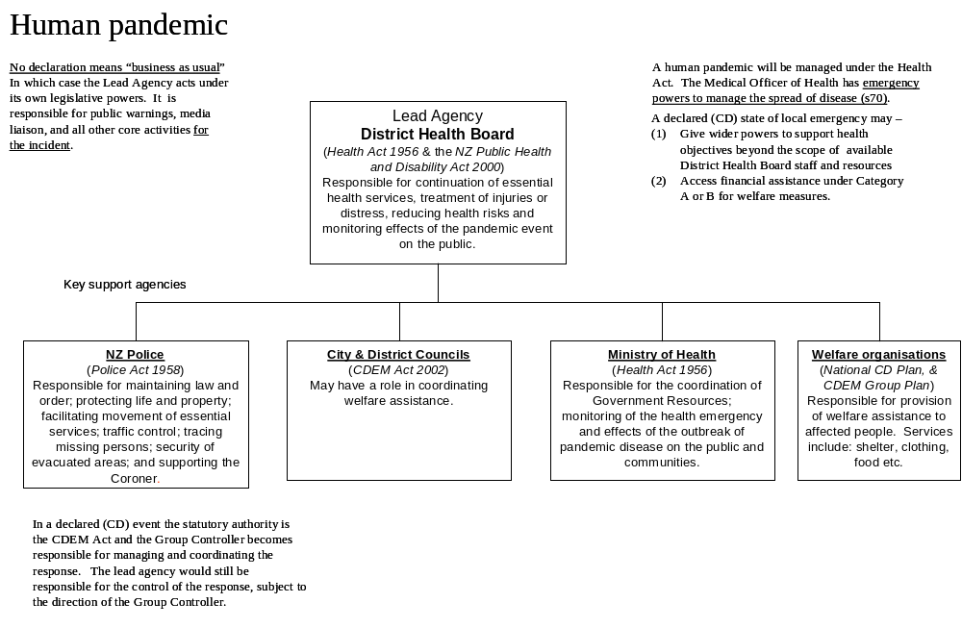
Section “2.6 Operational Structures and Relationships” of this plan sets out schematically the modified operational structure that will be applied during a pandemic. The HB CDEM Group Plan (8.6) sets out the responsibilities of the lead agency and the role and relationship with of the CDEM Group Controller.
7. RECOVERY
The scale of Recovery required after a pandemic outbreak is very much dependant on the scale of the impact of the event on the community.

If the outbreak is for an extended duration and is devastating in its impact on the population, recovery planning may need to cater for the following:

- Welfare and psychological impacts on the community
- Economic effects
- “Demographics” and their impact on community functioning

Due to the uncertain nature of recovery in this context planning has not yet begun on the recovery phase but the Health Response Coordinator and Group Controller should give early consideration to the appointment of a Recovery Manager for the CDEM Group (which may be dependant on where the main impact is, if localised) and to commence planning for recovery.
Annex I “EXPECTATIONS” AND “RESPONSIBILITY MATRIX”
Code | Description | Local Actions | Plans to consider activating | DHB Actions
White  (now) | Interpandemic period or human infections overseas, but rare or no human to human spread | HECC to review plans  Increased vigilance | Communication plan | - Te Whatu Ora Hawke’s Bay liaison with CDEM and other agencies for pandemic planning.  - Chair Health Emergency Coordinating Committee.  - Update Te Whatu Ora Hawke’s Bay emergency/pandemic plan including developing Communications Plans at Alert Code White.  - Plan for Community Assessment Centres (CAC).  - Position CAC equipment.  - Conduct exercise of response plans.  - Identify Te Whatu Ora Hawke’s Bay staff for Incident. Management Team positions.  - Identify Incident Management Team training needs and arrange training as required.  - Notify clinical and public health staff of case definitions, clinical advice and control measures.  - Review plans for rapid immunisation campaign.  - Increased vigilance and surveillance especially with ports of entry into New Zealand.  - Review plans for managing a pandemic including quarantine planning. | All agencies  - Assist Te Whatu Ora Hawke’s Bay in developing joint Communications Plan at Alert Code White.  - Conduct ongoing planning for EOC site including communication links.  - Interagency cooperation for pandemic planning.  - Concurrence on expectations between agencies.  - Participate in exercises (lead by Te Whatu Ora Hawke’s Bay).  - Complete Business Continuity Plans.  CDEM  - Complete CDEM Pandemic Plan.  - Liaison with Te Whatu Ora Hawke’s Bay for planning & participate in Health Emergency Coordinating Committee.  - Assist in exercise of response plans.  - Establish clusters that will contribute to CEM & IEM planning.  Police  - Update Business Continuity Plan to include pandemic.  - Participate in Health Emergency Coordinating Committee.  - Confirm Police involvement for Te Whatu Ora Hawke’s Bay sites including planning urgent response.  - Participate in exercise of response plans.  Fire Service  - Update Business Continuity Plan to include pandemic.  - Participate in Health Emergency Coordinating Committee.  - Confirm fire procedures for Te Whatu Ora Hawke’s Bay sites.  - Confirm fire requirements and procedures for CAC sites.  - Participate in exercise of response plans.  St John  - Update Business Continuity Plan to include pandemic.  - Support Te Whatu Ora Hawke’s Bay planning & participate in Health Emergency Coordinating Committee.  - Participate in exercise of response plans.  TLAs  - Update Business Continuity Plan to include TA functions & pandemic.  - Draft plans for contribution to community continuity and logistics.  - Provide relevant advice when requested to Health Emergency Coordinating Committee.  - Support Te Whatu Ora Hawke’s Bay planning and participate in exercises of response plans.  Lifelines  - Update Business Continuity Plan to include pandemic influenza.  - Provide relevant advice when requested to Health Emergency Coordinating Committee.  - Participate in exercise of response plans.  Welfare Agencies  - Update Business Continuity Plan to include pandemic.  - Participate in Health Emergency Coordinating Committee.  - Participate in exercise of response plans.

Yellow | Human infection in NZ (but not in Hawke’s Bay) but no human to human spread or rare instances of spread to close contacts. | Convene Incident Management team  Activate EOC  Enhance Surveillance | Hawke’s Bay Pandemic plan  Communication plan  Training plan | - Advise all agencies change in Alert Status  - Activate Te Whatu Ora Hawke’s Bay pandemic plan.  - HECC meet with CDEM Group.  - Place Te Whatu Ora Hawke’s Bay staff on alert.  - Manage clinical & public health response.  - Increase security at Te Whatu Ora Hawke’s Bay sites.  - Prepare for activation of CACs.  - Inform agencies of pending CAC activation.  - Place CAC staff on alert.  - Isolate cases and treat. | All agencies  - Joint communications plan implemented at Alert Code Yellow.  - Confirmation of interagency cooperation and plans for pandemic planning.  - Confirmation of expectations between agencies.  - Prepare for CIMS activation and establishment of EOC.  - Activate interagency communication networks.  - Activate internal agency response plans.  CDEM  - Confirm/prepare to activate CDEM pandemic plan.  - Participate in Health Emergency Coordinating Committee.  - HECC meet with CDEM Group.  - Place CDEM staff in support of CAC on alert.  - Finalise clusters CEM & IEM plans.  Police  - Confirm and prepare to activate Police Business Continuity Plan.  - Participate in Health Emergency Coordinating Committee.  - Monitor requirement for increased police presence at Te Whatu Ora Hawke’s Bay sites.  - Prepare to provide support to any CAC on establishment.  Fire Service  - Confirm and prepare to activate Fire Service Business Continuity Plan.  - Participate in Health Emergency Coordinating Committee.  - Fire safety checks of all Te Whatu Ora Hawke’s Bay facilities.  - Confirm CAC fire safety – sites and equipment.  St John  - Confirm and prepare to activate Business Continuity Plan.  - Participate in Health Emergency Coordinating Committee.  - Support Te Whatu Ora Hawke’s Bay site activation on occurrence.  TLAs  - Confirm/prepare to activate local authority Business Continuity Plan.  - Confirm plans for contribution to community continuity and logistics.  - Provide relevant advice when requested to Health Emergency Coordinating Committee.  - Support Te Whatu Ora Hawke’s Bay/CAC site activation on occurrence.  Lifelines  - Confirm and prepare to activate Lifelines Business Continuity Plan.  - Provide relevant advice when requested to Health Emergency Coordinating Committee.  - Lifelines Co-ordinator attend DPC/CCDEM Group meeting.  Welfare Agencies  - Confirm and prepare to activate Welfare agencies Business Continuity Plans.  - Participate in Health Emergency Coordinating Committee.  - WCG Chair attend DPC/CDEM Group meeting.
Yellow | Human infection in Hawke’s Bay but no human to human spread or rare instances of spread to close contacts.
Yellow | Increasing transmissibility of virus (substantial pandemic risk) overseas but no cases in NZ
Yellow | Increasing transmissibility of virus (substantial pandemic risk) overseas. Clusters or multiple cases in NZ (none in Hawke’s Bay) | Convene Incident Management team  Activate EOC  Enhance Surveillance  Prepare to activate for code red  Prepare to activate CACs  Ensure familiarisation of unit / agency specific plans.  Commence briefing of staff  Establish links with recovery manager | Hawke’s Bay Pandemic plan  Command and control plan  Communication plan  Training plan
Red | Human case or cases in Hawke’s Bay (human to-human transmission limited or localised) | Convene Incident Management team  Activate EOCs 24/7  Enhance Surveillance  Case management and contact tracing  Consider request for Full activation | Command and Control plan  Training plan  Communication plan  Port and Airport plan  Antiviral and PPE plan  Community Assessment Centres  First case plan  Quarantine and Isolation plan  Closure of public places  Management of the dead | - Advise all agencies change in Alert Status  - Activate Te Whatu Ora Hawke’s Bay pandemic plan.  - Activate IMT & EOC.  - Activate workforce contingency plans.  - HECC meet with. CDEM Group  - Prepare for activation of CACs.  - Inform agencies of pending CAC activation.  - Activate/Recall Te Whatu Ora Hawke’s Bay staff.  - Activate/Recall CAC staff.  - Introduce enhanced staff surveillance and sickness reporting and follow up any Influenza-Like-Illnesses.  - Isolate cases and treat.  - Track all staff contacts and review health status.  - Isolate cases and treat.  - Increase security at Te Whatu Ora Hawke’s Bay sites.  - Provide Incident Controller.  - Increase treatment focus of CACs.  - Immunise priority populations. | All agencies  - Joint communications plan at Alert Code Red.  - Activation of all business continuity plans – no longer draft status.  - Ensure continuation of interagency integration of pandemic plans.  - Activation of CIMS structures and EOC.  - Provide agency Situation Reports to EOC and national agencies.  - Continue interagency/health communication networks.  - Ensure Recovery phase of agency plans have final review.  CDEM  - Activate CDEM Pandemic Plan if requested.  - Support Te Whatu Ora Hawke’s Bay EOC.  - Provide advisory staff to support Te Whatu Ora Hawke’s Bay & Participate in EOC.  - CDEM use of Powers to support Police/Medical Officer of Health.  - Assist in activation of Community Continuity plans.  Police  - Activate Police Business Continuity Plan.  - Participate in EOC – provide Liaison Officer.  - Police enhancement of security at Te Whatu Ora Hawke’s Bay sites – potential for urgent response.  - Police involvement in traffic control around Te Whatu Ora Hawke’s Bay sites.  - Police enhancement of security at CAC sites – potential for urgent response.  - Preparation short notice response to law & order issues at Te Whatu Ora Hawke’s Bay or CAC sites.  - Provide support for community continuity and logistics.  - General police control of law and order.  Fire Service  - Activate Fire Service Business Continuity Plan.  - Participate in EOC – provide Liaison Officer.  - Predeturmine response for fire emergency.  St John  - Activate Business Continuity Plan.  - Participate in EOC – provide Liaison Officer.  - Support Te Whatu Ora Hawke’s Bay/CAC site activation.  TLAs  - Activate local authority Business Continuity Plan.  - Provide support for community continuity and logistics.  - Participate in EOC – provide Liaison Officer.  - If agreed support Te Whatu Ora Hawke’s Bay/CAC site activation.  Lifelines  - Activate Lifelines Business Continuity Plans.  - Participate in EOC – provide Liaison Officer.  Welfare Agencies  - Activate Welfare agencies Business Continuity Plan.  - Participate in EOC – provide Liaison Officer.
Red | Increased and substantial transmission of virus within New Zealand (whether or not cases in Hawke’s Bay) | Full activation | Activate all plans

Green | Pandemic over and or population protected by vaccination | Stand down of critical staff  Plan for deferred activities  Transition to recovery manager | Communication plan | Advise all agencies Alert Status Green.  - HECC meet with CDEM Group.  - De-Activate Te Whatu Ora Hawke’s Bay pandemic plan.  - De-activate Activate IMT & EOC.  - De-activation of CACs.  - Manage return to normal health services.  - Recovery, debriefing and lessons learnt.  - Support CDEM Recovery process. | All agencies  - Joint communications plan at Alert Code Green.  - Activation of recovery phase of all pandemic plans.  - Ensure continuation of interagency integration of plans.  - De-activation of CIMS structure and EOC.  - Continue interagency/health communication networks.  - Resume normal functions and Business Continuity Plans.  CDEM  - HECC meet with CDEM Group.  - Participate in Health Emergency Coordinating Committee debriefs.  - Activate recovery phase of pandemic plan – Business Continuity Plan.  - De-Activate advisory staff supporting at Te Whatu Ora Hawke’s Bay.  - Provide support for de-activation of CAC sites.  - Co-ordinate Community Continuity & recovery plans.  Police  - Activate recovery phase of Business Continuity Plan.  - Participate in Health Emergency Coordinating Committee debriefs.  - Preparation of Police short notice response to law and order issues at Te Whatu Ora Hawke’s Bay sites or CAC sites.  - General police control of law and order.  Fire Service  - Activate recovery phase of Business Continuity Plan.  - Participate in Health Emergency Coordinating Committee debriefs.  St John  - Activate recovery phase of Business Continuity Plan.  - Participate in Health Emergency Coordinating Committee debriefs.  - Support Te Whatu Ora Hawke’s Bay/CAC site de-activation.  TLAs  - Activate recovery phase of Business Continuity Plan.  - Provide relevant advice when requested to Health Emergency Coordinating Committee debriefs.  - Support Te Whatu Ora Hawkes Bay/CAC site de-activation.  - Lifelines  - Activate recovery phase of Business Continuity Plan.  - Provide relevant advice when requested to Health Emergency Coordinating Committee debriefs.  - Welfare Agencies  - Activate recovery phase of Business Continuity Plan.  - Participate in Health Emergency Coordinating Committee debriefs.

Community Assessment Centre (CAC)
Plan



Pandemic Plan
for
Community Assessment Centres

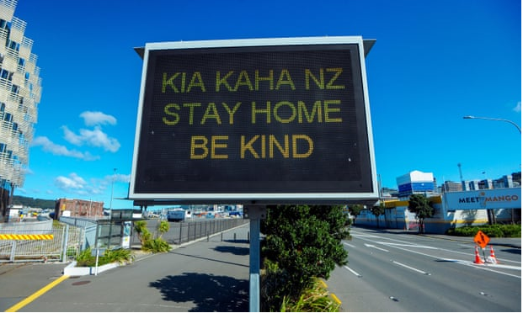

April 2023
Activation of Community Assessment Centres

I, hereby declare the activation of Community Assessment Centres in Hawke’s Bay due to a pandemic response Category Red declaration within the region.

Declared by:

Designation:
Te Whatu Ora Hawke’s Bay

Time and Date of Activation:

MEMORANDUM OF UNDERSTANDING
COMMUNITY ASSESSMENT CENTRE

Agreement between Te Whatu Ora Hawke’s Bay and
(Insert Provider Facility Here)

A Community Assessment Centre is activated by Te Whatu Ora, Te Matau o Māui during response to a pandemic event and acts to support the regional health response. Activation will be confirmed in writing.

(Insert provider) have agreed to provide a Community Assessment Centre under such circumstances and subject to the terms of this agreement.

This agreement sets out the responsibilities of both parties once the Community Assessment Centre is activated.

- As a Community Assessment Centre, (insert provider name) will provide:

(a) Clinical assessment, treatment and advice for pandemic-related illness.

(b) Supply of antiviral medication and appropriate medication as required.

(c) Triage and referral to other primary and secondary health care.

- Te Whatu Ora Hawke’s Bay will provide:

- Medical supplies, including personal protective equipment, as required for response.

- Additional personnel when required as per current Te Whatu Ora, Te Matau o Māui, Pandemic Plan held on the Community Assessment Centre premises.

- Additional resources as reasonably required.

      - Costs

All reasonable costs associated with staffing, supplies and utilities incurred in operating the Community Assessment Centre and associated with the response will be met by Te Whatu Ora Hawke’s Bay.

Signed |  | Signed
 | Executive Director  Te Whatu Ora Hawke’s Bay |  | General Manager/ CEO  (Insert Provider Name Here)
Date |  | Date

Contents

Introduction | 8
Role of Community Assessment Centres | 9
Function | 9
Essential Features | 10
Funding | 10
Suggested Sites | 10
Resourcing a Community Assessment Centre | 11
Community Assessment Scope and Operation | 13
Recognition and Management | 14
Community Outreach Service | 15
CAC Process and Flow Diagram | 16
Communication Plan | 17
Reporting System | 17
Surveillance | 17
Isolation of Suspected Cases | 18
Infection Prevention and Control | 18
Environmental Cleaning | 18
Public Facing Communications | 19
Laboratory and Radiology Services | 19
Supplies | 19
Temporary Accommodation | 20
Training | 20
Appendices | 22
Preferred Physical Site Characteristics | 23
Human Resource Requirements | 25
Personal Protective Equipment | 27
Specimen Collection | 30
Vaccines – General Information | 32
CAC Situation Report | 33
Pharmacy – CAC Medicines Supply | 35
Adult CAC Clinical Record | 39
Child CAC Clinical Record | 40
Influenza | 41
Ministry of Health Case Definition | 42
Checklist – Influenza Pandemic Strain | 43
Patient Care Clinical Pathway | 44
Pandemic Minimum Dataset | 45
Management of Patients with Influenza-like Illness | 46
Use of Antivirals | 47
Information on Quarantine (Home Isolation) for Influenza | 51
COVID-19 | 53
COVID-19 Ministry of Health Case Definition | 54
Clinical Criteria for COVID-19 | 55
HB COVID-19 Pandemic Data | 56
Testing Guidance COVID-19 | 56
COVID-19 Care in the Community Framework (2022) | 56
Hawke’s Bay COVID-19 Coordination System | 57
Antiviral Therapy | 59
COVID Variants of Concern | 60
Staying at Home, Patient Information | 62
Community Outreach Service Pandemic Response | 63
Introduction | 64
Function | 64
Workforce Development | 64
Work Allocation | 65
Work Allocation | 65
Operational Procedure for Home Visiting | 65
Resources and Administration | 66
Pandemic Minimum Dataset | 68
Pandemic Outreach Nursing Assessment | 69
Pandemic Outreach Service Progress Notes | 71
Welfare Support Request | 72
Phone Call Log Sheet – Pandemic Outreach Service | 73
Glossary | 74

INTRODUCTION

Pandemics are typically characterised by the rapid spread of a novel virus or bacteria across the world, resulting in unusually high morbidity and death for approximately two to three years. Factors that need to be present for a pandemic to occur include: the emergence of a new viral or bacterial subtype; the capacity for the pathogen to spread efficiently from person to person; and being virulent enough to cause disease.

The primary purpose of this plan is to provide the framework and methodology to efficiently respond to pandemics in the community.

Assumptions

- Pandemics are inevitable.

- The respiratory mode of transmission is most likely to lead to significant disease spread.

- Zoonotic diseases such as SARS, MERS, H7N7, Ebola and H1N1 are known, the risk of another zoonotic disease as causative agent remains possible.

- Outbreaks, as experienced in the SARS-CoV-2 pandemic, can occur simultaneously throughout much of New Zealand, inhibiting shifts in human and material resources that normally occur with natural disasters.

- Widespread resource constraints will occur.

- The effect of a pandemic on individual communities will be relatively prolonged -- weeks to years -- when compared to minutes-to-hours observed in most other natural disasters.
- Widespread illness in the community will also increase the likelihood of sudden and significant shortages of personnel in health care therefore reconfiguration of the service model is required to meet the demand.

- Despite the pandemic event, a level of routine primary care delivery will need to continue while minimising the risk of cross infection from patients with pandemic related illness. Telehealth models of care are a necessary addition to support service delivery.

- Community Assessment Centres (CAC) are a strategy to provide for primary care surge capacity and a level infection prevention and control, and are triggered by Code Red – pandemic imminent.

ROLE OF COMMUNITY ASSESSMENT CENTRES

During a pandemic, the role of Community Assessment Centres (CACs) will be to provide the primary care surge capacity arising from a sudden increase in demand. These centres will be a means of concentrating the initial assessment of people with emerging infectious disease (EID) symptom criteria away from individual general practices and hospital emergency departments, the usual first ports of call for people who are unwell.

CACs will be for pandemic cases that meet the case definition and for people that are likely to benefit from early clinical intervention. In addition, CACs will support the provision of home-based self-care in association with telephone triage, advice and outreach services as required.

FUNCTION

The primary functions of a CAC will be to:

- provide clinical assessment and advice
- provide triage and referrals to other primary health or secondary health care (if capacity exists)
- enable health professionals to specialise in telephone triage, pathogen recognition, and disease management
- practice and provide advice on infection prevention and control, and self-management for consumers
- provide secure distribution centres for anti-virals in accordance with Te Whatu Ora guidelines
- provide intelligence data for regional and national reporting
- redirect and manage pandemic health demand away from existing health facilities

CACs will be facilities for the community that:

- are identified as a place for the community to seek help and information
- obviate the need for extensive travel (which might help slow the spread of the pandemic)
- will enable the community and the health workforce to be utilised in an efficient and effective way
- are responsible for rationing scarce resources in accordance with national policy
- have the capacity to stream patients into appropriate clinical pathways as available
- are a means of providing emergency public health interventions close to the community and concentrating on the problem immediately at hand
- have local leadership.

A CAC Situation Report (page 29) must be completed every 24 hours and sent to the Emergency Operations Centre at Te Whatu Ora Hawke’s Bay.

ESSENTIAL FEATURES

CACs will be stand-alone facilities set up for example in community centres, general practices or after-hours clinics not being used for the treatment of other conditions When choosing a facility, the following features will be a priority:

- they are locations that people are familiar with and can access easily
- they have easy drive-up access with separate entry and exit
- they are suitable for undertaking the functions noted above
- they have staff facilities such as toilets and hand basins
- there are available and sufficient essential support systems such as water, electricity, and heating
- there is the ability to implement infection prevention and control practices
- there is staff, site and material security
- there is secure storage
- there is a means of disposing infectious waste

CACs will be planned with the needs of the community in mind.

Active consideration needs to be given to how they could provide services to people who are less mobile, who do not have easy access to transport, or are relatively isolated. There is no one size, or even range of sizes, that fits all. For example, a mobile CAC model may be feasible in some circumstances. CAC’s will need to be progressively activated as the pandemic evolves with initial activation occurring at the loss of cluster control in Hawke’s Bay, this will be advised by the Medical Officer of Health (MOH).

Social factors should also be acknowledged in planning a CAC location. Factors such as trust, and pre-existing relationships with a service or structure are important.

During the SARS-CoV-2 pandemic (2019-2023), Care in the Community Teams (CitC) developed community rapport that supported the most vulnerable to access health and welfare. These teams remain an important addition to support CAC’s to identify and respond to welfare need in the affected community, and work in addition and collaboration with the CDEM Welfare response.

Ideally, CACs will be open for a minimum of 12 hours a day, dependent upon workforce availability. Full time security will be necessary.

FUNDING

Community Assessment Centres will be funded by Te Whatu Ora. It is critical that services are free to the community.

SUGGESTED SITES

Hastings Health Centre City Medical
Te Mata Peak Practice The Doctors Napier
Totara Health Flaxmere Tamatea Medical Centre
The Doctors Hastings Taradale Medical Centre
CHB Health Centre Wairoa Health Centre

A Memorandum of Understanding page 4 will be signed and activation will be authorised by Te Whatu Ora Hawke’s Bay usually incrementally as clusters of pandemic cases are notified in Hawke’s Bay.

A small number of facilities are identified as potential CAC’s to ensure control of information, consumables, medication delivery and workforce, remembering more isolated communities can be assisted through the outreach process.

It may be appropriate as the situation progresses to consult with local marae and Hauora providers in rural areas regarding the operation of a CAC directly from the marae. This would involve appropriate resourcing and training for those involved.

RESOURCING A COMMUNITY ASSESSMENT CENTRE

Te Whatu Ora Hawke’s Bay is responsible for staffing support, supply of Personal Protective Equipment (PPE), clinical supplies for the CAC and its Outreach Service along with any other resources required.

Provision will to be made for information collection including the ability to record patient details. Facilities will need to adhere to strict IPC principles and monitor the health of their staff. Effective communications to enable telephone triage, or communication with referring and referred providers are essential.

Te Whatu Ora Hawke’s Bay will be responsible for the safety of all personnel working for them. Police communication centres will be supplied with a current list of high-risk facilities to ensure immediate response to any calls for assistance. Police will liaise with local security firms in relation to high priority facilities in terms of need, risk and action required.

Set-up Requirements:

- Security provision
- PPE (isolation gowns, disposable gloves, surgical masks, PFR95 masks, eye protection)
- Antivirals and other identified appropriate medication
- Tympanic thermometers
- IV administration equipment
- Oxygen masks, tubing and cylinders with regulators
- Resuscitation tray
- Stethoscopes
- Tongue depressors
- Ear speculum
- Nasopharyngeal swabs
- Blood collection equipment
- Antimicrobial hand gel
- Environmental wipes
- Plastic or perspex screens for reception areas
- Screens to separate areas
- Swap out fabric furnishings for easy clean surfaces
- Rubbish bins with lids
- Biohazard bin
- Cleaning products as approved by IPC CNS
- Plastic bags for personal effects
- Tissues
- Stationery and patient notes or Patient Management System (PMS)
- Clipboards
- Directional Signage
- Surgical scrubs if advised by IPC CNS

COMMUNITY ASSESSMENT SCOPE AND OPERATION

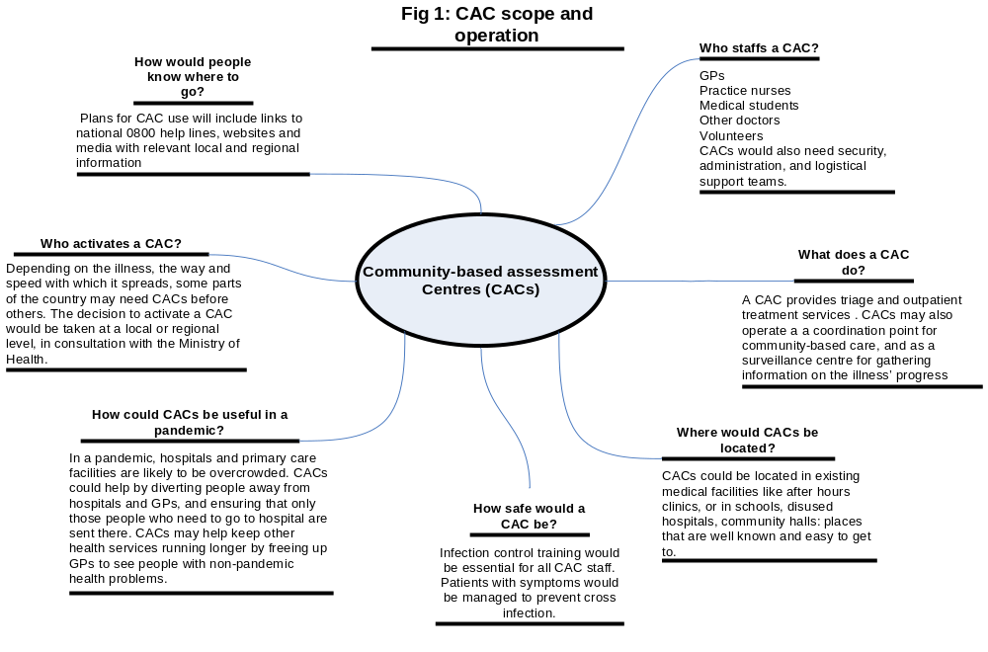
RECOGNITION AND MANAGEMENT

In the event of an emerging infectious disease-related emergency all CAC’s need to have the following minimum capabilities:

- contact details for advice about, and referral of, suspect and/or probable patients
- access to updated clinical information on the emerging infectious disease including case definition and management and treatment guidelines
- appropriate visible signage advising patients and others of any restrictions or required actions
- access to appropriate PPE for staff, including administration
- an identified IPC resource person
- availability of infection prevention and control staff and facility training

The appropriate triage form should be selected to screen suspected cases. Patients who telephone and are advised to attend a CAC should be asked to bring their current medicines with them.

The patient care clinical pathway should be followed for all identified suspect cases with a clinical record completed. Antiviral medicines will be supplied to patients meeting the criteria, some antibiotics and paracetamol may also be supplied directly from the CAC. Prescriptions for other medicine will be scanned and emailed to the patient’s usual pharmacy for home delivery (prescription to be marked “influenza” or the appropriate pandemic pathogen to alert pharmacy staff). See Pharmacy CAC Medicines Supply (page 30).

Admission and treatment guidelines will be supplied by Te Whatu Ora Hawke’s Bay.

Antiviral medicines will be used in the ‘stamp it out’ phase for:
- The treatment of early cases
- Post-exposure prophylaxis of contracts
- Possibly pre-exposure prophylaxis of health-care workers

Antiviral medicines will be used in the ‘management’ phase for:
- Patients with severe clinical pandemic illness.
- Patients with pandemic symptoms who are at high risk of pathogen-related complications (immunocompromised or suppressed patients, pregnant women, severe or poorly controlled congestive heart failure, severe chronic respiratory disease, severe asthma, patients on renal replacement therapy).
- Patients with pandemic illness symptoms who live or work in high risk institutions (residents of aged residential care facilities [ARC] or other residential care facility, people who provide services in relatively closed settings to persons at high-risk).
- Cluster and/or infection control where appropriate on discussion with the Medical Officer of Health (MOH)

The MOH will be responsible for application to the Ministry of Health (MoH) for release of the national supply to the Hospital Pharmacy.

Effective vaccines are unlikely to be available for at least 12-16 weeks at which point the Public Health Service will coordinate a regional immunisation campaign.

Isolation and quarantine requirements will be enforced early in the pandemic under the direction of the Medical Officer of Health (MOH) with information provided to patients and contacts.

COMMUNITY OUTREACH SERVICE

Patients who are home bound or requesting outreach services will be triaged via CAC and assessed for service appropriateness.

Outreach services are resource intensive so triage will apply to all referrals. Once the service is operationalised two registered nurses will plan the visit using the Outreach guidelines. The nurses will operate under the appropriate patient care clinical pathway and standing orders for supply of antiviral and other medication. The nurses must have direct access to a designated general practitioner at the CAC for advice as required.

A designated vehicle meeting infection prevention and control standards will be allocated to the CAC for outreach service provision. Any patient requiring assistance at home should be referred to the Welfare Coordinating Group by contacting Civil Defence Emergency Management.

Equipment required:

- Sets of PPE (gown, gloves, PFR95 mask, eye protection, surgical ear loop mask)
- Antimicrobial hand gel
- Tympanic thermometers
- Stethoscope
- Tongue depressors
- Antiviral, paracetamol and approved antibiotic medication
- Patient notes and minimum dataset forms
- Biohazard bag

See the Community Pandemic Outreach Service Plan.

CAC PROCESS AND FLOW DIAGRAM
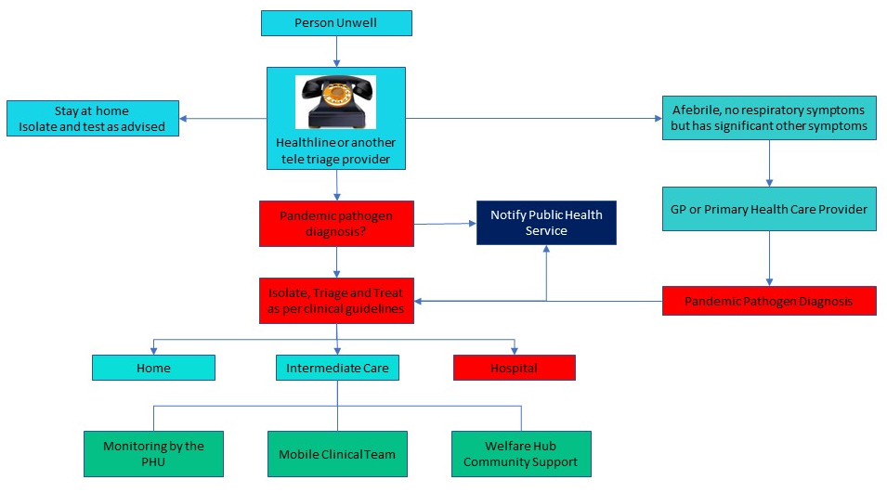
COMMUNICATION PLAN

Name | Title | Contact | Availability

DHB emergency.response@hbdhb.govt.nz
Sandra Bee | Emergency Management Advisor | 878-8109 | On-call
 | CNS Infection Prevention and Control | 878-8109 | On-call

Public Health Unit CIMSOpsPublicHealthUnit@hbdhb.govt.nz
 | Medical Officer of Health | 878-8109 | On-call

Useful Websites:
Ministry of Health http://www.moh.govt.nz/pandemicinfluenza
https://www.health.govt.nz/covid-19-novel-coronavirus/covid-19-response-planning
WHO http://www.who.int
CDC http://www.cdc.gov

Notification of probable cases must be made to Public Health Unit, Te Whatu Ora Hawke’s Bay. During Phases 5 and 6, daily reports to Emergency Operations Centre at Hawke’s Bay Hospital are to include numbers of probable and confirmed cases, staffing, resource levels and shortfalls of same.

REPORTING SYSTEM

Early in the Pandemic
Immediate notification of the first suspected cases is crucial. Phone 834 1815 (seven days). Ask to speak to a Medical Officer of Health (MOH). Do not leave a message. Make sure you speak directly to a MOH. Detailed information will be required about each case and the MOH will work closely with the centre to formulate an immediate plan of action, including investigation and management of the case and contacts.

When the MOH advises that a Hawke’s Bay Pandemic is established
At this point the MOH will advise all centres that the reporting requirements are to be reduced to a minimum, Pandemic Minimum Data Set (PMDS), e.g. report date, name, age, gender, ethnicity and suburb or street address. PMDS Forms to be emailed to Te Whatu Ora Hawke’s Bay Emergency Operations Centre, emergency.response@hbdhb.govt.nz.

SURVEILLANCE

Surveillance means collecting and reporting data about cases to describe the evolving epidemic to help guide a response. Surveillance will be carried out by the Public Health Unit (PHU).

Surveillance updates will be available for practitioners on the Te Whatu Ora Hawke’s Bay website: https://hawkesbay.health.nz/current-public-health-warnings-and-alerts/

ISOLATION OF SUSPECTED CASES

The separation of routine patients from those suspected of having the pandemic infection must be planned. This will be achieved by providing separate entrance/waiting rooms/treatment rooms for patients with symptoms. Designated staff should manage the patients in this area.

Prompt triage prior to entering the facility will assist in patient placement. Staff directing patients to the appropriate area should use the symptoms checklists. Providing a surgical mask and hand gel at the point of entry will minimise transmission to others and contamination of the environment.

INFECTION PREVENTION AND CONTROL

Staff able to work from home without effecting business, should be encouraged to do so.

It is recommended that all staff be vaccinated each year against seasonal influenza, coronavirus and other appropriate communicable diseases. While this may not protect against a pandemic, it will maintain the general wellness of your team. Unwell staff should stay at home.

Initial precautions

Initial precautions if someone is suspected of having pandemic illness include:

  - Keep your distance
One metre is accepted as safe and significantly reduces your exposure
  - Wear a surgical mask or PFR95 as clinically indicated
Also offer a surgical mask to any patient and support people
  - Frequent hand hygiene
Use an antimicrobial hand gel or wash in warm water with flowing soap, dry hands with paper towels
  - Ensure separation of patients with respiratory symptoms from other patients
  - Ventilation
Keep windows open if possible. If air conditioning is used, ensure that designated areas can be isolated from the rest of the facility or turn the air conditioning off. Mobile hepa filters may be utilised from the Emergency Management Advisor (Te Whata Ora Hawke’s Bay) if supply is available.

Essential supplies

  - Disposable gloves (if indicated)
  - Surgical masks
  - Tympanic thermometers
  - Tissues – for waiting and consulting rooms
  - Waste disposal bins with lids and medical waste disposal bags
  - Antimicrobial hand gel or hand washing facilities’ (flowing soap, water and paper towels for drying)

Pandemic guidelines for PPE use must be followed.

ENVIRONMENTAL CLEANING

Horizontal surfaces should be wiped down after each suspect patient. Patient care areas and bathrooms must be cleaned at least daily on completion of other routine cleaning.
Each facility must have documented Pandemic Environmental cleaning guidelines approved by IPC CNS, Te Whatu Ora Hawke’s Bay.

These should include:
- High touch areas
- Floors
- Staff areas
- Use of environmental wipes
- PPE for cleaning personnel. (mask, gown, eye protection and gloves)
- Approved cleaning equipment and chemicals (sodium hypochlorite 100mL in 1L of water)
- Disposable cleaning cloths
- Management of non-disposal patient equipment
- Waste and linen management

Minimal linen should be used and changed after each patient taking care not to shake it. All waste (except sharps) must go into the biohazard bag.

Linen and waste must be emptied daily or when containers are two thirds full. Daily collection of waste is contracted by Te Whatu Ora Hawke’s Bay.

See attached COVID Cleaning guidelines.

PUBLIC FACING COMMUNICATIONS

Messages to the public will be distributed centrally by Te Whatu Ora Hawke’s Bay following MoH advice, this will assist in managing expectations. Te Whatu Ora will also provide public information on local arrangements.

Information pamphlets are available on the MoH website, https://www.health.govt.nz/covid-19-novel-coronavirus

Regular bulletins will be coordinated through Te Whatu Ora Hawke’s Bay. A hotline number may be made available through Te Whatu Ora for updated information on 0800 777 790.

LABORATORY AND RADIOLOGY SERVICES

Laboratory specimens may only be collected in the early stages of the pandemic. See specimen collection procedures.

Patients with suspected pandemic illness should not be sent to a community laboratory for collection of throat or nasopharyngeal swabs or blood testing.

Specimens should be bagged and couriered to the Laboratory at Te Whatu Ora Hawke’s Bay.

Radiology service arrangements will continue as normal arrangements dictate. They will be supported by TRG Imaging for non-pandemic patients with transport to services the responsibility of the Te Whatu Ora Hawkes Bay.

SUPPLIES

PPE will be supplied to each centre by Te Whatu Ora Hawke’s Bay to manage initial cases. Resupply will be through the national reserve once activated.
PPE and essential supplies include: disposal gloves, PFR95 and surgical masks, isolation gowns, disposable aprons, eye protection, (face shields and safety goggles), thermometers, tissues, environmental wipes, waste disposal bins with lids, antimicrobial hand gel, flowing soap and paper towels for drying.

Equipment for collection of multiple specimens (as describe above) for viral culture and PCR.

Supply levels must be checked regularly with reordering from the Te Whatu Ora Hawke’s Bay via the sitrep and include:
- Consumables, clinical and administrative
- Linen
- Laboratory supplies
- Medicine supplies

Te Whatu Ora Hawke’s Bay or receiving facility will ensure secure storage of all medicines and medical supplies under their care including the movement of medical supplies to other facilities.

The MOH will approve the distribution of antivirals and request the release of the national reserve.

Te Whatu Ora Hawkes Bay Pharmacy will:

- store antivirals
- pre-label the antivirals so that a doctor or nurse can issue the medicine by writing the name and required dose on the label
- arrange transport to the provider who will supply the medication to the patient
- monitor stock issued

TEMPORARY ACCOMMODATION

Temporary accommodation for staff who are willing to work but do not wish to go home will be arranged by Te Whatu Ora Hawke’s Bay.

Coordination of temporary accommodation, if required, for patients who live alone or isolation needs dictate, will be organised by Te Whatu Ora Hawke’s Bay.

Requests for temporary accommodation should be advised in the sitrep for action.

TRAINING

A training plan has been prepared by Te Whatu Ora Hawke’s Bay to ensure consistent messaging for all staff.

Regular pandemic training should be undertaken by GP practices as part of their emergency planning to ensure staff understanding and preparedness.

WORKFORCE MANAGEMENT

A CAC will require clear clinical and operational leadership. This leadership will need to be drawn from existing public health, primary and secondary health care services and will utilise all health practitioners. Administrative staff, cleaning staff and security personnel will also be critical to the operation of a CAC. Trained community volunteers may also be utilised to undertake task-oriented functions under supervision of clinical staff.

Workforce management requires sensible rostering, cover for sickness, absenteeism and attention to staff welfare. Rostering should consider short rotations in consistent teams for pandemic care provision. When in full PPE, adequate break time with a maximum two-hour shift in the isolation area is recommended. Workload monitoring is essential.

During the workforce identification and planning phase, liasion with staff and if time allows, screening by the Occupational Health Service is recommended. This is to determine availability, assess clinical skills and identify any associated personal health risk for service delivery as front-line health workers.

Workforce planning should consider the need for increased staffing during the peak of the pandemic. See example of pandemic wave prediction.

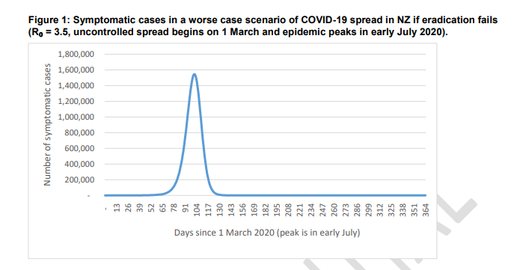

https://www.health.govt.nz/system/files/documents/publications/report_for_chief_science_advisor_-_health_-_24_march_final.pdf

Note: The graph above depicts a potential scenario for a pandemic wave based on a Ministry of Health modelling tool which drew on international data from the COVID 19 Pandemic and its predicted application in New Zealand. Modelling can provide a guide only and is dependent on multiple factors such as pathogen virulence, health system preparedness, vaccine availability and prevention measures. Workforce planning to meet demand is essential to manage during peaks, noting workforce themselves will be inevitably be affected.

Reception and recruitment of volunteers will be carried out centrally, with placement of volunteers being made according to the information supplied by each agency detailing tasks that may be allocated, skills required and exclusion criteria. Each agency is responsible for area specific orientation of volunteers following attendance at a generic orientation programme.

APPENDICES

PREFERRED PHYSICAL SITE CHARACTERISTICS

General Location Characteristics

- Parking capacity
- Emergency services access and parking
- Proximity to population centres
- Pre-triage collection point
- Staged entry to manage crowd
- Information displays – signage opportunities
- Ability to cordon the site off allowing room for patients to access – effect on nearby roads/residents/businesses
- Security
- Familiarity of site to immediate community
- Ventilation

Assessment and Treatment Areas

Red line / green line to separate patients:
- Multiple entries
- Registration area
- Waiting area(s)
- Screens for reception areas
- Assessment area: triage
- Transfer and pre-hospital treatment area
- Patient education/information/counselling area(s)
- Discharge area
- Adjunct services: radiology, laboratory

Storage and Administration

- Secure pharmaceutical supplies area
- Medical supplies, especially secure stores for PPE
- Patient records
- Triage tags/transport and transfer forms
- Ability to stockpile equipment and supplies

Support Services

- Medical waste
- Laundry
- Catering

Staffing

- Current staff levels at all required skill levels, including security staff
- Access to additional staff (consider impact on other services) including volunteer and health support service staff
- Insurance and personal liability cover for practitioners and volunteers
- Staff support services, including staff family support
- Training needs: infection prevention and control; triage methods; communication; telephone advice and triage; personal protection
Physical Requirements (Infection Prevention and Control Only)

Entry

- Posters, masks and hand gels outside facility to be put on/used before entering
- Antimicrobial hand gel dispensers outside facility so that people entering clean their hands before touching the door handle
- One point of entry for all patients so they do not miss triaging
- Protective screen at reception to minimise droplet spread

Reception area

- No toys magazines or newspapers
- Minimal, washable furniture

Treatment rooms

- Separate room to minimise exposure/ risk of transmission to others
- Designated toilet facility with appropriate hand hygiene facilities
- Sufficient space: wherever possible the practitioner should have sufficient space to be more than one metre away from the patient when not carrying out a physical examination
- Minimal equipment and supplies in the room
- Washable surfaces
- Pedal operated rubbish bins/linen skip
- Arm operated taps
- Wall dispensers for antimicrobial hand gel

Equipment

- Disposable equipment should be used whenever possible
- Masks, gloves, gowns, eye protection
- Antimicrobial hand washes/gels
- Tympanic thermometers
- Pulse oximeters
- Biohazard bags
- Approved cleaning solutions: hospital grade surface disinfectant or wipes
- Disposable cloths
- Tissues

HUMAN RESOURCE REQUIREMENTS

General Requirements

These requirements are for all staff, regardless of role.

- Knowledge of infection prevention and control: general principles and specific requirements (if any) relating to the pathogen involved
- Ability to cope with highly pressured situations
- Communication skills
- Focus on teamwork
- Adaptability
- Commitment to maintaining confidentiality of patients and fellow staff

Specific Requirements

The following tables set out the skills and types of personnel that are likely to be required to take on specific functions in a CAC environment.

Functions | Skills/personnel
Administration
Site administration/management - staff scheduling, support and welfare, assessing service demands and supply | Management/administration.
Co-ordination of patient care  On-site training, orientation and task allocation for staff, volunteers and family members | Medical training, knowledge of basic patient care, triage, infection prevention and control and occupational health and safety, leadership, co-ordination and communication skills.
Receptionist, health records management, information technology resource | Communication skills, public relations, rapid situation assessment, clerical skills, IT systems knowledge and problem-solving skills.
Patient care
Medical triage | Medical training/nurse, ideally with emergency care training.
Medical management | Physician or nurse with physician backup.
Transfers/discharge  Infection prevention and control training for family/other carers | Medical training/nurse, ideally with experience in discharge planning and infection prevention and control. Links with community-based care organisations.
Patient assessment and basic treatment | Instructed in nursing care: rehydration, feeding, vital signs monitoring, giving medications.
Infection prevention and control
Monitoring infection prevention and control practices and safety in the CAC | Nursing skills, preferably with infection prevention and control and teaching experience.
Transportation
Patients and staff | Appropriate licence and insurance; infection prevention and control training.
Services
Maintenance | Plumbing, electrical, air conditioning (not on-site).
Laundry | Off-site provided by contractor.
Cleaning | Cleaning of patient care areas, waste disposal, supply in toilet facilities.
Security
Public order and personal safety | Crowd and traffic control; controlling entry of patients and protecting staff inside and outside the building.
Social services
Social service/community care | Counselling, accessing community-based resources/social workers.
Psychology/pastoral care/grief counselling | Social workers, church leaders, psychologists, local service clubs/support groups, victim support services. Links with community-based care organisations for referral and follow-up support.

Different operational zones of the CAC will require different skills sets, noting, however, that all CAC staff members will need infection prevention and control and self-care training.

CAC clinic area | Service provided | Training requirements
Entry point | Primary assessment | Security  Trained non-medical workers
Patient registration | Register incoming patients  Vital signs | Trained non-medical staff; receptionists  Medical professional (nurse, doctor, health care assistant
Waiting room(s) | Initial assessment | Nurse, physician
Treatment room(s) | Secondary assessment and treatment plan  Provision of oxygen, supportive treatment for patients who arrive in distress | Physician  Advanced first aid
Transfer | Waiting area for patients transferred to hospitals | Trained non-medical
Education/discharge | Information for patients and families/carers; follow up resources and links with community-based care | Trained non-medical

PERSONAL PROTECTIVE EQUIPMENT

Recommendations for PPE use

Personal protection equipment (PPE) includes masks, eye protection, gloves, gowns and aprons. Varying levels and types of PPE are required, depending on the level of exposure and the risk of transmission.

Whatever the level of PPE to be used, education and training is necessary to ensure the equipment is used and disposed of correctly, to maintain the equipment’s effectiveness.

Estimate for PPE

One patient requires one Medical Officer (MO) and one Nurse:
PPE required for 1 patient = 2 masks, 2 pair gloves, 2 gowns

MO sees 4 patients per hour = 8 pair gloves per hour
= 96 patients per 24 hours
= 192 pairs per 24 hours
= 672 patients per week
= 1344 pairs gloves per week
Gloves supplied per box = 100 therefore 26-27 boxes of gloves per week

PFR95 masks ≤4 hours = 12 per day per one MO and one Nurse (6 each)
= 84 per week
PFR95 masks supplied per box = 35 therefore 2.4 boxes per week

Surgical masks for patients = 672 patients per week
Surgical masks supplied per box = 50 therefore 13-14 boxes per week

If the gown is to last 4 hours = 12 per day (as for masks)
= 84 per week
Gowns supplied per carton = 50 therefore 2 cartons per week

Gowns - you will need to decide how long your gown should last. In the hospital situation a gown is single use. In the primary care setting you may decide to use one gown for 4-8 hours. This will depend on the contact with patients and the care and contamination of the gown.

Gloves may not be required for all patient contacts. Hand hygiene (antimicrobial hand gel or soap and water wash) will be sufficient in most cases.

NOTE: These numbers are estimates only and may vary during the phases of a pandemic. There are many variables to be considered i.e. patients seen, acuity and potential for contamination of PPE.

Summary of PPE requirements

 | Entering Room but no close contact (> 1 metre from patient) | Close patient contact (<1 metre from patient) | Aerosol generating procedure being performed (including nose/throat swabs)
PFR95 mask | No | No | Yes
Surgical mask | Yes | Yes | No
Isolation gown | No | No | Yes
Gloves, non-sterile | No | No | Yes
Eyewear, protective | No | No | Yes

Use of disposable surgical masks, gloves

Disposable surgical masks are recommended for first responders and health care/support workers in a health care setting who are at risk from droplet transmission.

Disposable gloves are recommended as a means of reducing the likelihood of virus transmission when handling objects contaminated with respiratory secretions. Apart from health care settings, the use of gloves is less important than careful hand hygiene. The use of gloves does not replace the need for hand hygiene.

Disposable gowns or splash resistant aprons may also reduce opportunities for contamination.

Checklist for Staff before Entering Designated Areas

The following points must be checked before entering an isolation area:

- Cell phones or pagers left outside the area along with pens, stethoscopes and tourniquets
- Shoulder length hair must to clipped or tied back
- Shoes should cover and protect feet from splashes and dropped equipment and should have wipeable surfaces
- A mask must be worn and fit securely
- A gown must be worn and be tied firmly
- Gloves should be worn covering the wrists

Using Personal Protective Equipment

NB: The correct donning and doffing process must be followed. A doffing area must be designated with the appropriate equipment i.e. hand hygiene products and waste disposal bins

If any of the following occurs the mask must be changed:
- if you touch it
- if it is grossly contaminated
- if it becomes wet for any other reason
- if it becomes hard to breathe through

Masks should be placed in a biohazard bag after removal.

If at any time gloves become contaminated, they must be removed, hand hygiene performed and clean gloves put on.
Donning and Doffing Poster
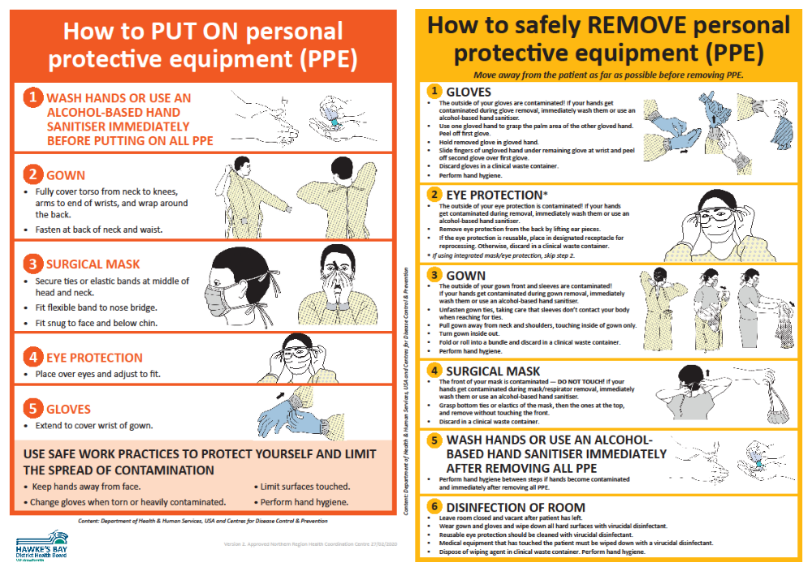
SPECIMEN COLLECTION

All samples should be sent by the usual Southern Community Laboratories specimen collection service to Hawke’s Bay Hospital Laboratory.

Who should be swabbed?
- Swabbing should be reserved for only those patients with pandemic illness who are in high risk groups or situations.

People on antiviral medicine
- Antiviral medicine reduces the yield from viral swabs.
- If an adult case has commenced a twice-daily treatment course of antiviral medicine, do not take swabs. Children excrete a higher viral load. If a child case has been on a twice-daily treatment course of antiviral medicine for >48 hours do not take swabs.
- For contacts on once-daily prophylaxis with antiviral medicine who develop symptoms, a swab is indicated if within 48 hours of commencing antiviral medicine.

People not on antiviral medicine
- Virus shedding declines with time in untreated patients.
- Do not take swabs from an adult case who has had symptoms for five days or longer.
- Children (especially young children) shed for longer, so untreated children can be swabbed even if they have had symptoms for longer than five days.

Samples required
- Nasopharyngeal swab in viral transport medium

Sample collection
Respiratory specimens should be collected as early as possible in the course of the illness. The likelihood of recovering most viruses and many bacteria diminishes markedly >72 hours after symptom onset. Some respiratory pathogens may be isolated after longer periods.

Equipment
One nasopharyngeal swab with non-wooden shaft and synthetic fibre tip
One virology swab with viral transport medium
One pair of scissors
PPE i.e. gloves, gown, PFR95 mask, eye protection, antimicrobial hand gel

(i) Collection of nasopharyngeal swabs
Use a pernasal swab with non-wooden shaft and synthetic fibre tip:
Insert swab into one nostril, parallel to the palate, rotate gently and advance until resistance is felt. (One eye will often water when swab is in the correct position.)
Press swab tip on the mucosal surface of the mid-inferior portion of the inferior turbinate and leave in place for a few seconds, then slowly withdraw using a rotating motion.
Place swab into viral transport medium tube.
Snap or cut off the cap with scissors and discard the cap
Ensure tube lid is secure and labelled correctly.

- If the viral transport medium is liquid
Cut the swab sticks off just below the level of the bottle - so that there is no swab pressure for the viral media lid to pop off.
Ensure lid is firmly closed on viral specimen and taped to prevent leakage of viral media, ensure the specimen is labelled correctly.

Packaging and Transport:

- The laboratory form should clearly indicate that this is a request for “PCR testing for novel (pathogen) infection”. Write “copy result to the Medical Officer of Health”. Notifying the Medical Officer of Health is not required before sending the swab.
- Ensure the laboratory request form is fully completed with details including the NHI number and that the specimen container contains the patient name and NHI number.
- Specimens should always be bagged ensuring that the snap lock is securely sealed. Place the request form in the pocket of the outside bag.
- Specimens should be transported by Southern Community Laboratories to the Hawkes Bay Hospital Laboratory.

VACCINES – GENERAL INFORMATION

Vaccine Management should be based on the following assumptions:

- There will be a minimum of 6 months between a novel virus alert and the availability of vaccine, as evidenced in the COVID-19 Pandemic.
- The entire population will be susceptible and may require two or more doses of vaccine for adequate protection.
- The proportion of vaccine to be distributed and administered through the public versus the private sector is unknown. Even so, the amount, if not the proportion, of vaccine that will be distributed through the public sector during a pandemic will be greater than the amount distributed by the public sector in non-pandemic years.
- There will be a national contract for purchase of vaccine.
- Multiple vaccines will likely be available quickly, requiring workforce training, education and preparedness.

Vaccine Administration

Vaccinators are authorised by the Medical Officer of Health pursuant to regulation 44a of the Medicines Regulations. Hawkes Bay has authorised vaccinators available with a database being maintained to record all vaccinations. A list of currently authorised vaccinators is held by the PHU.

In response to the COVID-19 pandemic, the provisional vaccinator workforce was instrumental in providing a rapidly trained vaccination workforce. In addition, non-regulated vaccinator roles i.e. COVID Vaccinator working under supervision (CVWUS) or similar workforce may also feature as part of a regular vaccination team. It is important that the workforce is trained and supervised to ensure Vaccinators comply with current legislation.

Priority Groups List for Receipt of Vaccine

Because vaccine shortage during a pandemic is likely, the MoH, in conjunction with various advisory committees, will formulate recommendations for a rank-order list of high priority groups for vaccination. The order of these groups will be based on a number of factors, including the need to maintain the infrastructure necessary to carrying out the pandemic response plan; to limit mortality among high-risk groups; to reduce morbidity to the general population; and to minimize social disruption and economic losses.

While any Priority Groups List will be subject to change, the list will most likely include the following groups:

- Health-care workers and public health personnel involved in the distribution of vaccine and antiviral agents
- Persons responsible for community safety and security, e.g. police, fire-fighters, military personnel, corrections officers, "first responders" not included in first priority group (e.g. ambulance officers)
- Other highly skilled persons who provide essential community services whose absence would either pose a significant hazard to public safety (e.g. air traffic controllers) or severely disrupt the pandemic response effort (e.g. persons who operate telecommunications or electric utility grids, care givers at residential facilities). [NOTE: Members of this target group are likely to vary widely from region to region, depending on local circumstances.]
- Persons considered to be at increased risk of severe influenza illness and mortality

Vaccination will be coordinated by the Public Health Service at Te Whatu Ora Hawke’s Bay.

CAC SITUATION REPORT
(To be completed every 24 hours)

Organisation: CAC – XXXXX (Location)

Event:

Date:

To: Te Whatu Ora Hawke’s Bay

Origin
Person Submitting Report

Position
Location

Contact

Telephone
Cell phone
Email
# | Item | Remarks
1 | For Period  Duration of Report
2 | Overview of Event
3 | Assessment of Impact
4 | Critical Issues
5 | Planning and Intelligence Report / Issues
6 | Operations Report / Issues
7 | Logistics Report / Issues

8 | Communications Issues
9 | Liaison Issues
10 | Other Activity such as off-site or by other agencies
11 | Factors (e.g. limitations) that may limit ability to respond including staff limitations and resources required to continue response effectively if over and above current status
12 | Proposed activity for the next period
13 | Issues for Debrief
14 | Next Report Due

PHARMACY – CAC MEDICINES SUPPLY

Medicine Safety in CBACs and Swabbing General Practices
Medicine safety is essential and the following resources should be considered and in-place before CAC staff provide medicines directly to patients.

Medicine storage
It is important the medicines are stored correctly and safely. Medicines may be stored in ‘Clean’ and / or ‘Dirty’ areas within each surge locality and must be stored:
- In a secure location - unauthorised people and public must not have ready access
- Away from direct light
- Not in the same location as food

Clinical check
For patients not enrolled in the practice, access to Te Whatu Ora Hawke’s Bay Clinical Portal and Manage My Health portal (via Clinical Portal) to review prior medicine supply:
- co-morbidities,
- medicine allergies/intolerances, and
- potential medicine related harm due to ongoing long-term medicines

Medicine Safety
Access to New Zealand Formulary (http://nzformulary.org/) for assessing potential and actual medicine related harm
- Drug interactions e.g. warfarin- changes to INR
- Cautions e.g. prednisone- impact on patients with diabetes
- Contra-indications

Medicine Information
Please consider having pre-printed medicines information sheets available to provide to the patient with the medicines. These can be downloaded from New Zealand Formulary (http://nzformulary.org/).

Medicine Supply at CAC Facility Sites
It is recommended that medicine supply to individuals is either:
- In take home packs
- Individual prescription electronically transmitted to individual’s usual pharmacy

Which supply option above is used is a decision for each individual prescriber.

Medicines supplied
- Daily stock check by team leader or delegated nurse before 1500 hours, or time agreed by the Operational Lead
- Order is phoned, faxed, or emailed to Te Whatu Ora Hawke’s Bay Pharmacy with the Cost Centre Code visible
- Medicines delivered to CAC the following day, or as agreed with the Pharmacy team

Individual Prescriptions
The following information is to be included on a prescription from the CAC
- Community Assessment Centre (CAC)
- URGENT
- Delivery
- Please include the delivery address if this is different from their usual home address
- Individual’s contact telephone number

NOTE: Please manage on case by case basis for those individuals who live rurally and delivery is not an option.

Stock Order Form Community Assessment Centre

To: HBH Pharmacy Date ___________________

From: Community Assessment Centre

Contact person and Phone ___________________________

Please supply the following:

Drug | Strength | Dose (label instructions) | Pack Size | Order (in pack size)
Paracetamol | 500mg tablets | 1-2 tablets four times a day | 30 tablets | THP
Paracetamol | 120mg/5mL | Dose by weight | 100mL | THP
Paracetamol | 250mg/5mL | Dose by weight | 100mL | THP
Ibuprophen | 200mg tablets |  |  | THP
 | 100/5mL | Dose by weight |  | THP
Ondansetron | 4mg tablets
Salbutamol | Inhaler 100mcg/dose | 2-6 puffs via spacer PRN | 1 inhaler
Symbicort | 200/6
Symbicort Plus
Spacers |  |  | 1 spacer
Duroresp | 200/6
Prednisone | 20mg tablets | 40mg once daily 5/7 | 10 tabs
Azithromycin
Amoxicillin | 250mg caps | Three times a day 5/7 | 15 caps
Amoxicillin | 500mg caps** | Three times a day 5/7  or 1000mg once daily for 10 days GAS | 15 caps  20 caps
Amoxicillin | 250mg/5mL susp** | Three times a day 5/7  or 750mg once daily for 1- days GAS | 100mL + water for reconstitution
Augmentin  (amoxicillin + clavulanic acid) | 500mg tablets | Three times a day 5/7 | 15 tabs
Augmentin  (amoxicillin + clavulanic acid) | 250mg/5mL | Three times a day 5/7 | 100mL + water for reconstitution
Erythromycin EthylSuccinate* | 400mg tablets | 2 tabs twice daily 7/7 | 28 tabs
Erythromycin EthylSuccinate* | 400mg/5mL susp | 10–12.5 mg/kg every 6 hours for 7 days  or 20mg/kg twice daily GAS | 100mL + water for reconstitution
Flucloxacillin | 500mg tablets
Cephalexin | 500 mg tablets
Doxycycline | 100mg tablets | 200mg stat then 100mg once daily 7/7 | 8 tabs
Ceftriaxone | 1g IV
Cefazolin | 1g IV
Penicillin | 1.2g IV
Loperamide | 2mg caps | 2 stat then 1 PRN | 10 caps
Paediatrics
Pedialyte | Bottles (500mL) | PRN | 1 box (20)
Amoxycillin | 250/5mL
Flucloxacillin | 250/5mL
Cephalexin | 250/5mL
Erythromycin | 400/5mL
*Check drug interactions with NZ Formulary
**Please indicate dose for label and pack size
NOTE: Water for reconstitution of antibiotics must be to exact volume required.

Adult CAC Clinical Record

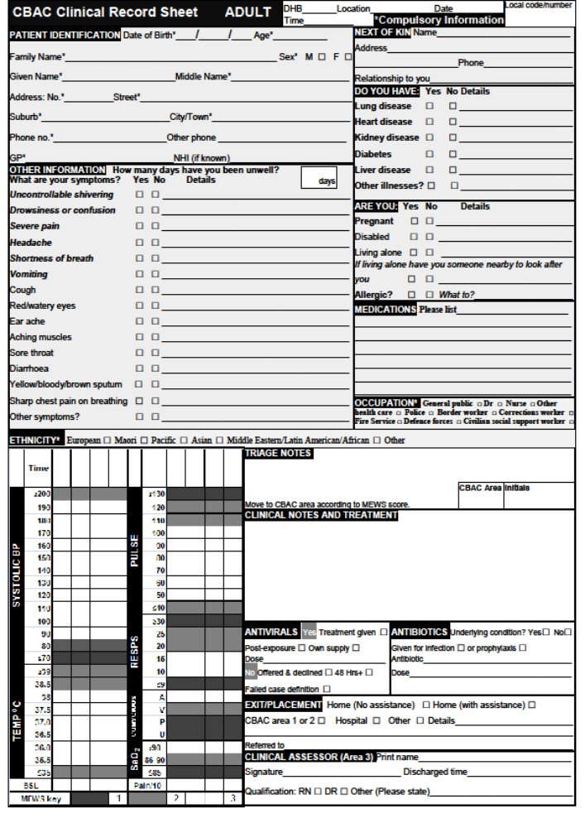
Child CAC Clinical Record

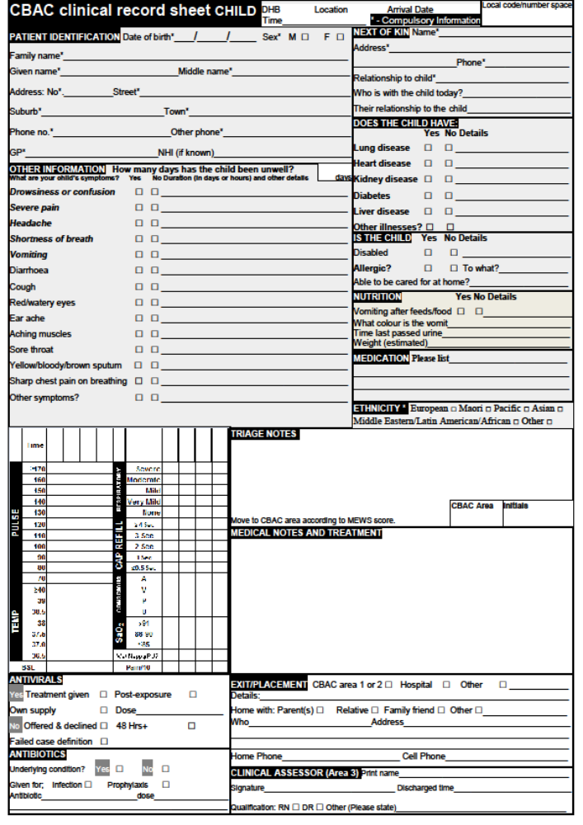


PANDEMIC INFLUENZA

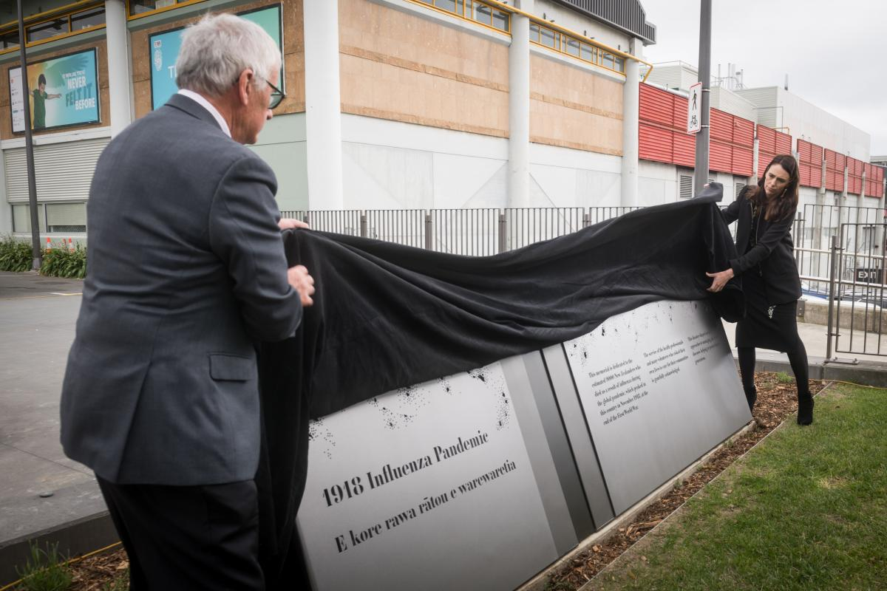

A memorial plaque remembering the estimated 9000 New Zealanders who died in the 1918 global influenza pandemic was unveiled at Pukeahu National War Memorial Park (March, 2019)

INFLUENZA

MINISTRY OF HEALTH CASE DEFINITION

Suspected case of Influenza
Person with an influenza like illness of abrupt onset, characterised by:
  - History of fever, chills and sweating; or
  - Clinically documented temperature >38 C; and
  - Cough or sore throat

Probable case of Influenza

Person with an influenza like illness who has a strong epidemiological link to a confirmed case or defined cluster.

Confirmed case
An individual for whom laboratory testing demonstrates one or more of the following:
      - positive viral culture; or
      - positive RT-PCR; or
      - four-fold rise in novel influenza virus specific neutralising antibodies.

CHECKLIST – INFLUENZA PANDEMIC STRAIN

Complete the following checklist at first contact with patient, i.e. in triage room or over the telephone.

May 2019

Yes/No
1. |  | History of fever, chills, myalgia or clinically documented fever > 38⁰C
2. |  | PLUS, two or more of the following
 |  | Headache

Malaise

Cough

Sore throat

Patients with both 1 and 2 meet the definition of influenza-like illness.

Patient Care Clinical Pathway

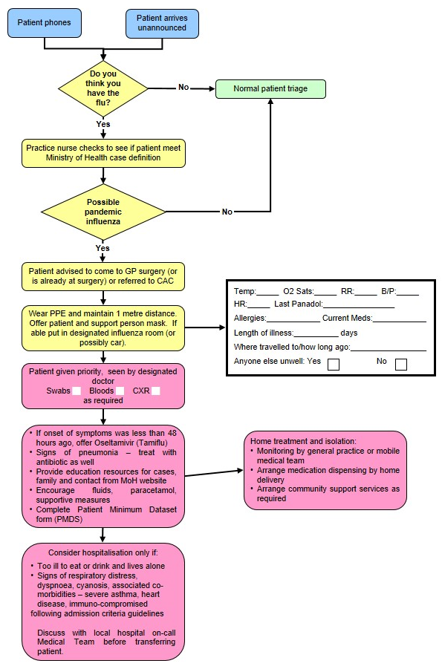
PANDEMIC MINIMUM DATA SET

Name of Practice: | Date:
Clinical Assessor: | Signature:

Name: Given | Middle | Family
Address:
House Number:
Street:
Suburb:
Town:

Gender: M / F | DOB: |  | NHI:
Ethnicity: | European | Maori | Pacific | Other

Please Circle Appropriate Codes
Category Codes |  |  | Antiviral Status Codes
GEN | General Public |  | TRT-T | Treatment provided – Tamiflu
HCN | Health Care Nurse |  | TRT-R | Treatment provided – Relenza
HCD | Health Care Doctor |  | OWN-T | Antiviral treatment from own supply - Tamiflu
HPA | Health Care Ambulance |  | OWN-R | Antiviral treatment from own supply - Relenza
HCO | Health Care Other Direct Contact |  | POP-T | Post exposure prophylaxis with Tamiflu
BOR | Border Worker |  | POP-R | Post exposure prophylaxis with Relenza
POL | Police |  | Antibiotic Codes
DEF | NZDF Member |  | NIL | No antibiotics provided
COR | Corrections Worker |  | TRT | Antibiotic treatment provided – evidence of existing respiratory bacterial infection
FIR | Fire Service Worker |  | PRO | Prophylactic/precautionary antibiotics provided because of unusual vulnerability to bacterial infection (e.g. person with COPD, CHF, asthma or other condition)
SOC | Civilian Social Support Worker |  | Antibiotic Prescribed
Treatment Rationale Codes |  |  | AUG | Augmentin
ILI | Severe influenza-like illness |  | COT | Co-Trimoxazole
HRG | High risk group |  | DOX | Doxycycline
HRI | High risk institution – MUST be discussed with the Medical Officer of Health |  | FLU | Flucloxacillin
Please fax completed form and copy of prescription to: 0800 856 923

Management of Patient with Influenza-Like Illness

Influenza-like Illness (ILI)

History of fever, chills, myalgia or clinically documented fever ≥ 38°C
and two or more of the following
Cough, sore throat, headache, malaise
High Risk Groups

People with influenza-like Illness who are at high risk of influenza-related complications:
People who are immune compromised or suppressed (transplantation, haematological and solid organ malignancy on chemotherapy/radiotherapy, HIV, autoimmune disorders, etc)
Pregnant women – discuss with infectious diseases physician
Mental health patients on Clozapine

Anyone over six months of age with chronic medical conditions, such as:
Severe or poorly controlled congestive heart failure
Severe chronic respiratory disease
More severe asthmatics (e.g. people on oral steroids, high dose steroid inhalers, or steroids and long acting beta-agonists)
Renal replacement therapy

People with influenza-like illness who live or work in residential institutions, (e.g. prisons, boarding schools, nursing homes). Please discuss with Medical Officer of Health telephone: 8341815.

Does this person meet clinical criteria for Severe ILI?
SIRS Criteria
Clinical Criteria for Severe ILI
More than one of the following:
Temperature ≥ 38°C
Heart Rate > 90
Respiratory Rate >20

Is the patient in a high risk group?
Self-manage at home.
Do not prescribe National Reserve Tamiflu or antibiotics
Fax prescription(s) to authorised pharmacy
Fax Patient Minimum Data Set form to 0800 856 923
Instruct patient or relative to collect Tamiflu
Advise to stay in isolation until well

Consider hospital assessment if patient has any of the following:

T > 39°C
SBP < 100
HR > 110
RR > 25
O² Saturation < 92
Vomiting > 1 in 24 hrs
Confusion
Rigors
Pleuritic Chest Pain
Inability to self-care
Dehydration

These criteria are not prescriptive and cannot replace clinical judgement
Yes
No
Yes
No
USE OF ANTIVIRALS

Influenza viruses develop significant resistance quickly for M2 channel blockers. In New Zealand, zanamivir is for ‘in hospital’ treatment and prophylaxis of influenza in hospitalised patients subject to restriction. Therefore, only oseltamivir (Tamiflu) will be described in detail.

First line health care workers will be using antivirals from the Governments stockpile, because the antiviral medication will be in short supply when the pandemic strikes. Te Whatu Ora (directly or through Medical Officers of Health) will be communicating guidelines, protocols, and priorities for its use.

Tamiflu might be used prophylactically for exposed travellers, containment of sporadic clusters, essential services staff and therapeutically for all patients (initially), high-risk patients, essential services staff.

Tamiflu is indicated for the treatment of influenza in adults and children 2 weeks of age and older who have been symptomatic for no more than 2 days (see section 4.4 Special warnings and precautions for use).
https://www.medsafe.govt.nz/profs/Datasheet/t/Tamiflucapsusp.pdf

Tamiflu is indicated for the prophylaxis of influenza in adults and children >1 years of age. Vaccination is the preferred method of routine prophylaxis against infection with influenza virus.

Presentation

Tamiflu 30 mg hard capsules
Tamiflu 45 mg hard capsules
Tamiflu 75 mg hard capsules

Tamiflu 6mg/ml powder for oral suspension

Dosage and Method of Administration

Tamiflu may be taken with or without food. However, Tamiflu taken with food may enhance tolerability in some patients.

Standard Dosage

Treatment of influenza

Treatment should begin within the first 48 hours of the onset of symptoms of influenza.

Adults and adolescents
The recommended oral dose of Tamiflu capsules in adults and adolescents ≥ 13 years is a 75mg capsule twice daily, for 5 days. Adults and adolescents ≥ 13 years of age that are unable to swallow capsules may receive a dose of 75mg Tamiflu suspension BD for 5 days.

Infants and Children ≥1 to < 13 years of age
Infants and children 1 year old may receive the required Tamiflu dose in the form of capsules. Patients unable to swallow capsules may receive the appropriate dose of Tamiflu oral suspension, see Patients unable to swallow capsules).
The recommended weight adjusted dosing regimens of Tamiflu for children ≥ 1 year of age are:

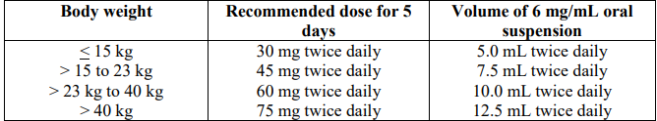

Infants 2 weeks to < 1 year of age.
The recommended oral dose of Tamiflu for infants 2 weeks to less than 1 year of age is 3 mg/kg twice daily, for 5 days. These dosing recommendations are not intended for infants who have a post conceptual age of less than 36 weeks.

Special dosage instructions
No dose adjustment is necessary for patients with creatinine clearance above 60mL/minute. In patients with creatinine clearance between 10 and 30mL/minute receiving Tamiflu it is recommended that the dose be reduced to 75mg of Tamiflu every other day or 30mg suspension every day. No dosing recommendation is available for patients undergoing routine haemodialysis and continuous peritoneal dialysis with end stage renal disease and for patients with creatinine clearance ≤ 10mL/minute.

No dose adjustment is required for patients with hepatic dysfunction and no dose adjustment is required for elderly patients.

The safety and efficacy of Tamiflu in children under 1 year has not been established. Tamiflu should not be used in children under 1 year of age.

A bottle of 30g Tamiflu powder for oral suspension contains 25.713g of sorbitol. One dose of 45mg oseltamivir administered twice daily delivers 2.6g of sorbitol. For subjects with hereditary fructose intolerance this is above the recommended daily maximum limit of sorbitol.

Prophylaxis of influenza

The recommended oral dose of Tamiflu for prophylaxis of influenza is 75mg once daily for at least 10 days. Therapy should begin within two days of exposure.

Contraindications

Hypersensitivity to oseltamivir phosphate or any component of the product.

Information derived from pharmacology and pharmacokinetic studies of oseltamivir suggest that clinically significant interactions with other medicines are unlikely.

At present, insufficient data are available in pregnant women taking Tamiflu to enable an evaluation of the potential for oseltamivir cause foetal malformations or foetal toxicity. Tamiflu should therefore be used during pregnancy only if the potential benefit justifies the potential risk to the foetus.

https://www.medsafe.govt.nz/profs/Datasheet/t/Tamiflucapsusp.pdf

INFORMATION ON TAMIFLU

How effective is the anti-viral medicine Tamiflu against influenza?

Tamiflu is one of two medicines that are effective against the strains of Influenza A and B.

The WHO have advised all health authorities to stockpile anti-viral medicines to prepare for a pandemic. New Zealand has followed that advice.

Will Tamiflu cure people sick with the Pandemic Influenza virus?

We don't know for sure.

When people have seasonal influenza, Tamiflu reduces symptoms and may shorten the duration of illness by a day and a half.

If otherwise healthy people who are ill with influenza take it, they are less likely to develop complications of influenza. Those complications are usually treated with antibiotics.

Does Tamiflu prevent people from getting influenza?

Yes, it does, but it is not the best means of preventing influenza. Vaccination is the best protection against influenza, which is why people are encouraged to immunise against seasonal influenza every year. Tamiflu will help until a pandemic vaccine arrives.

For more information on Tamiflu, including how it works against influenza, see the datasheet, http://www.medsafe.govt.nz/profs/datasheet/+/Tamiflucapsusp.pdf.

How does Tamiflu work?

It is a medicine that only works against influenza viruses A and B.

It does not work against other viruses or bacteria that can cause illness similar to influenza or that can cause respiratory infection. If taken within 48 hours of becoming ill it stops the virus from bursting out of infected cells, infecting new cells and possibly other people.

Will masks help protect me and my family from the influenza virus?

A surgical mask, if put on someone who is sick, will help reduce the spread of infection, because it will reduce the amount of virus spread by coughs and sneezes.

People who are not sick and who are very close to the person who is coughing and sneezing - closer than 1 metre - may get some protection by covering their own nose and mouth with a mask. Again, this is because the mask will catch some of the virus in the cough and sneeze droplets.

What about interactions between Tamiflu and other drugs I am taking?

There are no significant interactions known.

Side effects
Most people taking Tamiflu experience no side effects. A small proportion will experience one or more of the following:

Common | Less commonly
Nausea 8-10%  Vomiting 2-8%  Headache 2-17%  Diarrhoea  Abdominal pain 1-4 %  Dyspepsia  Conjunctivitis | Eczema  Rash  Convulsions  Arrhythmias  Altered consciousness  (usually in children or adolescents)

INFORMATION ON QUARANTINE (HOME ISOLATION) FOR INFLUENZA

You have been asked to stay in isolation because:

- You have suspected influenza and are infectious to others. Isolation in your home should continue for 72 hours after starting Tamiflu or 7 days from the onset of illness if you are not taking Tamiflu.

- You may have been exposed to influenza. Isolation in your home should continue for 72 hours after starting Tamiflu or 7 days from the onset of illness if you are not taking Tamiflu.

The period of isolation may be lengthened if somebody else in your household becomes sick with suspected influenza.

We want you to restrict your activities to protect the safety of your family, friends and the community. This information sheet is to tell you what isolation means.

Staying at home

You must not go to school, work, child care or out in public until cleared by the Public Health Nurse. This means you must not attend shopping centres, movies, parties or any social gatherings at all.

Visitors

You should have no visitors until you come out of isolation. Talk by phone and have things delivered to the door. Sometimes a visitor is essential (for example someone has to come into the house to give you essential home support). The visit should be brief. You and the visitor must both wear a mask. Talk with the visitor outside in the open air if possible and keep at least two metres away from them.

Preventing the spread of infection

- Stay in a part of the house where you have minimal contact with other people. Try to keep well people and sick people apart.
- Give people who have a fever and/or diarrhoea plenty to drink.
- Give Paracetamol for fever. Do not give Aspirin to children under 12 if they have a fever.
- Open doors and windows and ventilate the house as much as possible.
- Cover your mouth and nose with a tissue or toilet paper when you are coughing or sneezing. Put the used tissue straight into a rubbish container. Wash and dry your hands afterwards.
- Wash and dry your hands after you use the bathroom or toilet. Wash and dry your hands before you prepare food and eat, and when you are looking after sick people.
- If you have more than one toilet, then one should be reserved for use by sick people.
- Twice a day clean the following:
- with 1-part household bleach to 10 parts water:
- toilet handle and door handles of toilet, bathroom and rooms of isolated people
- bathroom sink and taps
- Nobody else should use anything that could be contaminated with your throat or nose secretions or coughing or faeces – e.g. towels, handkerchiefs, eating utensils, food, bed linen, cigarettes, marijuana joints, P pipes, kava bowls.
- Sharing bedding, clothing and utensils may spread infection, but you do not need to wash a sick person’s bedding, clothing and utensils separately from the rest of the families. If you wash and dry all these things in the usual way they will then be safe for others to use.
Using face masks

- Sick people should wear a surgical mask if anyone is in their room and if they have to leave their room.
- People who are in quarantine but not sick should wear a particulate respirator (N95) mask if they are in the same room as a sick person.
- Essential visitors to the house should wear a particulate respirator (N95) mask through their visit.

Used masks should be put in the normal household rubbish.

Coming out of isolation

You will receive notification when you are cleared to come out of isolation. At that time, you will be non-infectious to others. It will then be safe for you to resume your normal life.

Questions

Your Public Health Nurse, general practice or Healthline will be happy to answer any questions.

COVID-19

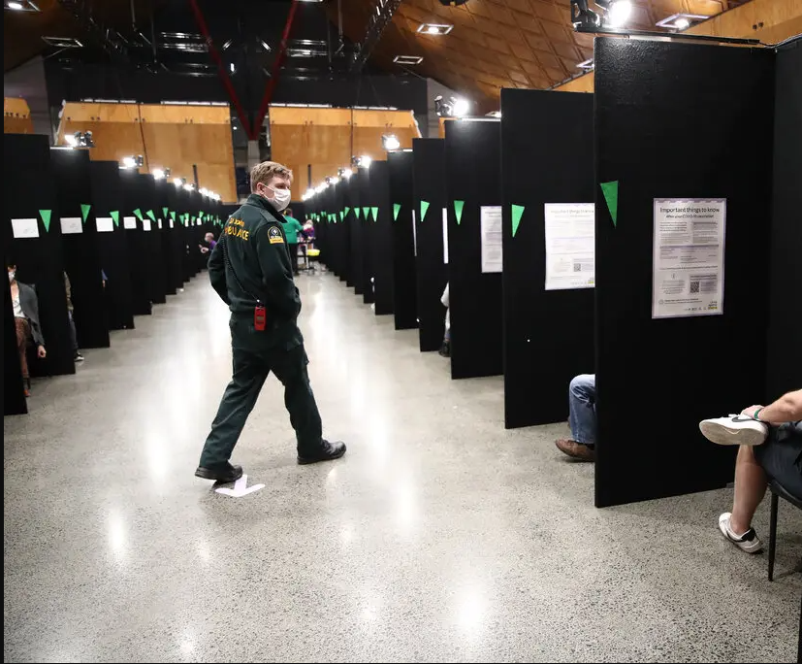

COVID-19 MINISTRY OF HEALTH CASE DEFINITION (2022)

Confirmed case

A case that has laboratory definitive evidence.
Laboratory definitive evidence requires at least one of the following:
- detection of SARS-CoV-2 from a clinical specimen using a validated NAAT (PCR). Very weak positive results will only be labelled a confirmed case when the result is confirmed on a second sample.
- detection of coronavirus from a clinical specimen using pan-coronavirus NAAT (PCR) and confirmation as SARS-CoV-2 by sequencing
- significant rise in IgG antibody level to SARS-CoV-2 between paired sera
- detection of SARS-CoV-2 from a clinical specimen using a validated laboratory multi-target NAAT (PCR) OR a validated single target point of care NAAT (PCR) test

Probable case
A close contact of a confirmed case that has a high exposure history, meets the clinical criteria and for whom testing cannot be performed, or
A close contact of a confirmed case that has a high exposure history, meets the clinical criteria, and has a negative PCR result but it has been more than 7 days since symptom onset before their first negative PCR test was taken.
An individual with a positive result from a clinical specimen using a certified rapid antigen test (RAT), either supervised or self-tested who
- Has symptoms consistent with COVID-19 OR
- Is a close contact of a confirmed or positive case OR
- Is asymptomatic (in phase 3 only)

Historical case

A confirmed case that is deemed to have recovered (no longer considered infectious) at the time of testing or a person with a positive NAAT(PCR) result with a high CT value, which is followed by a negative rapid antigen test (RAT).

Under investigation case

A case that has been notified where information is not yet available to classify it as confirmed, probable or not a case.

Not a case

An ‘under investigation’ case who:
- has a negative test and has been assessed as not a case;
- a person where SARS-CoV-2 has been detected, where the detection is determined to be due to a previous COVID-19 infection which has already been recorded either in New Zealand or overseas within the previous 28 days from release.
- a person who has detection of SARS-CoV-2 from a clinical specimen but, following further investigations such as serology, repeat testing, history, and symptoms, they are deemed to not be a case (e.g. a likely false positive).

CLINICAL CRITERIA FOR COVID-19

The clinical criteria support health professionals to identify those with a higher risk of having COVID-19.

Common symptoms of COVID-19 infection are similar to other viral illnesses such as colds and influenza.

COVID-19 positive persons usually present with at least one of the following symptoms:

- new or worsening cough
- sneezing or runny nose
- fever
- temporary loss of smell or altered sense of taste
- sore throat
- shortness of breath
- fatigue/feeling of tiredness

Less common symptoms may include diarrhoea, headache, muscle aches, nausea, vomiting, malaise, chest pain, abdominal pain, joint pain or confusion/irritability.

Symptoms tend to arise around two to five days after a person has been infected but can take up to 14 days to appear. The virus can be passed to others from up to two days before symptoms develop.

Other conditions that require urgent assessment and management should always be considered as possible diagnoses alongside COVID-19.

https://www.health.govt.nz/system/files/documents/pages/primary_care_quick_reference_guide_june_2022.pdf

HB COVID-19 PANDEMIC DATA SET (as at September 2022)

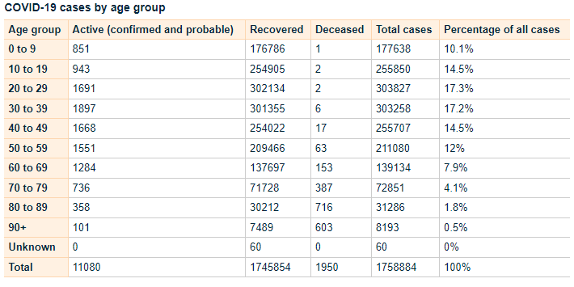
https://www.health.govt.nz/covid-19-novel-coronavirus/covid-19-data-and-statistics/covid-19-case-demographics#all-cases

Testing Guidance COVID-19

https://www.health.govt.nz/system/files/documents/pages/testing_operational_guidance_for_general_practice_10_march_2022.pdf

COVID-19 Care in the Community Framework (2022)

https://www.health.govt.nz/system/files/documents/pages/covid-19-care_in-the-community-framework-25aug22.pdf

HAWKE’S BAY COVID-19 CO-ORDINATION SYSTEM

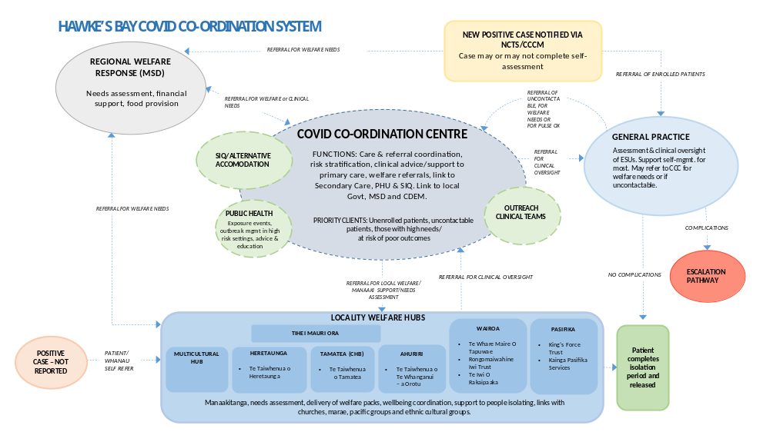
Patient Management Pathway

Assessment and Definition | Severity | Mild |  | Moderate |  | Severe/Critical
Assessment and Definition | Clinical definition | No symptoms | Any COVID symptoms without features of pneumonitis | A clinically stable patient with any evidence of COVID-19 pneumonitis:  - New onset (or worsening) shortness of breath OR  - Infiltrates on plain chest radiograph OR  - Hypoxaemia that is EITHER: |  | Any of the following:  - Requiring CPAP or high-flow nasal oxygen to maintain saturation ≥ 92% OR  - Acute respiratory distress e.g. RR >30 OR  - Rapidly deteriorating clinical trajectory | Any of the following:  - Requiring mechanical ventilation to maintain saturation ≥ 92% OR  - Requiring advanced circulatory support
 |  |  |  | ...mild (92-94%), transient, or exercise-induced only (i.e. not requiring continuous oxygen therapy OR | …sustained but able to maintain ≥ 92% (≥90% for patients with chronic lung disease) with up to 4L/minute oxygen via standard nasal cannula
Assessment and Definition | Stage of infection | Almost all cases in the first 5 days; throughout in most vaccinated patients without risk factors |  | Progression to moderate/severe disease most commonly develops ~ 5-7 days post onset of illness in patients with significant risk factors; the trajectory of deterioration can sometimes be rapid
Assessment and Definition | Site of care | Community |  | Individual decision | Hospital
 | Anti-viral therapy | Paxlovid OR Remdesivir OR Molnupiravir  If <5 days illness AND meets high risk criteria |  |  | Consider Remdesivir if <7days illness |  | Nil
Therapeutics | Respiratory support | Nil |  |  | Oxygen via NP | CPAP (or HFNO) | Mechanical ventilation
Therapeutics | VTE prophylaxis | Nil | Low dose Enoxaparin  if hospitalised |  | Low dose Enoxaparin  (or consider therapeutic dose) | Low dose Enoxaparin
Therapeutics | Corticosteroids | Nil | Consider inhaled Budesonide  if meets high risk criteria |  | Dexamethasone
Therapeutics | Immune modulation | Nil |  |  | Baricitinib or Tocilizumab |  | Tocilizumab
 | Antibody therapy | Nil

ANTIVIRAL THERAPY

Taking antiviral medicines to treat COVID-19

COVID-19 antiviral medicines are available to treat eligible people with COVID-19 at home. COVID-19 medicines must be commenced within the first five days of the onset of COVID-19 symptoms. When taken early in COVID-19 illness, these medicines have been proven to reduce hospitalisation and death.

These medicines are free for eligible people with COVID-19 within five days of their symptoms starting. If eligible, persons may get a prescription from their usual healthcare provider, or the medicine may be supplied without a prescription from some pharmacies.

Eligibility for COVID-19 medicines

People with a high risk of severe illness from COVID-19 are eligible for treatment with COVID-19 medicines.

To be eligible for COVID-19 antiviral medicine the consumer must:
- have symptoms and have tested positive for COVID-19 or
- have symptoms and be a household contact of a person with COVID-19

One of the following must also apply:
- a severely weakened immune system
- Down syndrome
- sickle cell disease
- aged 75 years or older
- previously been admitted to an intensive care unit as a result of COVID-19 and have tested positive again

Persons may also be eligible if they meet two or more of the below criteria:
- high-risk medical conditions
- over 50 years of age
- of Māori or Pacific Island ethnicity
- not vaccinated for COVID-19, or are not up to date with COVID-19 vaccinations

Please note: These medicines may not be suitable for everyone, even if they meet eligibility criteria.
More information about eligibility can be found on the Pharmac website, including its access criteria assessment tool.
Te Whatu Ora has developed an Eligibility Guide for COVID-19 antiviral medicines:

https://www.health.govt.nz/system/files/documents/pages/eligibility-guide-for-covid-19-oral-antiviral-meds-12aug22.pdf

Types of COVID-19 medicines available

Three COVID-19 antiviral medicines are available to treat eligible people with COVID-19 in the community:
Nirmatrelvir with ritonavir (branded as Paxlovid)
Molnupiravir (branded as Lagevrio)
Remdesivir, an infusion treatment (branded as Veklury).

For more information see the following links:

Paxlovid
https://www.healthnavigator.org.nz/paxlovid/
https://www.medsafe.govt.nz/profs/Datasheet/p/paxlovidtab.pdf

Lagevrio
https://www.healthnavigator.org.nz/medicines/m/molnupiravir/
https://www.medsafe.govt.nz/profs/datasheet/l/lagevirocap.pdf

Remdesivir
https://www.healthnavigator.org.nz/medicines/r/remdesivir/
https://www.medsafe.govt.nz/COVID-19/treatment-applications.asp

https://www.health.govt.nz/covid-19-novel-coronavirus/covid-19-health-advice-public/advice-people-covid-19/covid-19-medicines

Return of Symptoms Following Paxlovid Treatment

For some people, symptoms may return after completing a course of Paxlovid. This is known as Paxlovid rebound.

People experiencing Paxlovid rebound do not appear to get severely ill. Symptoms are usually mild and typically resolve within three days.

It is normal for some people recovering from COVID-19 to have symptoms that come and go for some time, regardless of whether they have taken antiviral medicines.

Patients should stay home and recover until 24 hours after they no longer have symptoms if:

- their symptoms returned after finishing the five-day course of Paxlovid
- and it’s 28 days or less since their first symptoms appeared or they tested positive

There is no need to take another course of Paxlovid if symptoms return during this time.

COVID VARIANTS OF CONCERN

There is a high likelihood that a new COVID-19 Variant of Concern will emerge within weeks or months. The timeframe and clinical impacts of these variants is not clear, but it is important that we prepare for new, more severe variants that could emerge.

On 30 March 2022, the World Health Organization (WHO) released its Strategic Preparedness, Readiness and Response Plan to End the Global COVID-19 Emergency in 2022. It sets out key strategic adjustments that, if implemented rapidly and consistently at national, regional, and global levels, will enable the world to end the acute phase of the pandemic.
The capacity and adjustments necessary to end the acute phase of the COVID-19 pandemic can and should lay the foundations for a future in which the world is prepared to prevent, detect, and respond to pandemic threats.

To support Government preparedness and response efforts, the Ministry of Health (the Ministry) has developed Aotearoa New Zealand’s Strategic Framework for COVID-19 Variants of Concern (the Strategic Framework), which builds on the plans and enabling systems that have held the Ministry in good stead over the last two years. It identifies the contextual factors, range of indicators, and baseline and response measures required to ensure that we are prepared to respond to the emergence of a new variant of concern.

Variant Scenarios

Five scenarios have been developed to inform the potential range of responses that may be required. There may be particular viral characteristics that may change, and any decisions are likely to be made before a detailed evidence base is formed.

The scenarios are based on evidence on the likely characteristics of new variants and their characteristics, including research into similar scenarios that other countries have used, and have been externally reviewed by the COVID-19 Technical Advisory Group and the Strategic Public Health Advisory Group. They have also been considered by the COVID-19 Independent Continuous Review, Improvement and Advice Group as part of engagement.

The scenarios range from high clinical severity and high immune escape to low clinical severity and low immune escape, and a scenario that includes co-circulating diseases. All scenarios assume a variant that is able to out-compete Omicron BA2 because it is more transmissible.

The variant scenarios are:

- High clinical severity, high immune evasion: similar to Omicron but with greater severity. Therapeutics, vaccines and/or prior infection may not work or protect well.
- Low clinical severity high immune evasion: similar to Omicron. Therapeutics and vaccines may not be effective at controlling spread or symptoms, but hospitalisation rates remain manageable.
- High clinical severity, low immune evasion: the virus is highly transmissible with high case numbers, but current effective immunity and vaccination is protective for most.
- Low clinical severity, low immune evasion: the virus has enough transmissibility to create a high case load, but current effective immunity is protective and what disease there is, is milder than experienced in previous waves. Effective treatments are available for vulnerable populations.
- Multiple co-circulating variants of concern with different levels of virulence and severity and different levels of cross-protection, as we see with influenza. This scenario potentially draws features from the other scenarios.

For reference, all the hypothetical scenarios are compared to the current Omicron planning scenario. For further information please click on the following link.

https://www.health.govt.nz/system/files/documents/pages/220601_final_summary_of_voc_sf_for_cabinet_paper_21_june.pdf

STAYING AT HOME, PATIENT INFORMATION

If you have been advised to stay at home after a test, you should do so until you receive a negative test result.

If someone in your household or bubble is a Close Contact and they develop symptoms, it is recommended that you (regardless of whether you are vaccinated or unvaccinated) stay at home until the Close Contact returns a negative test (taken after their symptoms started).

If you develop symptoms, you should get a test and stay at home (or in your current accommodation) until you receive a negative test result and until 24 hours after your symptoms resolve.

What it means to stay at home:

- If you have symptoms, stay away from your household members if possible.
- You should not go to work or school. If you are unable to work from home while awaiting COVID-19 test results, a short-term payment may be available to your employer (or you, if you are self-employed) to help support you. For more information visit the Work and Income website.
- It is important that you do not use public transport, taxis or similar transport methods.
- You should not have any visitors in your home (including tradespeople).
- Where possible, ask friends or family to shop for you. If this isn’t possible, order supplies online. Make sure any deliveries are left outside your home for you to collect. If you need assistance, the Ministry of Social Development has information about where you can go for services and support, what you can get help with, and contact information. Visit the Ministry of Social Development website.
- If you need medical assistance, call ahead to your health provider. Clean your hands with hand gel and put on a face mask before you enter any health care facility.

https://www.health.govt.nz/covid-19-novel-coronavirus/covid-19-health-advice-public/covid-19-staying-home

OTHER USEFUL LINKS MoH

Epidemic Notice and Orders
https://www.health.govt.nz/covid-19-novel-coronavirus/covid-19-response-planning/covid-19-epidemic-notice-and-orders

Community Response Framework
https://www.health.govt.nz/covid-19-novel-coronavirus/covid-19-response-planning/covid-19-community-response-framework

For more information see the MoH Website.

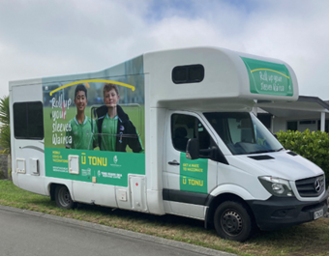

Community Outreach Service Pandemic Response

INTRODUCTION

The primary purpose of this plan is to outline the service required to support those individuals who are identified as being homebound or unable to access health service through the appropriate Patient Management Pathway.

Identification will occur via hospital, Community Assessment Centre (CAC), General Practitioner or community welfare hubs.

Patients will be triaged via phone and the call details logged to the appropriate geographical area. The call sheets will then be given to the Coordinator covering the outreach service and passed on to the team covering that particular area.

Patients who are homebound will need to be visited and assessed by a registered nurse following infection prevention and control procedure.

This plan will attempt to provide a broad base from which the Community Outreach Service will deliver services.

FUNCTION

The identification, diagnosis, assessment, care planning, delivery, and monitoring of a patient’s condition within the home setting.

Liaison with medical staff, nursing staff, and other community-based agencies will be required, depending on each individual situation and on the needs required by that individual or family.

As outlined in the Patient Care Clinical Pathway, individuals who require home isolation and treatment will need:

- Monitoring by CAC or by outreach mobile medical team
- Dispensing of medication by home delivery and
- Community support services arranged as required

WORKFORCE DEVELOPMENT

Overall leadership will be from the Public Health Service.

- Recruitment of staff - from all health disciplines. May include Iwi Providers, NGO’s, and Occupational Health Nurses.

- Training / Education - Resources used may include face to face and online training for relevant staff.

Training will focus on key principles of:
- Infection prevention and control / epidemiology
- Ability to manage in high pressure situations
- Communication
- Adaptability
- Confidentiality
- Professional safety
- Home visiting procedure
- Dispensing of medication / Standing Orders
- Self-care

- Mentoring - experienced Public Health staff will work alongside new staff for orientation until confident.

- Rostering - there will be a need for flexibility, with regular breaks. Staff will be encouraged to monitor their own and colleague’s health. A buddy-up system will be utilized after hours and during the night.

WORK ALLOCATION

Community Outreach Teams

Will be attached to each CAC and consist of:

- A medical practitioner - a General Practitioner or locum GP who has the capacity to be rostered outside of their regular practice.
This position is responsible for providing medical support and advice to the nursing staff in the outreach teams.
- Registered nurses – Practice Nurses, Public Health Nurses, District Nurses or any other registered nurses or agency nurses ideally with community experience.
- Community support workers - Public Health staff currently working in this position, Health Protection Officers, nursing students and any volunteers with previous health care experience. These individuals will support the Registered Nurses and be responsible for restocking and packing of equipment.
- Clerical Support - phone work, database management, general clerical duties.
- Phone workers - for daily follow up calls to identified clients (may be Registered Nurses or Community Support Workers).

A Coordinator will identify the number of nurses and community support workers required. This will be determined based on need and availability of staff. The requirements will be assessed regularly.

Each mobile team will be allocated a geographical area to manage.

Each team may have four to five registered nurses and two community support workers, but this is flexible and would need to be altered accordingly.

Each nurse would be able to manage approximately 7-14 home visits per shift (based on a maximum of 30 minutes per visit over an 8.5 hour shift). This is allowing for travel and 30 minutes for break times and the refurbishment of equipment and administration at the end of the shift.

After hours, it is expected that the field workers will work in pairs to ensure safety.

OPERATIONAL PROCEEDURE FOR HOME VISITING

Home visits will be in response to logged calls for the identified geographical area.

- Initial assessment will be performed by a Registered Nurse

Any complicating factors identified during assessment to be referred to the Medical Practitioner for further advice and review.

- Administer antiviral medicines as necessary according to standing orders. Provide a patient information sheet as required.

- Provide information on Quarantine (Home Isolation) information and ensure understanding.

- Assess need for welfare support and refer where needed to CDEM Welfare Coordinating Group.

- Provide household with details for further follow up contact should the need arise (if condition worsens, or other complications occur).

Necessary equipment:

- Vehicles (one per visiting nurse or community support worker on shift)
- Mobile phones (one per vehicle)
- List of contact numbers
- Maps, appropriate to geographical
- Documentation – Assessment sheet
Patient notes / progress forms
Phone follow up sheet
CDEM welfare referral forms
Information sheets – Antiviral medicines
Home Quarantine
Contact details
Death Certificates
- Clinical equipment - PPE kits
Disposable thermometers
Stethoscopes
Antiseptic hand gel
Biohazard bags
- Medication – Antiviral medicines
Paracetamol

Resources and Administration

Clerical support will be required to be responsible for:

- development and maintenance of a database system
- providing copies of all documentation needed by teams
- sending referrals to the appropriate individuals or agencies
- additional duties (as they are identified)

Phone workers (either Registered Nurses or Community Support Workers) will have the responsibility of daily calls to households needing follow up. They may identify that a repeat home visit and assessment is necessary and this will then be referred back to the outreach mobile team.

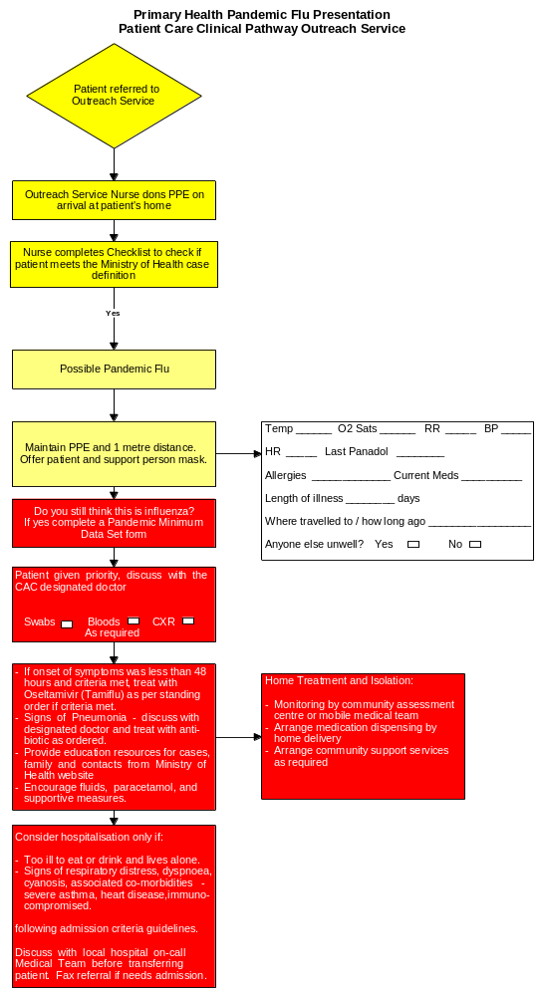

PANDEMIC MINIMUM DATA SET

Name of Practice: | Date:
Clinical Assessor: | Signature:

Name: Given | Middle | Family
Address:
House Number:
Street:
Suburb:
Town:

Gender: M / F | DOB: |  | NHI:
Ethnicity: | European | Maori | Pacific | Other

Please Circle Appropriate Codes
Category Codes |  |  | Antiviral Status Codes
GEN | General Public |  | TRT-T | Treatment provided – Tamiflu
HCN | Health Care Nurse |  | TRT-R | Treatment provided – Relenza
HCD | Health Care Doctor |  | OWN-T | Antiviral treatment from own supply - Tamiflu
HPA | Health Care Ambulance |  | OWN-R | Antiviral treatment from own supply - Relenza
HCO | Health Care Other Direct Contact |  | POP-T | Post exposure prophylaxis with Tamiflu
BOR | Border Worker |  | POP-R | Post exposure prophylaxis with Relenza
POL | Police |  | Antibiotic Codes
DEF | NZDF Member |  | NIL | No antibiotics provided
COR | Corrections Worker |  | TRT | Antibiotic treatment provided – evidence of existing respiratory bacterial infection
FIR | Fire Service Worker |  | PRO | Prophylactic/precautionary antibiotics provided because of unusual vulnerability to bacterial infection (e.g. person with COPD, CHF, asthma or other condition)
SOC | Civilian Social Support Worker |  | Antibiotic Prescribed
Treatment Rationale Codes |  |  | AUG | Augmentin
ILI | Severe influenza-like illness |  | COT | Co-Trimoxazole
HRG | High risk group |  | DOX | Doxycycline
HRI | High risk institution – MUST be discussed with the Medical Officer of Health |  | FLU | Flucloxacillin
Please fax completed form and copy of prescription to: 0800 856 923

PANDEMIC OUTREACH NURSING ASSESSMENT

Current Number of Household Members: | Number in Household Unwell:
Surname:
First Names: | DOB:
Street Address: | UR No.
Suburb:
City:
Phone Numbers:  Home:____________________________  Mobile:___________________________  Contact Number:____________________ | Ethnicity:  NZ European  Pacific Island |  |  | Maori  Other
GP: | Language Spoken:
SYMPTOMS  How many days have you been unwell?  Have you had? (Please tick boxes)  - Fever or chills YES □ NO □  - Cough YES □ NO □  - Sore throat YES □ NO □  - Aching muscles YES □ NO □  - Headache YES □ NO □ Red, watery eyes YES □ NO □ Diarrhoea YES □ NO □  - Earache YES □ NO □  - Vomiting YES □ NO □  - Confusion or drowsiness YES □ NO □  - Shortness of breath YES □ NO □  - Sharp chest pain on breathing YES □ NO □  - Yellow, bloody or brown phlegm (spit) YES □ NO □  - Any other symptoms ………………………….……  ………………………………………………………………… | OTHER INFORMATION  Are you over 65 years old? YES □ NO □  Are you pregnant? YES □ NO □  Do you have?  Chronic lung disease (e.g. asthma, COPD) YES □ NO □  Heart disease YES □ NO □  Kidney disease YES □ NO □  Diabetes YES □ NO □  Liver disease YES □ NO □ Other conditions? YES □ NO □  Details …………………………………………………………  Are you on regular medications? YES □ NO □  Allergic to antibiotics? YES □ NO □  Details …………………………............................................  Do you live alone? YES □ NO □  Have you family or friends nearby  to look after you? YES □ NO □  Do you have a disability? YES □ NO □  Details ………………………………………………………….
Tamiflu Prescribed (if onset less than 48 hours and criteria met): Yes No

Information sheets given: Tamiflu Yes No

Home Quarantine Yes No

Welfare Needs:
Referral to CDEM Welfare Advisory Group: Yes No

Requires follow up Home Hospital

Details: ______________________________________________________________________

Signature: | Date:

Date:
Temperature:
Pulse:
Respirations:
Blood Pressure:

PANDEMIC OUTREACH SERVICE PROGRESS NOTES

Surname: | DOB:
First Names: | UR No.

Date |  | Signed

WELFARE SUPPORT REQUEST
PANDEMIC OUTREACH SERVICE

Referral To: Civil Defence Emergency Management Welfare Coordinating Group

Please assess for Welfare Support
Client Details:
Name: ……………………..………………………………………………………………………………………………………………………
Address: ………...……………………………………………………………………………...……………………………………………….
…………………………………………………………………………………………………….....................................................
Phone numbers: ……………………………………………………………………………………………………………………………….
Ethnicity: …………………………………………………………………………………………………………………………………………
Language Spoken: ……………………………………………………………………………………………………………………………
Caregiver-Name & Relationship to Client: ……………………………………………………………………………………………
……………………………………………………………………………………………………………………………………………………….
Reason for Referral:
……………………………………………………………………………………………………...……………………………………………….
……………………………………………………………………………………………………...……………………………………………….
……………………………………………………………………………………………………...……………………………………………….
……………………………………………………………………………………………………...……………………………………………….

Whanau/Social Situation: ……………………………………………………………………………………………………...……………………………………………….
……………………………………………………………………………………………………...……………………………………………….
……………………………………………………………………………………………………...……………………………………………….
Number in house: …………………………………………………………………………………………………………………………….
Ages of family members: …………………………………………………………………………………………………………………..

Name/Details of Referrer: ………………………………………… Date: …………………………………………………….
……………………………………………………………………………………………………...……………………………………………….

PHONE CALL LOG SHEET - PANDEMIC OUTREACH SERVICE

Date: |  | Time:
Surname:
First Names: |  | DOB:
Street Address: |  | UR No.
Suburb:
City:
Phone Numbers: |  | Ethnicity:  NZ European  Maori  Pacific Island  Other
Home:
Mobile:
Contact Number:
Details of Call:
___________________________________________________________________________
___________________________________________________________________________
___________________________________________________________________________
____________________________________________________________________________

Follow up Required? Yes No

If yes, what?
1. Phone call Date due: _______________ Time due: _______________
2. Home visit Within 24 hours Within 48 hours

Referred to Outreach coordinator for above follow up? Yes No

Signature: | Date: |  | Time:
Area Code:
(will be systems-based across geographical area & relate to Outreach team for that area)

GLOSSARY

E.I.D
Emerging Infectious Disease

Endemic
(of a disease) persisting in a population or region, generally having settled to a relatively constant rate of occurrence

I.L.I
Influenza like Illness

Novel
A new strain that has not previously been identified in humans, new and not resembling something formerly known

Pandemic
(of a disease) prevalent throughout an entire country, continent or the whole world: epidemic over a large area

Sitrep
Situation Report

Zoonotic
Any disease of animals communicable to humans

Communication
Plan

PANDEMIC
COMMUNICATION PLAN

CONTENTS

- Aim
- Objectives
- Stages
- Key Linkages
- CIMS Structure and Role of Communications Officer
- Key Messages
- Communication Channels
- Main Audience (people who are directly affected by the pandemic)
- Partners (organisations and agencies that have a direct role in the pandemic health response)
- Stakeholders (people who have an interest in the pandemic response or are closely related to the Main Audience)
- Spokespersons
- Resources required
- Communication surveillance and post-event evaluation

1. AIM OF TE WHATU ORA HAWKE’S BAY PANDEMIC COMMUNICATION PLAN

To guide appropriate public participation in order to reduce morbidity and mortality from a pandemic virus, while at the same time building trust and credibility with partners, stakeholders and the general public.

Potentially every New Zealander has an interest in this issue. This communications plan attempts to identify them in broad groups, noting that some audiences will become important channels for further information dissemination.

Timely, informative and accurate communication during all phases of a pandemic is critical for an effective emergency response operation. Dissemination and sharing of information among public health officials, government officials, medical care providers, the media and the general public will be one of the most important facets of the pandemic response.

Discrete objectives/audiences/initiatives/key messages will be developed for each of the identified phases.

It is likely there will be widespread circulation of conflicting information, misinformation and rumours. Communication must be coordinated among all relevant agencies to ensure consistent messages to the general public.

There will be a great demand for accurate and timely information regarding:

  - Circulation of a pandemic strain
  - Disease burden
  - Disease complications and mortality
  - Disease control efforts, including availability and use of vaccines, antivirals and other preventive and treatment measures
  - "Do's and Don'ts" for the general public
  - Maintenance of essential community services

There will be a special need for information for the general public and our staff about how and why a priority group list for receipt of vaccine was developed.

Public education will be an important part of the immunisation campaign because, as in a mass immunisation with any vaccine, it is likely that following problems will be encountered:

- any symptom or illness that closely follows vaccination may be attributed to the vaccine, and
- any febrile respiratory illness that later occurs will be viewed as vaccine failure.

Certain groups will be hard to reach, including people whose primary language is not English, people who are hearing and visually impaired.

Demand for information by health care providers will be so great that existing methods for educating health care providers will have to be expanded during the inter-pandemic period.

2. OBJECTIVES OF TE WHATU ORA HAWKE’S BAY PANDEMIC COMMUNICATION PLAN

- Providing accurate, timely, accessible, consistent and appropriate information to the general public, “partners” and “stakeholders” about pandemic influenza and the ways that people can protect and look after themselves.
- Working closely with Te Whatu Ora Hawke’s Bay and its media team.
- Raise awareness of potential consequences of a pandemic.
- Ensure Hawke’s Bay people have clear information about how to prepare themselves and their families / whanau for a pandemic, and where to get help.
- Work closely with agencies identified in the Hawke’s Bay and the Regional Emergency Management Plan using the CIMS structure.
- Work closely in partnership with Māori and Pacific people to ensure information is accessible, understandable and culturally appropriate.
- Actively seek feedback from the general public, “partners” and “stakeholders” and using this to change the messages as required.
- Portray an “organisational body language” which is honest, open and trustworthy.
- Identify and minimise potential communication threats.
- Monitor messages (media, social media, audience, stakeholders and partners) and make adjustments as required.
- Review and evaluate Te Whatu Ora Hawke’s Bay Influenza Pandemic Communication Plan.
- Ensure media spokespersons are trained and aware of key messages.
- Minimise public alarm.
- Reiterate existing public health messages such as handwashing, cough etiquette and other messages as determined by the event.
- Ensure that confidence in Te Whatu Ora Hawke’s Bay’s competence and capability is maintained.

Principles

- Te Whatu Ora will lead all communications on human health.
- The MoH will adopt the World Health Organisation (WHO) pandemic phases and escalate its response as WHO advises a shift to a higher phase.
- That clear trigger points for moving up a phase are defined and agreed by Government.
- That Te Whatu Ora will move into a formal CIMS structure at a pre-defined point.
- That the Communications Officer will be supported by a team of communications personnel, sufficient to operate a 24/7 roster when required.
- That resourcing will be available for the production of materials/advertising campaigns etc as we move into higher phases.
- That all Government agencies will take responsibility for devising key messages appropriate to their agency/sector to complement Te Whatu Ora key messages.

Te Whatu Ora Hawke’s Bay Communications Management Plan will be activated by the Incident Management Team.

Responsibilities of the Communications Manager

Below are suggested actions for the Communications Manager and the Incident Management Team staff during the various phases of a pandemic:

- Ensure all information is clear, confirmed and approved by appropriate authority before release to the media or public. Do not release unconfirmed information or speculate on the extent of the emergency, despite repeated urging by reporters to do so.

- Monitor news programs and review news articles and social media for accuracy. Correct serious misinformation whenever possible.

- Establish an Information/Media Centre, in consultation with the Incident Management Team.

- Respond to staff requirement for accurate information using the intranet Our Hub as the main source of factual information and then utilise other information as appropriate such as notice boards and posters.

- Provide public information according to priorities. Ensure the external website Our Health is used as the place to refer the public to for accurate and up-to-date information linking to other key stakeholders such as Te Whatu Ora as appropriate.

- Ensure that official spokespersons are thoroughly briefed about all aspects of the pandemic.

- Keep Te Whatu Ora Hawke’s Bay Pandemic Incident Controller informed of all media/social media actions taken or planned.

- Keep Communications Managers in other jurisdictions and at other government levels informed of information released.

- Maintain log and a file of all information.

- Release prevention, control and treatment information, as appropriate.

- Respond promptly to media and public calls.

- Ensure monitoring of social media and make sure relevant posts are responded to.

- Release a public inquiry ("Rumour Control") 0800 telephone line number if appropriate.

- Consider additional methods of distributing emergency instructions.

- Arrange media briefings/press conferences on a regular or as needed basis utilising media contact list.

- Prepare news releases, as required.

- Provide emergency information in foreign languages, as required.

- Release morbidity and mortality figures when obtained.
- Gather all records kept during all phases of the incident and prepare a chronological summary of events, actions taken, inquiries made, and response given. Collect newspaper clippings and TV, video, if available.

NOTE: All news releases are to be handled by the authorised Communications Manager.

If the pandemic was affecting Hawke’s Bay only colleagues from neighbouring districts would be called to assist. Colleagues at TLAs may also be called if they are available as well as the MoH media team. The third option would be to call on freelance communications staff.

3. STAGES

The World Health Organisation (WHO) has a set of definitions that classify the stages of a pandemic. The New Zealand Pandemic Action Plan is based on the WHO pandemic stages. Risk communication activities will change depending on whether the pandemic is (1) pre-event: (2) event, or (3) post-event.

- Pre-event phase
The following are the communication objectives of the Pre-Event phase:
- Being prepared
- Determining key linkages and communication roles and responsibilities
- Identification of the main audience, partners (organisations and agencies that have a direct role in the pandemic health response) and stakeholders (people who have an interest in the pandemic response or are closely related to the main audience)
- Fostering alliances
- Selection of effective delivery methods, with special emphasis on reaching populations that are most likely to be affected by the pandemic and its complications
- Spokesperson preparation
- Planning for message content development and message testing (Te Whatu Ora)
- Event Phase
The event phase of an emergency/crisis is often characterised by uncertainty, rapid rate of change, and intense media interest. Simplicity, credibility, consistency and speed, count when communicating during this phase.
- Post-event Phase
The Post-Event phase is a time of retrospection and critical assessment for agencies or organisations responding to a crisis.
The public wants to hear about lessons learned and the steps that will be taken to prevent the situation from recurring. People want to be reassured of their safety, and they are in search of closure. Research has also shown that a community is most responsive to risk avoidance and mitigation education usually directly after a disaster has occurred because they have been sensitised.
The specific activities in the Post-Event stage can be organised into one of three groups:
Maintenance
- Relief/celebration/thanks for getting through the event
- Provide for the well-being and recovery of the crisis communication team
- Analysis of what went wrong/causes of problems
- Conduct public education.
Evaluation
- Monitor messages and events (media, public, partners, stakeholders)
- Debrief crisis communication response team (early)
- Review data on messages, delivery, and effects 0800#
- Develop results/lessons learned and report measures of success
Establishment of a New State of Readiness
- Implement pandemic communication plan changes

4. KEY LINKAGES

- Te Whatu Ora (which will lead all communications on human health)
- Agencies identified in the Regional Emergency Management Plan using the CIMS structure
- Partners and stakeholders – (it is important that communication pathways are well established during the pre-event phase)

5. CIMS STRUCTURE AND ROLE OF COMMUNICATIONS MANAGER

This Pandemic Influenza Communication Plan is based on the generic Co-ordinated Incident Management System (CIMS).

CIMS provides the model for command, control and coordination of an emergency response. The CIMS structure is particularly useful when several different agencies are required to respond to an emergency situation. It allows increased efficiencies through better coordination of resources and reduces the risk of service overlap and potential confusion at emergencies.

Role of Communications Manager
Manages media and staff inquiries and coordinates the release of information.

Primary Responsibilities
- Obtain briefing from the Incident Controller
- Establish a point of contact and media centre
- Compile general information regarding the incident cause, size, current situation, resources, losses, assets threatened and other matters of general interest
- Clarify, and confirm information
- Identify stories of interest to the media/social media
- Create relevant media releases /social media posts on a regular basis as appropriate
- Prepare script response to telephone enquiries from the public
- Identify potential issues / manage proactively
- Disseminate information at least on a two hourly basis to:
  - Emergency Medical Units/Community Assessment Centres
  - Emergency Department Hawke’s Bay Hospital
  - Health Centres
  - Private Hospitals
  - Triage Officers
this information to include the impact of the disaster on the community, assistance or resources available, action taken on requests and any other relevant information from Civil Defence Emergency Management
    - Prepare staff updates
    - Activate interagency media response to ensure consistent messages to the media
    - Arrange for a spokesperson
    - Use media monitoring to monitor and record relevant media/social media
    - Advise Incident Controller on communication strategies
    - Ensure all information releases are approved by the Incident Controller
    - Facilitate release of information
    - Record decisions, actions and other activities

6. KEY MESSAGES

Key messages will change during the different pandemic phases. Refer to Communication Action Plan (separate document).

- COMMUNICATION CHANNELS

Effective public health communication involves exchanging information in a way that allows two-way communication in which both “expert” and “lay” perspectives inform each other.

The two-way communication process (communicating with people rather than at people) helps to establish trust and facilitates a partnership approach (“you may be the experts on influenza but we are the experts on our community!”).

Studies have shown that people are more likely to follow public health advice which comes from trusted sources.

Some communication channels are better at reaching the audience and facilitating two-way communication. The following communication channels can be considered depending on the stage of the pandemic, on the characteristics of the audience and depending on the results of communications surveillance.

Each phase will lend itself to a mix-and-match approach of some of the following elements. (Refer to Table One).

- MAIN AUDIENCE (people who are directly affected by the pandemic influenza)

- Every person living in Hawke’s Bay
- Communities with pandemic illness
- Patients and their families
- Populations who are at high risk from the pandemic virus and disease complications i.e. Maori and Pacific people, elderly, people with chronic illness

Table One. Potential communication channels

Name of Audience: . . . . . . . . . . . . . . . . . . . . . . . . . . . . . . . .

Communication Channel | Importance  to audience | Does it allow a two way communication process?
0800 phone number
- Set up local 0800 number
- Pre-recorded message for a/hrs – or transfer to Ministry 0800 #
- Train operators
- Set up referral to Healthline 0800 611 116
- Appoint someone to have responsibility for updating information
- Set up a log for calls
Social media will be highly critical to reach people rapidly, all social media posts should link to an external website where all up-to-date information would be housed
Press conference called as appropriate, critical during early escalation of an event
Key stakeholder engagement and advisories such as early and rapid alerts to primary care utilising Health Hawke’s Bay PHO as well as Healthscape
Advertising: radio alerts triggered once decision made that situation fits a certain escalated scenario. This may include all local radio including Kahungunu
Balloons and flags
Backgrounder: background briefing usually held in conjunction with major announcement or event, also a one or two page note which provides context briefing for selected reporters
Mobile billboards (utilize TLA’s)
Briefings including presentation packs for Board members for staff/other groups
Texting as appropriate but referring to website
Churches
Community mailings
House to house mail drop if appropriate, triggered once decision made that situation fits a certain escalated scenario
Displays in supermarkets and McDonalds
Door to door visiting in high risk areas
Email updates/trees
Editors’ briefing: provides in- depth background to newspaper/radio/editors, on-the-record
Exhibits and expos
Face-to-face
(health professional to patient)
Fact sheets and fliers: used for supermarkets, fast-food outlets, petrol stations, libraries, direct mail drops, airports & any other transport networks
Fax trees
Frequently asked questions (FAQ’s): objective is to anticipate all commonly asked questions and provide consistent answers, may be circulated to journalists and/or reproduced in media/other places
Healthscape
Information pamphlets and brochures
Letter-to-the-editor and guest editorial/column: opportunity to present comments in your words
Magazine articles
Media advertising
Media advisory: a "heads up" to media to draw attention to upcoming event. when it is required to alert the media to an up date to the web site or some event
Media tour: media are invited to tour a work site, inspect a hospital, meet nurses at airport etc
Newsletters (including kohanga, preschools and schools)
Opinion leaders and role models
Posters, stickers, key rings, fridge magnets and public notices
Presentations
Profiles of key spokespeople: this underlines credentials and builds credibility of e.g. Medical Officers of Health
Public meetings and hui
Public notice boards e.g. libraries
Public service broadcasts: available from Radio NZ, TVNZ in national emergencies and may be able to be activated prior to that
Radio talkbacks (including ethnic-specific radio)
Small Group or Focus Group Meetings
Sports clubs, youth clubs and workplaces
Survivors stories
Teleconference: the newsmaker is interviewed by a handful of reporters from different cities, often combined with media conferences
T shirts
Videos – collecting information on video from the outset, will be used both during and post event
Website: An efficient way of communicating with the media, other interested parties and the general public.
- www.moh.govt.nz/pandemic has information for the public and information for health professionals

- Māori-specific Communications (MoH and Local)

Work with Te Whatu Ora Hawke’s Bay’s Māori Health Unit to ensure appropriate messaging.

Delivery of communications tools will be made via:

- Briefings with key Māori health representative in first instance
- Existing networks (NKII, Maori Health Unit, Healthscape marae list, Maori providers)
- Briefings with wider group of Māori representatives and influencers to brief Māori communities
- High-profile Māori to deliver key messages and provide updated information via Māori TV and mainstream TV channels, national and iwi radio stations
- Māori specific fact sheets (FAQs) that include general updates and specific information on community and cultural protocols (MoH to produce), including:
  - travelling to cultural hui – evaluate need, risk and health status before travelling
  - Marae gatherings (hui/hongi/tangi)
  - protocols on Marae (i.e. Māori hui) – how to minimise risk in event of a pandemic e.g. wananga/tangi/hui a iwi
  - food – e.g. do we put food on the table or do people help themselves
  - how to enforce high standards of hygiene to minimise risk when Māori gather
- Messages and information delivered in Te Reo Māori and English
- Social media posts as well as local community papers
- Website updated with Māori-specific information
- 0800 phone line with option for Māori-specific information and updates

- KEY PARTNERS (organisations and people who have a direct role in the health response)

- General practitioners
- Dentists
- Midwives
- Allied health professionals
- Practice nurses
- Pharmacists
- PHOs
- Iwi health provider
- Royston Hospital
- Pacific health provider
- Medical laboratories
- St John Ambulance
- Plunket
- Other Community and NGO groups which provide health services
- Hospital clinical staff
- Te Whatu Ora Hawke’s Bay staff – especially Emergency Department staff and Public Health staff, infection control and after-hours duty managers
- Institutions which have a health care component e.g. rest homes, HB Regional Prison
- Occupational health providers
- Undertakers
- Other government agencies in HB (WINZ, DoL)
- Central Region DHB team
- Hawke’s Bay Civil Defence Emergency Management Group
- Mayors and key elected local body officials (Wairoa, Napier, Hastings, Central Hawke’s Bay)
- Emergency Services
- Ministry of Health
- News media

- STAKEHOLDERS (people who have an interest in the pandemic response or are closely related to the Main Audience)

- Community leaders
- Maori leaders
- Pacific leaders
- Chamber of Commerce
- Citizens Advice Bureau
- Public libraries
- Preschools and Kohanga Reo
- Schools
- Eastern Institute of Technology
- Lifeline utilities (Power, Water, Gas, Sewage)
- Large businesses (PanPac, Heinz Watties, Richmond PPCS)
- Supermarkets
- Government agencies and NGOs dealing with welfare
- Local Members of Parliament
- Tourism/Hospitality operators eg hotels, motels, camping grounds
- Community support organisations and networks e.g. Age Concern, Grey Power

- SPOKESPERSONS

Spokespersons with the following characteristics are more likely to be trusted during an emergency:

- Subject matter expertise
- Meaningful responsibility for the emergency response
- Skillful communicator
- Previous media experience and risk communications training

The following people will act as Te Whatu Ora Hawke’s Bay spokespersons during a pandemic:

Hospital – Incident Controller / Chief Medical and Dental Officer
Public Health – Medical Officer of Health
Te Whatu Ora Hawke’s Bay Communications Manager

Media preparation should be an essential component of professional development for all of the Te Whatu Ora Hawke’s Bay spokespersons. It is important the spokespersons receive risk communications training and have regular media training updates at least annually.

Roles of Spokespersons in an Emergency and Recommendations for Spokespersons (CDC Emergency Risk Communication)
It is the task of the spokesperson to do the following.
- Take your organisation from an "it" to a "we"
- Build trust and credibility for the organization
- Gain support for the public health response
Ultimately, reduce the incidence of illness, injury, and death by getting it right
Recommendations For Spokespersons
Spokespersons should remember the following:
- Do not over reassure
- Acknowledge uncertainty
- Express that a process is in place to learn more
- Give anticipatory guidance
- Be regretful, not defensive
- Acknowledge people's fears
- Acknowledge the shared misery
- Stop trying to allay panic (panic is much less common than we imagine)
- Be relevant

- RESOURCES REQUIRED

The Communications Manager will require a variety of resources during a pandemic. These resources include computer facilities, space, equipment, supplies, communication channels and previously developed and pre-tested fact sheets. Many of the materials and pamphlets have yet to be produced and distributed by Te Whatu Ora.

Additional communications and administration staff will also be required.

- COMMUNICATION SURVEILLANCE AND POST-EVENT EVALUATION

Understanding the public is critical to effective communication. One of the objectives of the Te Whatu Ora Hawke’s Bay pandemic communications plan is to actively seek feedback from the general public, “partners” and “stakeholders” and use this to change the messages as required.

During the pandemic it will be important to monitor media/social media messages in Hawke’s Bay and carry out “communications surveillance” such as:

- reviewing articles from print, broadcast and the internet,
- Dedicated social media monitoring and responding to event,
- reviewing general public, partner, stakeholder, staff and media enquiries and,
- using communication channels which allow a two way communication process (e.g. web/internet) feedback from 0800 number, feedback from telephonists and staff

The strengths, weaknesses, opportunities and threats of the Te Whatu Ora Hawke’s Bay Pandemic Communications Plan will be assessed with lessons learnt, successes and things that need improvement during the post-pandemic period.

Appendix Health Education Resources/Fact Sheets

A full range of resources are available on the Ministry of Health website, including brochures, checklists, fact sheets, guidelines, letters, newsletters, and plans.
www.moh.govt.nz/moh.nsf/indexmh/pandemicinfluenza

Resources are down-loadable and come in a range of languages:
Amharic (Ethiopian), Arabic, Chinese, Cook Island, Hindi, Korean, Maori, Samoan and Tongan.

*N.B. According to Te Whatu Ora Hawke’s Bay translation service, the two most frequently-translated languages are Arabic and Samoan.

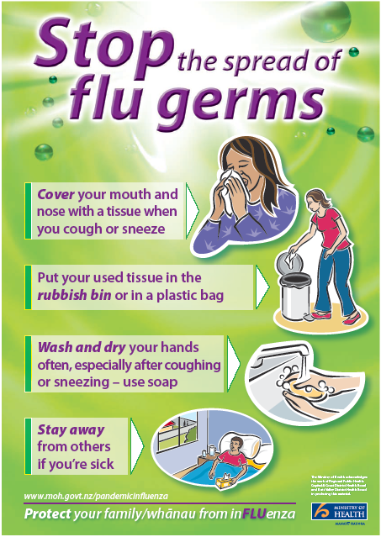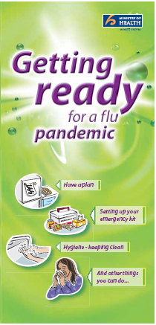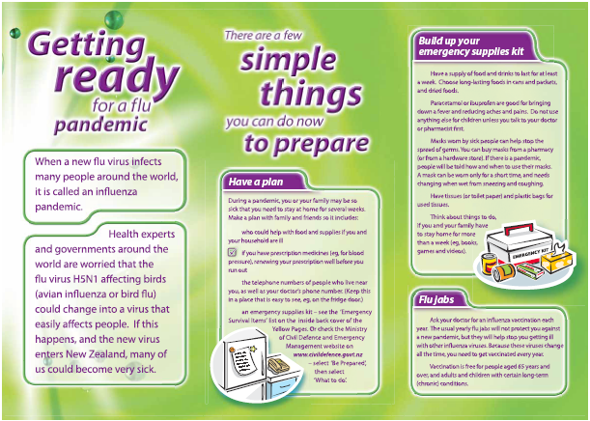

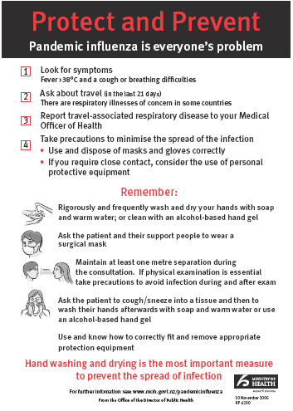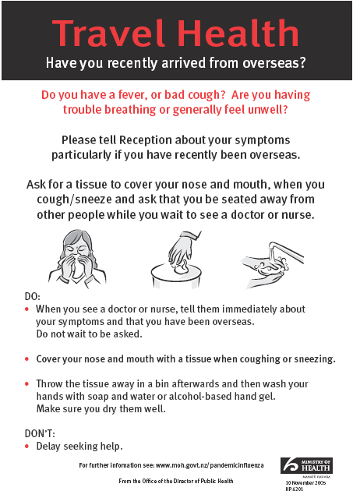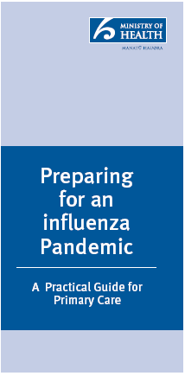

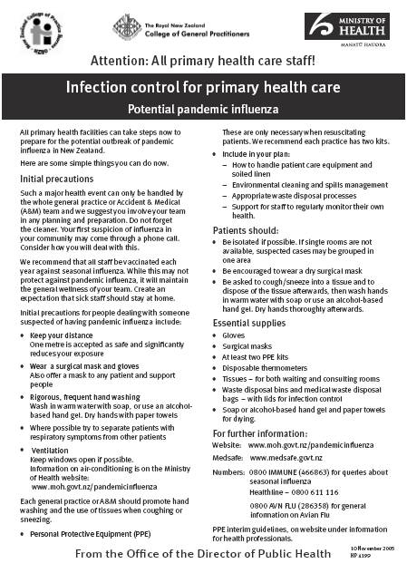

Te Whatu Ora Hawke’s Bay Communication Action Plan (linked to Triggers)

Code:
White
Te Whatu Ora HB | COMMUNICATION |  | ACTIVITIES |  | TE WHATU ORA COMMUNICATION ACTIVITIES
Audience | Key message/s |  | Medium |  | (Summary – for full plan refer to latest version of  NZ Pandemic Action plan)
Te Whatu Ora staff, services and service providers (NGOs) | Facts about the virus  ‘What is it”  FAQ about the virus  Specifically for primary care:  You need to plan and prepare  You need to order PPE  Clinical/technical info  Clinical pathways  CACS  Info on Tamiflu and vaccine  Printable resources (on CD)  MoH Posters  What to do with non-influenza pts  “You have important role to play during a pandemic”  “Hospitals may not be able to do much for pandemic influenza patients”  “The vast majority of care will be given by family, friends, neighbours”  NGO – specific:  -pandemic – “not if but when.”  -be aware…don’t panic….but you do need to be prepared  -tell us about your pandemic contingency plans  -here’s where you can find useful info to assist in your planning  -Te Whatu Ora staff can provide assistance |  | Email  Te Whatu Ora Hawke’s Bay intranet  Te Whatu Ora Hawke’s Bay website  Hard copy notices circulated via staff notice-board managers  CD containing resources/info relevant to GPs distributed (e.g. downloads from MoH website – how to…put on PPE; e-versions of tv ads to play in waiting rooms; key contacts and useful web addresses)  Copies of relevant Te Whatu Ora Hawke’s Bay plans/policies  NGO – letter first  - briefing and toolkit  - meeting to review plans |  | Continue to work with stakeholders to improve the communication information infrastructure  Continue to publish bulletins  Continue to provide accurate updates on the virus and the pandemic phase for the public and healthcare workers  Routine media monitoring
Clinical and public health staff | Case definitions, clinical advice and control measures, clinical pathway |  | Email  Face-face briefings  Te Whatu Ora HB intranet  Te Whatu Ora HB website  Including link to MoH and Te Whatu Ora websites |  | Inform key stakeholders of emergence of novel virus  Inform public of where to go for information 0800 # websites  Travel advice  Set up 0800# for health professionals  Produce resources for primary care  Create pandemic intranet for health sector use  Initiate background briefings for all health spokespeople  Explore culturally appropriate information channels for Maori and Pacific audiences  Initiate production of new material for paid media advertising
Media/Public  Other community groups – health and disability interest  e.g. Age Concern, Grey Power, Arthritis Foundation, CCS | Respond to any media enquiries about the risk  Social media monitoring and responding to posts  Proactively release information regarding planning activities  What can you do to protect you and your family  How to stop the spread of the virus  Getting ready for a pandemic  Reiterate key public health messages e.g. handwashing, cough and sneeze etiquette  Accurate info on Tamiflu i.e. may reduce the length/severity of the disease – it won’t cure you  Promote national 0800 number |  | Media releases  FAQs  Media Briefing  Via email  Updates in public section of board meetings (where media present)  Update Pandemic Planning Ad and print overruns as posters |  | Inform public of what the authorities will do in the event of a pandemic  Ongoing revision of key messages to reflect changes  Ongoing review of materials for Maori/Pacific/Asian audiences  Ongoing review of materials for specialist sector audiences, Agriculture, Education, Border Control, MFAT, Police MCDEM, Welfare, Travel and Tourism, businesses/unions, primary healthcare, older people, disabled people  Introduce new materials for people facing public: transport operators, retail industry, hospitality industry

Update contacts database | We’re preparing for pandemic – how do you prefer to receive information? | Email trees  Fax  Phone to gain info
Board  Community leaders Mayors/CEOs of TLAs  NKII  CEOs of other govt agencies  MPs | Regular updates | Via email
Ministry of Health | Regular updates re: local activity and consult re response to local issues | Phone and email
Pandemic  Stakeholders  Group  (e.g. Lifelines, HB Prison, Police, Civil Defence, funeral directors, Port, Airport) | As for media/public  Forward links to any sector-specific Ministry of Health advisories
Maori (in English & Maori)  Pacific Island | As above, plus culturally appropriate additional information  May be advisable to suspend or modify some cultural practices for the duration (e.g. hongi/tangi/kissing on the cheek) |  | MoH and TPK are working together to engage with established networks for the distribution of key messages to both rural and urban-based Maori  A Maori-specific communication plan has been incorporated into the overarching communications plan

Non-residents – e.g. tourists, foreign students/ + orchard/vineyard workers those not eligible for publicly funded health services | General information as per general population |  | Te Whatu Ora has prepared information for these groups of the population in a range of appropriate languages  Key messages are similar to those for the general population  Plus information on border control and travel advice (whether people can return home or not)

Code:
Yellow
TE WHATU ORA HB | COMMUNICATION | ACTIVITIES |  | TE WHATU ORA COMMUNICATION ACTIVITIES
Audience | Key message/s | Medium
GPs/primary care/all other NGO health providers | As for earlier phase (updated if required) |  |  | Review and refine, if necessary, communications plan  Increase frequency of media updates  Implement multi-media campaign fronted by trusted authority figure covering self-care/possible closures/where to go for help/community resources such as home-help etc
Clinical and public health staff | As for earlier phase (update if required)  Identify and publicise who spokespeople will be for pandemic media communications – inform all staff and stakeholders | Email  Staff notice boards  Intranet |  | Regular media conferences  Review documents with special reference to border control/tourism and travel sectors  Produce health leaflet for incoming travellers  Reiteration of key messages + txt messaging campaign

Public/media | Press conference re: first case in HB  Develop media pack with facts and advice on what public should and shouldn’t do  House all material on external Our Health website so it can be used as a place to refer everyone for up-to-date accurate information  Reiterate prevention, caring for someone with the virus, when and where to seek medical advice  Other messages as per phase one  Promote national and local 0800 numbers  (Clarify what information to be recorded on local number e.g. location of CACs)  + fact sheets -  self diagnosis  self care  how to stay healthy  social distancing | Link in with Te Whatu Ora advertising (newspaper/radio)  Social media posts  Media releases  Radio talkback  Te Whatu Ora Hawke’s Bay website  Flyers/posters in petrol stations/ supermarkets/ fast-food outlets  Increase local circulation of Te Whatu Ora resources  Mail drop to local households/ PO boxes | Increase Interagency communication  Ongoing media/social media monitoring  Review and if necessary, update pandemic stakeholders contact list  Implement multi-media campaign fronted by trusted authority figure covering:  Self care/caring for others  Staying safe  Limiting spread  Possible closures/mass gatherings  Where to go for help  Community resources such as home-help  Shopping help etc for a wide range of audiences  Possible introduction of video-streaming media conferences/hand hygiene demonstrations etc  Regular press conferences (daily) to support media updates if required  Review and update foundation documents with special reference to border management/tourism and travel sectors  Produce health leaflet for incoming travellers

Māori (in English and Maori)  Pacific Island | As above, plus culturally appropriate additional information  May be advisable to suspend or modify some cultural practices for the duration (e.g. hongi/tangi/kissing on the cheek)
Board  Community leaders – Mayors/CEOs of TLAs and communications advisors  NKII  CEOs of other govt agencies In HB  MPs | Regular sitreps  As per board and public info  Invite communications advisors to media conference/s and include on media release  Distribution list | Via email
Ministry of Health | Continue to liaise and update
Non-residents | General information as per general population + go home if possible Borders may be closed partially or completely for an unknown time

Code:
Red
TE WHATU ORA HB |  | COMMUNICATION | ACTIVITIES |  |  | TE WHATU ORA COMMUNICATION ACTIVITIES
Audience |  | Key message/s | Medium | Timing/  Responsibility
GPs/primary care/all other NGO health providers  Including:  Pharmacists  Maori health providers  Midwives |  | Update clinical advice as per earlier phases including info on PPE training and antiviral protocols  Information on quarantine centres  Information on community assessment centres  Provide regular surveillance updates to primary care: number of cases/deaths/location/lab confirmed |  |  |  | Continue phase three activities  Reiterate media protocols with Te Whatu Ora communications particularly with regard to communication re local cases  Coordinate communications to foreign governments media on situation in NZ  Provide advice to New Zealanders overseas  Review and promulgate new messages reflecting heath action e.g. vaccines, community assessment centres, quarantine centres  Review and increase frequency of media conferences updates (1 or 2 x daily)  Work with districts to develop key messages  Review and if necessary, revise educational materials and guidelines about infection control in the home, schools and workplaces  Activate crisis communications team and network  Work with public health to develop public education messages  Provide regular updates using important health notices, including new/updated case definitions and clinical guidelines  Implement plans to communicate with all relevant audiences, including the media and employees
Clinical and public health staff |  | Update clinical information  Disseminate to appropriate  staff members
Public/media |  | Provide information re:  - telephone triage  - CACS  - Info on any mobile in-home service  - Self diagnosis  - Self care  - How to stay healthy  As per earlier phase, health education and information but with more specific details on:  Social distancing  Closures – cancellation of public gatherings  Telephone triage  Facts and figures  Keeping yourself healthy  Protocols re death in home (what to do – who to call) | Constantly review messages and feedback and tailor messages and medium to suit changing situation
Board, community leaders (as per Code White) |  | Regular updates and copies of media releases

Code:
Green
TE WHATU ORA HB |  | COMMUNICATION | ACTIVITIES |  |  | TE WHATU ORA COMMUNICATION ACTIVITIES
Audience |  | Key message/s | Medium | Timing/  Responsibility
Clinical and public health staff  GPs/primary care/all other NGO health providers |  | Advise of changed status |  |  |  | Advise media public  Deactivate regional coordination teams  Resume normal functions  Terminate pandemic media campaigns  Initiate recovery information and actions campaign  Ongoing consultation with all key agencies  Coordinate communications to foreign governments, media on situation in NZ  Post stand-down: participate in the ministry-led review of emergency response  Debriefing  Lessons learned
Public/media
Board
Community leaders – Mayors/CEOs of TLAs and communications advisors
CEOs of other govt agencies in HB
MPs
Ministry of Health

Deceased Persons Procedures

Deceased Person Procedures: Pandemic

- Introduction

This Plan serves as a guideline in relation to the manner in which the deceased persons will be subject to post mortem mortuary and funeral processes.

Enabling legislation includes the New Zealand Health Act 1956, the Civil Defence and Emergency Management Act 2002, Coroners Act, Epidemic Preparedness Act 2006, along with the National Civil Defence Plan, the Ministry of Health Pandemic Action Plan, the Te Whatu Ora Hawke’s Bay Pandemic Plan and the Eastern District Police Pandemic Response Plan.

This plan outlines the requirements, functions and procedure that enable the process to operate in the most effective and efficient manner given the context of a Pandemic.

Therefore the aim of the Plan is to:
- Outline roles, responsibilities and procedures to be adopted.
- Provide effective and timely co-ordination.
- Provide a generic framework within which key partners can operate and develop contingency plans appropriate to their role during a Pandemic event.

There is no intention to store the bodies of deceased persons once the Pandemic event concludes (provided certificates of identification, Life Extinct and Cause of Death has been issued).

- Local Situation
Based on considerable information, both nationally and internationally it is evident a proportion of the population will become ill with influenza should human to human transmission occur and the Hawkes Bay area be affected. A proportion of the population will require out-patient visits, hospitalisation and some will die as a result of influenza related causes.

The exact numbers cannot be determined; however this Plan is based on extra ordinary numbers of death requiring standard coronial procedures.

Police will support the Medical Officer of Health and Te Whatu Ora Hawke’s Bay whilst maintaining their reporting and investigation obligations to the Coroners of the Hawke’s Bay.

Staff are reminded bodies cease to be infectious (from influenza) after death.

The intention is to avoid storing bodies if possible. The storage of bodies is Te Whatu Ora Hawke’s Bay responsibility. The Police responsibility is to work with the Coroner to ensure identity and cause of death is known.

- Vulnerability and Risk Analysis of local population
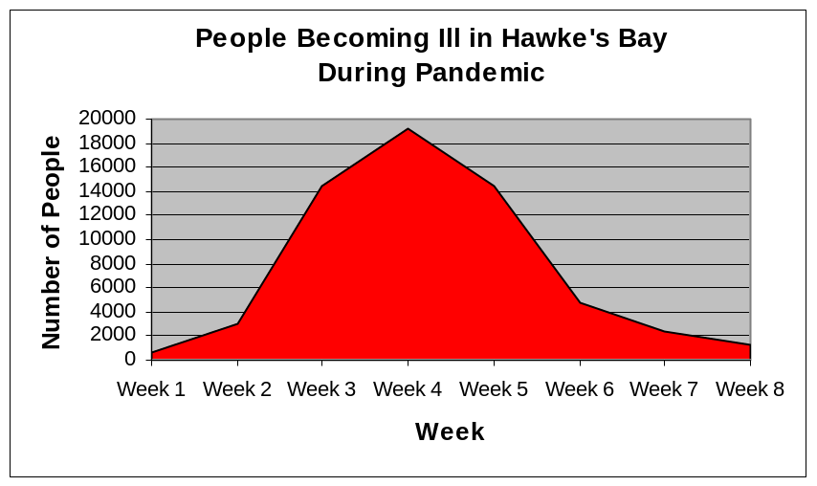

- Legal and Jurisdictional Responsibilities
Police will operate in support of the Medical Officer of Health and following notification from the Medical Officer of Health that a Pandemic is present in the Hawke’s Bay, will prepare for an extra ordinary number of deaths requiring certification, identification and associated funeral process.

- Trigger Point

This Plan will be implemented when the Medical Officer of Health advises of a Pandemic death in Hawke’s Bay or clusters of pandemic cases in any District of New Zealand including Hawke’s Bay.

- Local Emergency Management Resources
  - Te Whatu Ora Hawke’s Bay will, during this phase, retain the role of lead agency and Police in support.

Police will meet their statutory obligations to the Coroner pursuant to the provisions of the Coroners Act.

If a deceased person has been identified, certified as deceased and a cause of death established and certified, Police involvement will be significantly reduced. The body will be transported from the place of death by a Funeral Director directly to the grave and interred. Where the Funeral Director has been unable to notify Next of Kin (whänau representative) of the death (preferably prior to removal) Police will assist.

  - In the event that a temporary mortuary is required the following will occur:

Temporary mortuary provision will be established by Te Whatu Ora Hawke’s Bay who will also be responsible for providing sufficient body bag supplies with 600 stored at the Te Whatu Ora Hawke’s Bay Warehouse and additional requirements met through the Ministry of Health contract.

Te Whatu Ora Hawke’s Bay will be responsible for contacting funeral directors utilising the list held by the Public Health Service and advising of mortuary areas and delivery and uplifting procedures. New Zealand Police must also be contacted.

Personal Protection Equipment (PPE) must be used by all personnel dealing with any patient who has died as a result of the Pandemic.

The body is to be sealed in a bag prior to transfer to a mortuary and transfer is to occur as soon as possible after the death.

Those attending a deceased person who has died from a pandemic virus are to be advised the deceased had the virus and reminded of the standard precautions that are required in the event of exposure to the body. If in doubt advice should be sought from the Health Protection Officer, Public Health Service, Napier Health Centre - telephone 834 1815, after hours contact 878 8109.

  - The manner in which life extinct and cause of death will be certified is dependent upon legislation. At present the following people are duly qualified to verify death and can sign a Verification of Death (VOD) declaration that a person is deceased:
Registered Medical Practitioner
Nurse – Practitioner, Registered, or Enrolled
Registered Midwife
Intensive Care Paramedic
Paramedic
Emergency Medical Technician

- Cultural
Cultural obligations must be given paramount consideration. To this end, on activation of the temporary mortuary facility, contact will be made with the Maori Health Unit of Te Whatu Ora Hawke’s Bay. The unit will ensure an individual responsible for cultural liaison will be on site at the facility during its operation. Every effort must be made by the Funeral Director to advise NOK (whänau representative) of the death as soon as possible. If this cannot be achieved, Police will assist at the request of the Funeral Director.

- Structure of local emergency command system
The Lead Hospital and Specialist Services of Te Whatu Ora Hawke’s Bay is the Incident Controller during the response phase and Te Whatu Ora Hawke’s Bay as the lead agency.

Police will support Te Whatu Ora along with the Ministry of Civil Defence and Emergency Management and the local Recovery Manager during a Pandemic event.
- Medical Facilities and Mortuaries
Te Whatu Ora Hawke’s Bay has determined the location, functionality and use of temporary mortuary facilities along with the permanent facility.

Current planning has identified the area behind the Mental Health In-patient Unit at Te Whatu Ora Hawkes Bay as being the most practical site for the temporary mortuary. It can be secured, is of sufficient size and is proximate to the hospital and other support infrastructure.

If a temporary mortuary is established it is anticipated bodies will be stored in refrigerated containers (6) located on site. The focus will be on applying correct identification procedures and then moving the body on for either cremation/burial.

Transportation from the scene of a death to the grave or temporary or permanent mortuary facility will be facilitated by funeral directors.

Police will appoint a Mortuary Manager to assist Te Whatu Ora Hawke’s Bay in co-ordinating temporary mortuary facilities if such a facility is established.

There will be a need for security at the premises and this must be 24 hour.

It is the responsibility of Te Whatu Ora Hawke’s Bay to ensure security of the mortuary facilities and may require the hiring of security personnel to ensure this occurs.

Provision will be made by Te Whatu Ora Hawke’s Bay at the temporary mortuary for the secure temporary storage of property and personal effects associated to deceased persons pending uplifting by next of kin.

If Disaster Victim Identification (DVI) procedures are necessary they will be implemented by Police. Police will co-ordinate this function in consultation with Te Whatu Ora Hawke’s Bay. The DVI process will operate under the New Zealand Police Disaster Victim Identification procedures consistent with the Interpol DVI guidelines.
Police will be responsible for preparing sudden death files and liaising with the Coroner regarding Inquests in appropriate cases only. Police will investigate sudden deaths as directed by the Coroner.

- Funerals, (Public Gatherings), Tangi

The Ministry of Health and/or Medical Officer of Health will provide guidance regarding Public Gatherings during a Pandemic event.

Appendices

- Community Direction and Control
- Temporary mortuary facilities setup
- DVI Post Mortem Structure
- Burial Sites

Appendix 1

Community Direction and Control

Position | Name/Agency | Telephone
Lead Hospital and Specialist Services | Chris Ash  Te Whatu Ora HB | 878 8109
Medical Officer of Health | Dr Bridget Wilson  Te Whatu Ora HB | 878 8109
Medical Officer of Health | Dr Simon Baker  Te Whatu Ora HB | 878 8109
Infectious Diseases Physician | Dr Andrew Burns  Te Whatu Ora HB | 878 8109
Emergency Management Advisor | Sandra Bee  Te Whatu Ora HB | 878 8109
Infection Prevention and Control Advisor | Racquel Lewis and Jessica Hawke  Te Whatu Ora HB | 878 8109
Population Health Manager | Farley Keenan  Te Whatu Ora HB | 878 8109
Communications Manager | Emma Horsley  Te Whatu Ora HB | 878 8109
Police | Jeanette Park  Area Commander  NZ Police | 831 0700
Fire | Ken Cooper  Area Commander Eastern Fire Region | 835 2114
Ambulance Service | Ian Murphy  Operations Manager  HB Ambulance Service | 844 1950
Hawke’s Bay Regional Council | General Manager  HBRC | 835 1961
Hawke’s Bay Hospital | Call Centre | 878 8109
CHB Health Centre | Reception | 06 858 9090
Wairoa Hospital | Reception | 06 838 7099
Royston Hospital | Reception | 873 1111
Tracey Fitzgibbon | Coroner  East Coast | 870 3116
Appendix 2

Temporary Mortuary Facility Set-up

Location
This facility will be located at the rear of the Mental Health In-patient Unit at Hawke’s Bay Hospital. The hospital mortuary will be available for viewing as required.

See Annex 1 for layout.

Design and Layout
Reception area to handle urgent enquiries and receive
Storage area for supplies and equipment
Tent for body preparation
Refrigerated containers for body storage
Personal effects storage area
Hand washing facilities

Requirements for Preparation
- Tarpaulins to cover external fences
- Sawdust for drainage
- Refrigerated containers and power supply for same
- Tent
- Trolleys with large wheels to transfer bodies
- Gowns, gloves and masks
- Household gloves
- Gumboots, half length
- Body bags
- Refuse containers
- Soap, disinfectants, detergent
- Cleaning cloths and buckets
- Identification tags

Responsibility of Te Whatu Ora Hawke’s Bay Facilities Service
  - Provision and placing of refrigerated containers and power supply for same (6 containers can be supported by emergency power supply, requires running of a mains cable and a temporary switchboard)
  - Painting over any existing logos on containers
  - Building of shelving for containers (4 shelves at 55cm in height beginning 10cm off floor, 2m in length), each container to house 8 bays (this work may be contracted out dependent on current workload)
  - Numbering of shelves (top shelf for personal effects of three beneath)
  - Building of ramp into each container and placement of a board down the centre of the container to allow stretcher movement
  - Provision of marquee for body preparation and lighting for same
  - Provision and placing of tarpaulins for perimeter fence and sawdust for seepage
  - Provision of storm water protection

Responsibility of Te Whatu Ora Hawke’s Bay Procurement Department
- Provision of PPE, gloves, coveralls, large gumboots, body bags, plastic property bags and cable ties, hand sanitizer, wheelie bin refuse containers and cleaning materials
- Provision of 5 tables for the body preparation area
- Replacing of wheels on mortuary trolley to allow ease of movement

Procedures
Persons handling bodies should be advised to observe strict hygiene precautions including:
- Wearing a gown, gloves and a mask (gloves must be changed after each body, gowns may be worn for up to eight hours unless soiled or wet, masks may be worn for up to four hours unless wet)
- Washing hands and forearms with soap and water at the completion of each body
- Washing all surfaces after use with detergent and water followed by sodium hypochlorite 1:10 solution (100mL/1L water)
- Placing rubbish and linen in approved containers for disposal

Body preparation process:
- Body to be received in preparation area and placed in a body bag after clothing removal, body bag to be labeled
- All personal effects to be bagged and labeled
- Body and personal effects to be transferred to a container, body to be placed on a numbered shelf and placement documented
- Personal effects to be numbered corresponding to body number and placed on the top shelf of the bay in which the body is housed

Strict record keeping is required, this is the responsibility of the NZ Police.

Cleaning and Disinfecting of Containers Used
Turn off refrigeration, open doors to allow container to achieve ambient temperature (18⁰C) if possible.
Wearing household gloves and a gown, wash and scrub surfaces with warm water and detergent.
In a well ventilated area make up sodium hypochlorite 1:10 solution (100mL/1L water).
Apply solution to all surfaces and leave in contact for a minimum of 10 minutes (preferably up to 30 minutes).
Discard disposable cloths and protective clothing.
Clean brushes and mops in water and detergent, rinse well and allow to dry.
Update container record with cleaning procedure.

Annex 1

Temporary Mortuary Layout

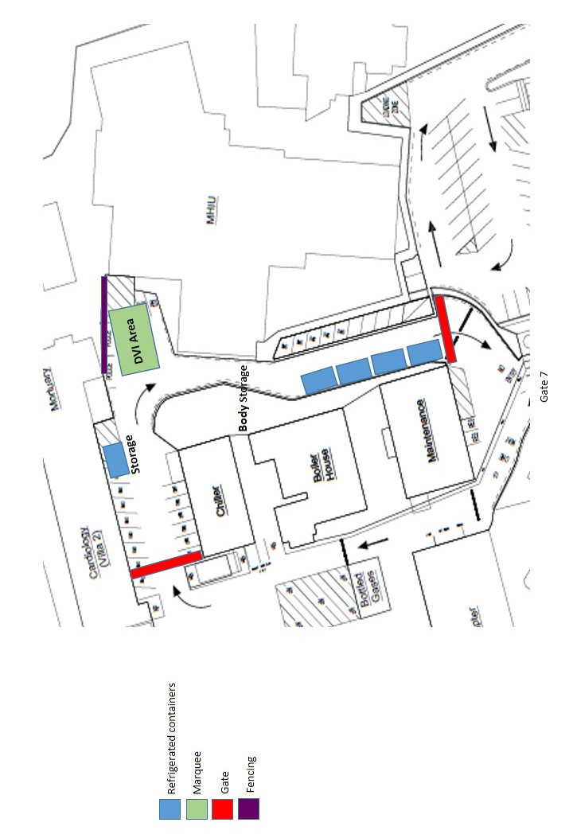
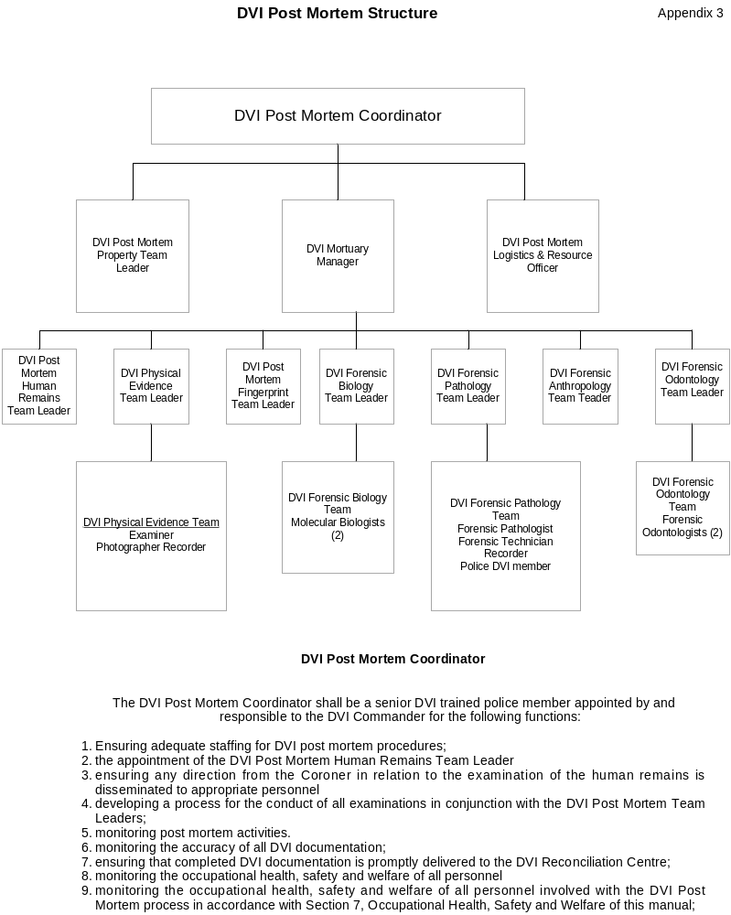
Appendix 4

Burial Sites (possible)

Hastings: 3000 plots + 9000 ash plots available

Wairoa: 177 plots + 19 ash plots

Napier: 2000 plots + 2500 ash plots

CHB: 2796 plots + 168 double plots + unlimited ash plots

Human Resources Frequently Asked Questions

To all employees

This information sheet is designed to answer some Frequently Asked Questions with regards to your employment before, during and after an event such as a pandemic.

During a pandemic we will have to run services and employees will be required to fulfil duties during this period.

The following principles have been considered during the planning and preparation:
- The safety and wellbeing of our employees will be taken into account. We understand that you have important and legitimate personal, family and community responsibilities. Where possible, our planning will take into account these needs.
- A key to the success of the planning and management of a pandemic is excellent communication and flexibility by both employers and employees. Identifying effective communication strategies will be part of the planning process.
- As a good employer we will provide you with access to information and consult with you on matters that affect you, wherever possible.
- We will use good safety, wellbeing and infection prevention and control practices to ensure that our workplace remains a safe place to be during a pandemic.

As usual all employees are required to adhere to organisational policies, procedures, guidelines and protocols during a pandemic.

If you have concerns or questions that have not been addressed by this information sheet, please discuss them with your Manager/Team Leader.

Frequently Asked Questions

Will Personal Protective Equipment (PPE) be provided to me at work during a pandemic?
Yes, if required, in line with Infection Prevention and Control policies. You should be mindful that unless you have direct contact with infected people there is no need for PPE to be worn. If you have further questions about PPE please contact the Infection Prevention and Control Team at Hawke’s Bay Hospital.

What do I do if I am concerned about my workplace being unsafe?
Discuss it with your Manager/Team Leader in the first instance, your safety and wellbeing representative, Occupational Health or Human Resources.

As mentioned earlier, we will be using good health and safety and infection prevention and control practices to ensure a safe work place.

What happens if I need to stay at home to care for my family?
Once again we recognise that you may have personal, family and community responsibilities. If you are concerned about how you will manage these during a pandemic, discuss it with your Manager/Team Leader in the first instance or Human Resources.

If it is not appropriate or possible for you to continue working while caring for your family, options such as sick leave or other paid or unpaid leave will be available in accordance with your employment agreement and organisational policies.

Do I have to come to work during a pandemic?
As our organisation will be providing essential services for our community during a pandemic, you will need to come to work. It is a reasonable expectation that you attend work where practicable steps have been taken to ensure your health and safety while at work during a pandemic.

If you have concerns about your health and safety, raise these with your Manager/Team Leader, and explain the reasons for your concern. If after discussion you are concerned that measures taken are insufficient to manage the risk of infection, you can refuse to work if you believe it is likely to place you in an immediate and significant risk of incurring serious harm.

The Health and Safety at Work Act 2015, obliges you to work together to resolve the matter, and allows you only to continue to refuse to work if you have reasonable grounds to consider it dangerous.

We recommend you communicate with your Manager/Team Leader during a pandemic. In addition if you choose to stop being available to work without discussing this with your employer, you are not meeting your employment obligations and disciplinary action may follow.

What happens if I get asked to work in a different way to what I normally do?
During a pandemic our ability to provide essential services to our community is dependent on the organisation being able to respond flexibly to the different scenarios a pandemic may create.

Through planning we may identify that work needs to be performed differently. If this is perceived to be a viable option, we will consult with you and your representatives in good faith to reach an agreement.

Will my terms and conditions of employment change?
Your terms and conditions of employment will essentially remain the same, however flexibility may be required with regard to the nature of tasks and duties to complete, hours and location of work.

Depending on the scenario that the pandemic presents, alternative arrangements may be available for employees who work flexibly during the pandemic.

Can my employer require me to stay at home?
Yes. Employers have a legislative obligation to make the work place safe for their employees. This may require employees to stay at home if:
- they are sick and present as an identified or potential hazard to the workplace
- the organisation is unable to manage the potential hazard of contracting the pandemic virus

If a situation arises, where we require you to stay at home, we will consult with you and clearly explain the rationale for our instruction.
Can I take annual leave during a pandemic?
Granting annual leave is always dependent on organisational needs. You will need to continue to be mindful that we are required to run services, during a period of time where we may be short staffed.

If you have any immediate concerns, please discuss these with your Manager/Team Leader in the first instance.

Can I take sick leave during a pandemic?
Authorisation for sick leave during this period will be treated as per organisational policies and procedures relating to Sick Leave and your relevant employment agreement. Communication will be a crucial factor during this period so please contact your Manager/Team Leader if you are feeling unwell, or have dependants to care for.

Can I take bereavement during a pandemic?
Yes, authorisation for bereavement leave during this period will be treated as per Te Whatu Ora Hawke’s Bay’s Bereavement Leave Policy and your relevant employment agreement.

Will I still get paid if I am not required at work?
The decision to require employees to stay at home will not be made lightly. A pandemic scenario is likely to impact on our services and normal business. At this stage we don’t know what those impacts are likely to be, however can anticipate that reasons for such a decision being made would include,
- closure of part of our business for a period of time during the pandemic,
- if a staff member is sick and presents as an identified or potential hazard to the workplace; and
- when the employer cannot provide a safe and healthy work environment for employees.

Under normal circumstances wages are payable when an employee is ready and willing to perform work. If the situation arises where we need to look at different ways of doing our work, we will consult with you, and consider options for working differently which may include the use of annual leave, sick leave and leave without pay.

Can my Manager/Team Leader require me to take annual leave during a pandemic?
Yes. Provisions under the Holidays Act 2003 allow employers to instruct employees to take annual leave with at least 14 days notice.

Who can make the decision to close my workplace during a pandemic?
An employer can close a workplace (i.e. require employees not to turn up to work) if it is determined that there is no other way to manage the safety risk of the workplace.

Employers can also be forced to close workplaces under the exercise of authority via the Health Act 1956 or the Civil Defence Emergency Management Act 2002.

For further information about the Influenza Pandemic please refer to the Ministry of Health website www.moh.govt.nz/pandemicinfluenza.

For more information about the planning occurring within Te Whatu Ora Hawke’s Bay, with regards to a pandemic, please contact emergency.response@hbdhb.govt.nz.

Interagency Plan for Management of First Cases

Interagency plan for management of first cases of a pandemic virus

Introduction

This plan is developed as part of a number of workstreams to enhance Hawke’s Bay pandemic preparedness

Definitions

Case: someone who is thought by a doctor to meet the case definition for pandemic influenza.

Contact: Anyone who has had:
- Contact with the respiratory secretions of a case in an enclosed space
- Contact with the faeces of a case
Household, work and institutional contacts during the infectious period of the case will almost always be defined as contacts.

Isolation means restricting the activities of cases until they are no longer infectious.

Quarantine means restricting the activities of contacts (people who have been exposed to a case but are still not sick) until the incubation period has expired.

Abbreviations
HECC – Health Emergency Coordinating Committee
EOC – Emergency Operations Centre
MOH - Medical Officer of Health
PHS – Public Health Service
PPE – personal protective equipment

Aims and general purpose
To minimise the spread of a pandemic virus by prompt management of first cases, contacts and clusters.

Assumptions
- The first case(s) are notified to the MOH before the epidemic has become widespread in Hawke’s Bay.
- Isolation of cases and quarantine of contacts are important early in an epidemic and may help to slow the spread of the disease. Isolation and quarantine will be enforced early in an epidemic.
- Not all cases will be sick enough to be hospitalised.
- General practitioners have access to PPE and are trained in its use.

Conditions under which the plan comes into force

This plan should be followed for all early suspected cases of a pandemic virus.

Operational Structure

Te Whatu Ora Hawke’s Bay is the lead agency during a pandemic. All other agencies are support agencies.

The MOH and the staff of the PHS will coordinate all activities related to management of cases and contacts of a pandemic virus.

Communication Plan/Issues

Types of messages, how they will be distributed, obligations on receipt

Cases will be notified to the PHS by health care personnel or the public. It is expected that practitioners will notify by phone early in the epidemic.

Preparedness

Relationships required
PHS |  | Doctors (hospital or community)
PHS |  | Police (for enforcement)
PHS |  | Laboratories
PHS |  | St John Ambulance (in case evacuation of cases to hospital is required)
PHS |  | Incident Controller (see Command and Control Plan)
PHS |  | Educational institutions and those in charge of any other public places or events

Risk assessment
Cases may not seek care from a doctor.

Doctors may not diagnose or notify suspect cases.

Doctors may not collect specimens correctly or arrange their urgent testing.

The training plan may not be implemented in time for all doctors to know how to arrange rapid testing.

Exposed contacts and the unexposed “worried well” may seek advice from health care providers who are not aware of the public health response processes.

There may be unmanageable sudden increase in demand for information from parties in the health sector, the media and the general community.

PHS may be unable to access sufficient support deployed from other parts of Te Whatu Ora Hawke’s Bay and unable to cope with the intensive workload required.

Operational Procedures

Roles, relationships and tasks

Agency | Role and task | Relationships
PHS | Manage the first cases under a CIMS structure. | All parties
Medical practitioners | Diagnose and notify cases. | MOH
Hospitals | Manage cases meeting hospital admission criteria (arrange lab testing, recommend and enforce isolation, give advice and support including PPE, provide treatment). Laboratory specimens should be collected by the attending doctor and sent immediately to the Hawke’s Bay Hospital Laboratory.² | MOH (pre-discharge)
PHS, MOH | Manage cases in the community (arrange lab testing, recommend and enforce isolation, give advice and support including PPE, provide treatment). Laboratory specimens¹ should be collected by the attending doctor and sent by taxi immediately to the Hawke’s Bay Hospital Laboratory. (This lab has a contract with Napier and Hastings taxi companies).² | Medical practitioners
PHS, MOH | Identify and manage contacts (recommend and enforce quarantine, give advice and support, provide prophylaxis). | Medical practitioners
Police | Respond to MOH request for assistance enforcing isolation or quarantine. | MOH
HBDHB | Coordinate volunteer and social support for people in isolation and quarantine. | MOH, PHS
CDEM | Welfare provision, event management, lifeline utilities | All parties
Community laboratories | Have no role with regard to collecting or testing specimens for a pandemic virus. All diagnostic samples are to be taken by the attending medical practitioner and sent to the Hawke’s Bay Hospital Laboratory
Hawke’s Bay Hospital Laboratory | URGENTLY arrange processing of diagnostic samples for PCR and serology. | Medical practitioners, MOH

Resources e.g. designated sites, equipment required
Cases requiring hospitalisation will be admitted into isolation in the Isolation Suites in B2 at Hawke’s Bay Hospital. The referring community medical practitioner must brief the Emergency Management Advisor before the case arrives.

For management of cases and contacts refer to Te Whatu Ora Hawke’s Bay’s Quarantine and Isolation Plan.

For supply and use of antivirals refer to Te Whatu Ora Hawke’s Bay’s Antiviral Distribution Plan.

Workforce issues
Urgent secondment of staff (e.g. nursing or clerical) to assist the PHS from other parts of Te Whatu Ora Hawke’s Bay would be helpful. This would only be feasible in the early stages of the epidemic (“stamp-it-out” phase) and would only be useful at that stage.

Reporting
Daily report on cases and clusters.
Daily count of number of cases in isolation and the number of contacts in quarantine.
This would form part of the daily PHS report to the Planning and Intelligence Manager.

Maori
Pandemic Plan Template

Hauora Māori Pandemic Plan Template
Prepared by Te Roopū Huihuinga Hauora Trust

This plan is committed to supporting the nationwide imperative to minimise the spread of a novel virus, and to minimise the health and safety and business risks that could occur during a pandemic. The Pandemic resources have been developed by Te Whatu Ora Hawke’s Bay are available to support Hauora Māori providers and Māori community pandemic initiatives.

Contents

Background | 4
Introduction | 5
Kaupapa Matua: Main purpose | 7
Co-ordination of Pandemic plans and reporting | 8
Communication and reporting process to CIMS | 10
Māori community access to medical services in emergency situation | 11
Māori Community-based Assessment Centre (CAC) information | 12
Māori community pandemic reporting form | 13
Managing a pandemic virus in the workplace / on the Marae | 14
How to minimise the risk of spread | 16
Ngā Mea Tikanga | 18
Community hui and home visits | 20
Information to highlight in home visits | 21
Family Emergency Plan | 22
Information on Quarantine (Home Isolation) for a pandemic virus | 23

background

“I never thought it likely they could be so fine a race of people as I now found them. They generally rose above the middle stature, some were even six feet and upwards, and all their limbs were remarkable for perfect symmetry and great muscular strength. Their countenances … were pleasing and intelligent …”

“Neither soap nor oil was known, but the body was cleansed every evening before the dances started…The Māori diet was so healthy that the teeth needed very little cleaning”

“So simple a diet accompanied with moderation must be productive of good health, which indeed these people are blessed within a very high degree…I do not remember a single instance of a person distempered in any degree that came under my inspection and among the numbers of them that I have seen naked. I have never seen any eruption on the skin or any signs of one by sores or otherwise. Such health drawn from such sound principles must make physicians almost useless…” (John Liddiard, 1814).

These early impressions of Māori provide us with a picture of a race that was generally healthy; life expectancy was on a par (if not better) than most other European countries. Māori had well developed economies and systems of trade. Their health protocols (public health systems) were progressive and culturally based. In the early 1800’s the Māori population was estimated at 150,000 people.

By the turn of the 19th Century (1896) the Māori population numbers were at their lowest with an estimate of just 42,000 people. Introduction of new diseases alongside tribal and land wars contributed to the decline of the Māori population. When the 1918 influenza pandemic (Spanish flu) hit Aotearoa it proved to be very severe and claimed Māori lives at a death rate of 42.3 deaths per 1000 compared to 5.8 deaths per 1000 for Europeans. During this time there were outstanding efforts by Māori leaders such as Maui Pomare and Peter Buck who, with the help of community leaders and funded wholly by the Māori communities concerned, worked to improve the condition of Māori housing, sanitation and health status of whānau.

Te Puea Herangi, of Tainui, implemented a pandemic plan when her Māori community suffered a small pox epidemic (1913-1914) and many refused to go to Pākehā hospitals. In response to this Te Puea set up a small settlement of nikau huts devoted to nursing the sick and inflicted back to health. Not a single person died and the isolation of the village largely prevented spread of disease. During the 1918 influenza pandemic Te Puea took under her wing some 100 orphans who were the founding members of the community of Tūrangawaewae at Ngaruawāhia. She was also instrumental in establishing marae-based health clinics.
Like the Spanish flu, the ill effects of subsequent novel influenza viruses have already claimed lives in Aotearoa. If little or no action is taken, there is a risk of 80% of whānau and communities becoming infected. Therefore, building on the examples of past Māori leaders, Hauora Māori providers and Māori communities must be vigilant and proactive in averting risk to uphold and ensure healthy communities.

INTRODUCTION

Marae committees, hapū and iwi leadership, Hauora Māori providers and the Te Whatu Ora Hawke’s Bay Māori Health Service are fundamental in implementing a successful approach to emergency pandemic plans and management of a pandemic virus in Māori communities.

Moreover, Hauora Māori providers and the Te Whatu Ora Hawke’s Bay Māori Health Service, play an important role in supporting timely and effective access to necessary health services for Māori and in disseminating accurate messages and information to marae and their communities.

Goals to achieve implementation of pandemic plans may include:
- Clear consultation processes undertaken with marae committees, hapū, iwi, Hauora Māori providers by Te Whatu Ora Hawke’s Bay CIMS Front Line Services Unit.
- Necessary resources as identified by Māori communities are obtained.
- Access to relevant training and in-service education.
- Acknowledgement of the unique features of whānau, hapū, iwi and Māori communities in each of their respective areas throughout Hawke’s Bay. This is very important as pandemic plans and reporting systems will need to be adjusted to the suitability of each of these areas.
- Determining and promoting consistent use of key prevention and intervention messages on the marae, in homes and communities in a safe and appropriate way.
- Working together with key organisation stakeholders i.e. marae committees, hapū and iwi leadership, Hauora Māori providers, Te Whatu Ora Hawke’s Bay Māori Health Service and CIMS Front Line Services Unit in delivering culturally appropriate and safe prevention, intervention and management of novel virus outbreaks in the whānau, hapū, iwi, and community.

Key considerations to measure successful implementation may include:
- Development of a local evaluation framework to measure outcomes of Māori communities’ emergency pandemic planning responses
- Effective communication and consultation processes are demonstrated by all key stakeholder organisations i.e. marae committees, hapū and iwi leadership, Hauora Māori providers, Te Whatu Ora Hawke’s Bay Māori Health Service and CIMS Front Line Services Unit
- Access to adequate and necessary training and educational resources has been readily obtained
- Consistent safe health practices and messages are evident during all marae and Hauora Māori provider hui e.g. pōwhiri, tangihanga, whakangahau, hui-a-iwi
- Understanding what is needed to address local need and raised awareness about local need is evident
- Whānau, hapū and iwi and the communities contribute positively and proactively when outbreaks of a pandemic virus occur

KAUPAPA MATUA: MAIN PURPOSE

This plan is a template which Hauora Māori providers, marae committees and Māori community groups can use and adapt to their own local needs.

For Māori a number of areas to reduce risk of transmission of a pandemic virus need to be considered and include:
- Co-ordination of implementation of pandemic plans and regular reporting of pandemic updates in the workplace, communities and homes
- The workplace responsibilities to kaimahi and those who visit the workplace
- The carrying out of tikanga processes such as pōwhiri and tangihanga
- Holding and attending hui out in the community and in homes.
- The health and safety and business risks that could occur during a pandemic.

This plan is supported by the following pandemic resources that have been developed by Te Whatu Ora Hawke’s Bay:

- Pandemic Plan for Health Services
- Pandemic Introduction Powerpoint
- Pandemic Planning Manual Training Resource
- Community Assessment Centres
- Pandemic Plan Template for General Practice
- Pandemic Presentation Powerpoint (Ministry of Health)
- Checklist for a pandemic Influenza case
- Patient Minimum Dataset Form
- Family emergency plan

The plan also acknowledges the emergency pandemic plans that are currently in place at local marae (through the work of marae committees, whānau, hapū and iwi); Kohanga Reo (as supported by their National Trust); Kura Kaupapa and Hauora Māori providers. It is hoped that the information contained in this template may strengthen and add value to that which is presently in place.
co-ordination of pandemic plans and reporting

The Māori pandemic planning coordination role and responsibilities lies with Te Whatu Ora Hawke’s Bay Māori Health Service. This service is the current point of contact for assisting and working with Māori communities, Hauora Maori providers, whānau, hapū and iwi.

Key responsibilities of this role include:
- developing a pandemic plan template for Hauora Māori providers and Māori community groups to manage an outbreak of influenza
- ensuring a process is developed for implementation of pandemic plans with significant Māori groups e.g. Hauora Māori providers
- managing communication from Hauora Māori providers, Māori community groups, whānau, hapū and iwi where calls are directed from the Te Whatu Ora Hawke’s Bay Coordinated Incident Management Structure (CIMS)
- coordinating activity with key stakeholders in particular Hauora Māori providers and Māori organisations.
- working closely with and keeping the Te Whatu Ora Hawke’s Bay Front Line Services Unit informed about concerns and pressures from Hauora Māori providers and Māori organisations
- providing direction and support by interacting with iwi / Māori communities

Coordinated Incident Management Structure (CIMS) Key Personnel
Name | Title | Contact
Sandra Bee | Emergency Management Advisor | 027 245 3692
Racquel Lewis and Jessica Hawke | Infection Prevention and Control Advisors | 878 8109

Māori input into the CIMS process is through representation of:
- Te Whatu Ora Hawke’s Bay Māori Health Service
The Te Whatu Ora Hawke’s Bay Māori Health Service also participates in the coordination process and Frontline Services Unit to ensure Māori health interests are protected for the duration of pandemic planning development, implementation and in pandemic virus outbreaks.

Considerations for Māori readiness and response in a coordinated incident management situation
- That Māori communities via Hauora Maori providers and marae have a designated person to provide weekly updates of pandemic activities to Te Whatu Ora Hawke’s Bay Māori Health Service to support accurate reporting to the CIMS structure
- That Māori communities undertake an assessment and action plan of how they can set up a Community Assessment Centre to assist large numbers of whānau, hapū and iwi members in rural and remote areas in preparation to contain and manage possible outbreaks.

Communication and reporting Process to CIMS

Key Groups
Main Tasks

Māori Pandemic Planning Coordination Team
Māori Health Unit
Receive & collate reports; follow up & clarify as necessary. Share & discuss reports to CIMS structure
Work collaboratively with Māori to respond & act in a timely, effective way to issues raised
Hauora Māori, Marae, Māori Community Pandemic Coordinators
Provide whānau, hapū & iwi weekly reports (see Māori Community Pandemic report form, page 12)

Whānau, Hapū, Iwi members
Raise & alert Hauora providers, Marae committees and /or community groups of influenza infections
Te Whatu Ora Hawke’s Bay Coordinated Incident
Management Structure
Māori membership: Māori Health Unit

Māori Community Access to Medical Services in Emergency Situation

Key Groups
Main Tasks

Initiate & mobilise medical response to address situation
Provide regular reports to Māori community:
emergency pandemic management progress
other emerging risks to the community
Hauora Māori, Marae, Māori Community Pandemic Coordinators/ Teams (as / where appropriate)
Assist medical team to access affected parts of community
Support with emergency pandemic management
Keep community updated
Community
Whānau, Hapū, Iwi members
Work with Te Whatu Ora Hawke’s Bay & Māori community pandemic response teams to ensure timely & effective access to affected / infected whānau, hapū, iwi members to:
minimise spread of infection
receive medical attention & care

Coordinated Incident Management Structure Key Frontline Services personnel
Sandra Bee: Emergency Management Advisor
Racquel Lewis and Jessica Hawke: Infection Prevention and Control Advisor

Māori Community – based Assessment Centre Information
A Māori Community–based Assessment Centre (CAC), if needed, will be activated by Te Whatu Ora Hawke’s Bay Front Line Services Unit through effective engagement and consultation with the Māori community concerned. This activation phase will be supported by the Māori Health Service. Medical staff support for the centre will be through local general practitioners and/or locums with the fall-back position being hospital registered medical officers (RMOs).
What’s needed | Getting started | How to achieve it
A central site that can cater for large numbers of whānau, hapū and iwi members in rural and / or remote areas to provide the primary care surge capacity arising from a sudden increase in demand | Identify marae and other locally based buildings that have adequate facilities to become a CAC | Engage & consult with Hauora Māori providers / marae on possible sites, venues with adequate facilities
Lists of local health organisations and community groups and the skills they offer | Work with Te Whatu Ora Hawke’s Bay to prepare promotional information about a CAC and its purpose | With Te Whatu Ora Hawke’s Bay Māori Health Service support, meet with organisations and Maori communities to educate on ‘creating’ a CAC in an emergency pandemic situation
Setting up a Community Assessment Centre (CAC) | Set-up as in CAC Plan | Have organisations and Māori community groups fill in an asset survey re programmes and services, equipment, supplies, communication links and staffing
Reporting - directly to the Frontline Services Unit & Medical Officer of Health | Reporting process as in CAC plan | Pandemic reporting processes put into action
Ensure centre is adequately resourced | Identify resources needed i.e.  • Staffing  • Personal protective equipment  • Antiviral agents and other medication  • Clinical supplies  • Standardised documentation  • Security  • Infection control approved furnishings and cleaning supplies | Prioritise and reconfiguration of resources and services to best meet the needs of the community
Community assessment evaluation strategy that demonstrates positive outcomes for Māori | Identify effective Māori community evaluation tools. What works and what does not work | Develop a local evaluation framework that will build and increase Māori evidence-based information
Māori Community Pandemic Reporting Form
Name of Community:

Month:

Hauora Māori Provider:

Whānau  (identified through numbers to protect privacy)  NB: How many are tamariki, rangatahi, pakeke and or kaumātua who may be affected | Current status of virus impact:  low = contained in home  medium = GP assisted  high = hospital input | Comments
managing A PANDEMIC VIRUS in the workplace / on the Marae

This procedure specifies what to do in cases where a pandemic virus is present and what the kaimahi and (name of organisation / Marae) will do to minimise the spread of the virus.

PERSONAL PROTECTIVE EQUIPMENT (PPE)
Provide kaimahi / whānau, hapū and iwi members with essential PPE equipment to reduce the risk of transmission either as a caregiver or patient.

PPE includes masks, eye protection, gloves, gowns and aprons. Varying levels and types of PPE are required, depending on the level of exposure and the risk of transmission.

Whatever the level of PPE to be used, education and training is necessary to ensure the equipment is used and disposed of correctly, to maintain the equipment’s effectiveness.

WHAT TO DO

If you have symptoms i.e. cough, sore throat, temperature:

- Stay at home until you have no symptoms.

- Phone your doctor if you are not improving or symptoms become worse.

- Try to stay at least one metre away from other people.

- For extended periods of sick leave a Medical Certificate will be requested, which you may need to request via phone contact with your GP rather than making a formal visit to minimise the risk of infecting others.

If you are caring for someone in your home who has a pandemic virus:

- Once you know the type of virus your whānau member has then:

  - Contact your manager immediately and inform them of the situation.

  - If the whānau member receives Tamiflu and if after three days the Caregiver has no symptoms of the virus, the Caregiver should be able to return to the work place / marae
(iii) Your manager will discuss with you the options available in terms of working from home and how the leave is to be recognised. If a staff member is working from home, this will be considered a normal working day.
(iv) Organisations/Marae will take a flexible approach in terms of agreeing to temporary arrangements for staff who need to work from home in these circumstances.

Please contact (name of manager / human resource kaimahi/ chairperson) in these circumstances.
If you suspect you or a work colleague has a pandemic virus while in the workplace:
- Inform the Line Manager.

(ii) The Manager will check for the following symptoms:
- High fever (or feels feverish and hot)
- Headache
- Fatigue and weakness
- Sore throat, cough, chest discomfort, difficulty breathing
- Muscle aches and pains
- Been in contact with someone diagnosed with the pandemic virus.
- If the answer is yes to most of these the Manager will direct the staff member to put on a surgical mask, go home immediately and contact a health professional.

(iii) The Manager will want to know everyone that the Kaimahi has been in contact with and will advise them accordingly.

(iv) The Manager will ensure the staff member’s work area is thoroughly cleaned and disinfected.

HOW TO MINIMISE THE RISK OF SPREAD

Good hand washing

- Wash your hands often with soap and running water. Dry your hands thoroughly with paper towels or hot air dryers.

- Alcohol-based hand hygiene products are now widely available in the kitchens and toilets. These are an effective alternative to hand washing.

- Avoid touching your eyes, nose or mouth after coughing or sneezing or removing a mask.

(v) You should always wash your hands:
a. After using the toilet
b. Before making or eating food
c. After handling cats, dogs or other animals
d. If you have been around someone who is unwell

Good coughing and sneezing habits

- Use a tissue to cover your nose and mouth when you cough or sneeze. Ensure a good supply of supplies tissues.

- Place the used tissue in a bin afterwards ( do not throw used tissues)

- Wash your hands with soap and water

- Dry your hands well on a paper towel or hot air dryer

(v) People who are coughing or sneezing or have symptoms will be advised to go home

Other measures

- Avoid close contact with people who are sick

- Avoid large crowds where possible

The organisation / Marae will:

- Provide a supply of tissues

- Provide a covered, lined bin for used paper towels and tissues

- Provide plastic bags to line bins that have a drawstring top

- Ensure the bins are emptied and new liners replaced regularly

- Ensure bins are disinfected with household bleach 100mL/1L once or twice weekly depending on use

- Provide hand washing facilities, i.e. running water, hand basin, soap and paper towels, or hand gel

(vii) Educate Kaimahi so that everyone practises good coughing and sneezing habits

(viii) Ensure kaimahi and visitors know and practise good hand washing and drying techniques by posting hygiene notices in appropriate places

(ix) Ensure shared work surfaces frequently touched by hands are disinfected with alcohol wipes or bleach every day e.g. computers, telephones counters, handles, railings etc

(x) Ensure cups, dishes and cutlery are washed with soap and hot water regularly

(xi) Ensure Kaimahi do not share personal items

(xii) Remove all magazines and paper from reception areas and lunch rooms

(xiii) Have a process in place to manage suspected cases, i.e. putting a mask on, isolation area, transport home etc

SICK LEAVE

Kaimahi current entitlements to sick leave with pay will be provided. This entitlement is to encourage Kaimahi to stay home if they are unwell and to minimise any potential financial impact. This needs to be accompanied by a Medical Certificate.

If any additional entitlement is required then normal leave provisions specified in employment agreements and organisational policy will apply. Consideration will also be given to utilising annual leave if the staff member is looking after unwell whānau for an extended period of time. For enquiries regarding leave entitlement contact (manager or HR person).

It is recognised that some cases may fall outside these parameters. In these instances management will take a flexible approach to identify the best way forward to:
(i) ensure the risk of spread is managed effectively;
(ii) support the well-being of the staff member and their whānau; and
(iii) ensure the interests of the organisation / Marae are managed appropriately.

NGĀ MEA TIKANGA

When carrying out tikanga processes that are a normal part of the organisation’s / Marae protocols, all Kaimahi / Marae committee members / whānau, hapū, iwi members will attend an in-service session on proactive pandemic virus management and ngā mea tikanga. The following key points are to be considered in regards to:

- Pōwhiri and Whakatau
Let the manuhiri know prior to attending the organisation / Marae the health safeguards that have been put in place to reduce and minimise the spread of the virus, e.g.
- Do not bring anyone to a hui that has symptoms i.e. coughing, sneezing, a runny nose, aches, fever, diarrhea, vomiting
- Hariru will be limited
- After the hariru and before partaking of any food, washing the hands is required
- Liquid soap cleansers, hand gel and tissues will be provided

Should anyone attend pōwhiri or whakatau who is deemed to be unwell:
- They should be encouraged to go home
- Before leaving the hui:
  - with the person’s agreement, contact details including name of GP will be written down for the organisation’s / Marae’s pandemic register and to co-ordinate any further follow up that may be required
  - a pandemic resource information kit will be given to the person, i.e.
- Pandemic Presentation Flip chart (Te Whatu Ora Hawke’s Bay template)
- Checklist for Case (Te Whatu Ora Hawke’s Bay Template)
- Family Emergency Plan (Te Whatu Ora Hawkes Ba’y template)
- Tissues, soap, hand gel, surgical face masks
- Koha of canned or dried food

- Should s/he require support and need a ride to return to their home, surgical masks will be provided for both the driver and the unwell person (and any others accompanying) who will be travelling in close proximity
- The relevant parts of the inside of the vehicle will be wiped down with disinfectant on return of the vehicle to the office/hui

- Tangihanga
- First and foremost, under no circumstances should anyone who has symptoms i.e. coughing, sneezing, aches, fever, diarrhoea and vomiting attend tangihanga
- When at the tangihanga, limit your contact with others (no kissing or hugging)
- Wash your hands after hariru and before having kai, keep hand gel, tissues, surgical mask and a plastic bag (for used tissues) in the car as a back up
- Promote and role model safe health practises in a sensitive and non-judgmental way
community hui and home visits

When organising hui and travelling out in the community and to whānau:

Key points to consider
- Keep hand gel, tissues, surgical face masks and a plastic bag (for used tissues and masks) in the car

- Engage with the community and whānau sensitively and effectively; and promote and role model safe health practices in a sensitive and non-judgmental way

- Give and teach consistent messages i.e.
- Reduce and minimise the spread of the virus
- Avoid close contact with sick people
- Cover your nose and mouth with a tissue when you cough or sneeze
- Wash your hands often with soap and water especially after you cough or sneeze, hand gel is also effective

- Prepare and provide resource kits with pandemic influenza information and distribute to whānau, i.e.
(i) Pandemic Presentation Flip chart (Te Whatu Ora Hawke’s Bay template)
(ii) Checklist for a Case (Te Whatu Ora Hawke’s Bay Template)
(iii) Family Emergency Plan (Te Whatu Ora Hawke’s Bay template)
(iv) Fact Sheets and Posters (Te Whatu Ora Hawke’s Bay Templates)
(v) Tissues, soap, antiseptic alcohol sanitized liquid cleanser, surgical face masks
(vi) Koha of canned or dried food

- Monthly Follow ups:
(i) Collect relevant information re: the number of whānau affected
(ii) Hand in information to the Manager to send to the Māori Health Service located at Te Whatu Ora Hawke’s Bay

Information to highlight in home visits
- Family preparedness in a pandemic situation
(i) Become familiar with the pandemic resource kit
(ii) As a family go through the Family Emergency Plan and write down key contact persons and their phone numbers
(iii) Put the Family Emergency Plan where it can be seen by all the family and easily located if/when an emergency pandemic situation arises
(iv) Carefully read Information on Quarantine (Home Isolation) (see page 23), ask your Hauora Maori provider to clarify anything you are unsure of
(v) Have family members practice:
- Covering their nose and mouth with a tissue when they cough or sneeze, then place the tissue in a lined bin with a cover.
- Washing their hands often with soap and water especially after they cough or sneeze, hand gel is also effective
- Teach whānau so that everyone learns good coughing and sneezing habits

- What to do if someone in the whānau becomes ill
(i) If you or whānau members are unwell then let you employer know and stay home, get plenty of rest, drink lots of fluid, keep sick whānau members away from other whānau members
(ii) Follow the guides provided in Information on Quarantine (Home Isolation) (see page 23).
(iii) If you or a whānau member have a high fever and are concerned phone the Helpline 0800 611 116 or your GP

Use your Family Emergency Plan information as a guide to help you know what to do and who to contact.

FAMILY EMERGENCY PLAN

Work through the checklist with all members of your household. Keep the Plan close to hand and in a convenient place at home, in your desk drawer at work, or next to the Emergency advice page in your Yellow Pages.

Name: | Home Phone:
Address:
Work Phone (Mum): | Mobile Phone (Mum):
Work Phone (Dad): | Mobile Phone (Dad):
Community Assessment Centre (CAC) Phone:
Location of CAC:
1. In a Pandemic situation we will:  • Remain indoors  • Observe hand hygiene  • Observe cough etiquette.  • Observe one (1) metre separation  • Conserve food and water supplies  • Turn on the Emergency radio  • Be aware of influenza-like symptoms | 2. The person responsible for collecting the children from school in an emergency is:  Contact Phone:
3. If we are required to go to the CAC or GP how do we get there? | 4. Who do we contact if we require more food or other essentials?
5. Who is to look after the children if the Schools’ close? | 6. What is the contact number of the local Pharmacy?
7. Our Neighbours | 8. Do we have enough of the following items to last at least 3 weeks?  • Water  • Soap  • Canned or dried food  • Pet supplies  • Baby food/supplies  • Waste disposal bags  • Batteries (radio & torch)  • Essential medicines  • Tissues  • Hand cleansing materials  • Face masks  • Fuel (if winter)
Local Radio Station Frequency: | Contact Numbers:  Police.  Civil Defence:
Pandemic packs are available at: www.thnz.co.nz

Information on Quarantine (Home Isolation)

You have been asked to stay in isolation because:
- You have a suspected pandemic virus and are infectious to others. Isolation in your home should continue for 72 hours after starting Tamiflu or 7 days after the onset of illness if you are not taking Tamiflu.

- You may have been exposed to the pandemic virus. Isolation in your home should continue for 72 hours after starting Tamiflu or 7 days after the onset of illness if you are not taking Tamiflu.

The period of isolation may be lengthened if somebody else in your household becomes sick.

We want you to restrict your activities to protect the safety of your family, friends and the community. This information sheet is to tell you what isolation means.

Staying at home.
You must not go to school, work, child care or out in public until cleared by the Public Health Nurse. This means you must not attend shopping centres, movies, parties or any social gatherings at all.

Visitors
You should have no visitors until you come out of isolation. Talk by phone and have things delivered to the door. Sometimes a visitor is essential (for example someone has to come into the house to give you essential home support). The visit should be brief. You and the visitor must both wear a mask. Talk with the visitor outside in the open air if possible and keep at least two metres away from them.

Preventing the spread of infection
Stay in a part of the house where you have minimal contact with other people.
Try to keep well people and sick people apart.
Give people who have a fever and/or diarrhoea plenty to drink.
Give Paracetamol for fever. Do not give Aspirin to children under 12 if they have a fever.
Open doors and windows and ventilate the house as much as possible.

Cover your mouth and nose with a tissue or toilet paper when you are coughing or sneezing. Put the used tissue straight into a rubbish container. Wash and dry your hands afterwards.
Wash and dry your hands after you use the bathroom or toilet. Wash and dry your hands before you prepare food and eat, and when you are looking after sick people.

If you have more than one toilet, one should be reserved for use by sick people.

Twice a day clean the following:
- toilet handle and door handles of toilet, bathroom and rooms of isolated people
- bathroom sink and taps
Use one (1) part household bleach to 10 parts water.

Nobody else should use anything that could be contaminated with your throat or nose secretions or coughing or faeces – e.g. towels, handkerchiefs, eating utensils, food, bed linen, cigarettes, marijuana joints, P pipes, kava bowls.

Sharing bedding, clothing and utensils may spread infection but you do not need to wash a sick person’s bedding, clothing and utensils separately from the rest of the family's. If you wash and dry all these things in the usual way they will then be safe for others to use.

Using face masks
The Public Health Nurse will show you how to wear a mask.
- Sick people should wear a surgical mask if anyone is in their room and if they have to leave their room.
- People who are in quarantine but not sick should wear a surgical mask if they are in the same room as a sick person.
- Essential visitors to the house should wear a particulate respirator (PFR95) mask through their visit.

Used masks should be put in the normal household rubbish.

Coming out of isolation
The Public Health Nurse or your doctor will tell you when you are cleared to come out of isolation. At that time you will be non-infectious to others. It will then be safe for you to resume your normal life.

Questions
Your Public Health Nurse will be happy to answer any questions.

¹ National Laboratory Guidelines for Pandemic Influenza: Collection and Handling of Human Specimens for Laboratory Diagnosis of Influenza with Pandemic Potential. ² S74AA of the Epidemic Preparedness Act 2006 states that the lab must advise the MOH of the results as well as the doctor.
Liddiard, John Nicholas. (1814). Narrative of a voyage to New Zealand: Performed in the years 1814 and 1815 in company with the Rev. Samuel Marsden

